



Online and Offline Activism in Egypt and Bahrain

James Fowler* and Zachary C. Steinert-Threlkeld* †

*University of San Diego, California, Department of Political Science
†With contributions from colleagues at the University of Oxford

Contents

Executive Summary 7
Research Questions 7
Summary of Findings 8
Introduction 9
Selection of Countries 10
Exploring Online/Offline Social Movements 11
Defining Terms 13
Identifying Tools and Strategies 15
Structure of Report 16
Methodology 17
Introducing the Digital Case Study 17
Integrating Qualitative and New Quantitative Methods 17
Machine Learning and Social Network Analysis 19
Three Datasets 19
Social Network Analysis 23
Content Analysis 25
Using Hashtags 25
Topic Models 26
Ethnographic Analysis 31
Semi-Structured Interviews and Fieldwork 32
Challenges and Limitations in the Field 36
Case Study: Egypt 37
Movements 39
April 6th Youth 39
No Military Trials 40
Anti-Sexual Harassment Campaign 42
Mass Mobilization 44
Moving into the Street 44
Complementing Offline Action 50
Formal and Informal Organizations Between the Online and the Offline 54
Information Dissemination 56
Building to Protest: Egypt’s Media Landscape 56
Offline and Online Dissemination 58
Domestic and International Audiences 68
Case Study: Bahrain 72
Movements 73
(Il)legal Opposition 74
Human Rights 75
February 14th Youth Coalition 77
Mass Mobilization 78
Movement to the Street 78
Complementing Offline Action 84
Formal and informal organizations 86
Information Dissemination 88
Building to Protests: Bahrain’s Media Landscape 88
Offline and Online Dissemination 90
Domestic and International Audiences 97
Conclusion 101
Bibliography 105

List of Figures

Figure 1: Protests in the Middle East and North Africa 10
Figure 2: Timeline of the 2011 Egyptian Revolution (18 Days) 38
Figure 3: Tweets in Support of Protest, Egypt 46
Figure 4: Tweets Coordinating Protests, Egypt 48
Figure 5: Percent of Movement Tweets from Mobile Device 52
Figure 6: Tweet Production by Movement, Egypt 53
Figure 7: Internet and Cell Phone Penetration in Egypt, 2009-2013 57
Figure 8: Facebook and Twitter Penetration in Egypt, 2010-2014 57
Figure 9: Anti-Sexual Harassment, Common Hashtags 61
Figure 10: NoMilTrials, Common Hashtags 62
Figure 11: April 6th, Common Hashtags 63
Figure 12: Anti-Sexual Harassment, Unique Hashtags 65
Figure 13: NoMilTrials, Unique Hashtags 66
Figure 14: April 6th, Unique Hashtags 67
Figure 15: Egypt Follower Network 70
Figure 16: Timeline of the Uprising in Bahrain 73
Figure 17: February 14th Youh Coaltiion Logo, on poster in Manama, 2014 77
Figure 18: Tweets in Support of Protest, Bahrain 81
Figure 19: Tweets Coordinating Protest, Bahrain 83
Figure 20: Bahrain, Mobility 85
Figure 21: Bahrain, Tweet Production by Movement 86
Figure 22: Cell Phone and Internet Penetration in Bahrain, 2009-2013 (ITU statistics) 89
Figure 23: Twitter and Facebook Penetration in Bahrain, 2010-2013 (ASMR statistics) 89
Figure 24: Human Rights, Common Hashtags 92
Figure 25: Youth, Common Hashtags 93
Figure 26: Human Rights, Unique Hashtags 95
Figure 27: Youth, Unique Hashtags 96
Figure 28: Bahrain Follower Network 99

List of Tables
Table 1: Identifying Tools and Strategies 15
Table 2: Digital Case Study 19
Table 3: Descriptive Statistics for Sifter Users 22
Table 4: Sample Tweets Based on Content Model 30
Table 5: Interview Procedure 33
Table 6: Sample Interview Questions 34
Table 7: Egyptian Activists Referencing Egyptian CSOs 55
Table 8: Egyptians Referencing Egyptian CSOs 55
Table 9: Egypt, Non-Activists' Interaction with Activists, Domestic and International 68
Table 10: Bahraini Activists Referencing Bahraini CSOs 87
Table 11: Bahrainis Referencing Bahraini CSOs 88
Table 12: Non-Activists' Interaction with Movements, Domestic and International 98
Table 13: Lessons Learned - Mass Mobilization 101
Table 14: Lessons Learned - Information Dissemination 102

Acronyms
BCHR – Bahrain Center for Human Rights
CSO – Civil Society Organization
GCC – Gulf Cooperation Council
HMLC – Hisham Mubarak Law Center
ICT – Internet and Communications Technology
MENA – Middle East and North Africa
REST API - Representational State Transfer Application Programming Interface
SMS – Short Message Service
SNA – Social Network Analysis

Executive Summary

In this report, we explore the ways in which six social movements in Egypt and Bahrain used online and offline activism to mobilize political activity during those countries’ 2011 protests. Information and communication technologies (ICTs)—the Internet and social media platforms, in particular—are widely perceived to have played an important role not only in disseminating information, imagery, and updates about the unfolding protests in the Arab Spring but also in helping to mobilize them. Understanding the relationship between actors and their communication technologies has thus become a central ambition of research into the events of the Arab Spring.

This report was conducted in response to the need within both the academic and policy communities to make sense of this complex relationship. It presents a multi-method, multi-sited investigation into six social movements that were active in the protests in Egypt and Bahrain in 2011. These two countries were chosen because the 2011 political events in each featured mass protests, active and involved civil society organizations (CSOs) and social movements, and different media environments.

The six movements were chosen to represent formal and informal organizations as well as marginalized groups. In Egypt, the April 6th (youth), Anti-Sexual Harassment (women’s rights), and No Military Trials (anti-military) social movements are analyzed; Bahrain’s February 14th (youth), human rights, and political opposition social movements are included. April 6th, Anti-Sexual Harassment, No Military Trials, and February 14th are informal organizations, while the Bahrain human rights and political opposition movements contain formal organizations. We then identified 41 individuals and organizations associated with the movements that also had Twitter accounts; 18 come from Egypt and 23 from Bahrain. 19 of the 41 – 12 in Egypt, 7 in Bahrain - were active at the beginning of 2011, and we purchased their tweets from a 3 month period. This quantitative data was combined with ethnographic data based on 30 interviews, 17 in Bahrain and 13 in Egypt, conducted during 6 weeks of fieldwork (3 in each country) in the fall of 2014.

We analyze these cases using research approaches from both ethnography and quantitative social science; all research was conducted during 2014, three years after the period under study. The ethnographic work—interviews and participant observation—unearths how activists understand and present the narrative of what they did, how, and why during those crucial weeks in 2011. The quantitative social science methods allow us to cross-reference this narrative with detailed analysis of the role of Twitter in each country. In combining these two approaches, we have developed a unique “digital case study” methodology that contributes to the growing literature on the Arab Spring.

Research Questions

Four years have passed since the mass protests that erupted in 2011 across the Middle East and North Africa (MENA) region. The role of social media in those protest movements has been much debated, and social media continues to factor prominently in analyses and reflections on this period, now popularly recognized as the “Arab Spring.” In an effort to better contextualize the events that unfolded in 2011 in Egypt and Bahrain, we return to the period of sustained protest of that year to provide a multi-method exploration of social media, political activism, and popular protest. Our analysis is guided by the following broad research questions:

Research Question 1
In what ways is mass mobilization of social movements the result of an interaction between online and offline activities and behaviors? Did actors use one realm more effectively than the other? Did actors’ offline strategy influence their online strategy, or vice versa?

Related to this question, we developed a second question focusing on how actors spread information – protest meeting points, tactics, etc. – to others, both those in and outside of the social movement.

Research Question 2
How did actors disseminate information within and outside each movement?

Summary of Findings

Our overarching finding is that the actors in both Egypt and Bahrain used offline activities much more than Twitter for both mass mobilization and information dissemination.

We find three pieces of evidence supporting the finding that mass mobilization occurred primarily through offline behaviors. First, qualitative evidence reveals that activists created mass mobilization primarily through word of mouth (via cellphones and in person interaction) or being in the street at the start of protests; activists did not, however, use Twitter to engage in mass mobilization. Second, social media complement actors’ offline behavior; once protests started, content production via Twitter occurred primarily through mobile devices, suggesting that Twitter was used to document events as they occurred. Third, formal and informal organizations interacted offline, but Twitter barely reflected this interaction. The important functions that the formal organizations provided, especially in Egypt, do not appear to have carried over into the online realm.

We also present three pieces of evidence to support the finding that information dissemination occurred primarily through offline behaviors. First, neither country had high levels of Internet or social media penetration, limiting the effect those tools could have on information dissemination. Second, physical spaces, such as formal organizations’ offices or large public gatherings, were the primary mechanisms of information dissemination; while this study’s actors tried to use Twitter to spread information, content analysis reveals they were unsuccessful. Third, we show there were low levels of interaction between the actors’ Twitter accounts and Twitter accounts not belonging to the actors; we then reconstruct separately the Twitter follower network for the Egyptian and Bahraini actors and find a large international audience, suggesting that Twitter may have been more important for international information dissemination than domestic.

Introduction

On December 17th, 2010, vegetable seller Mohamed Bouazizi self-immolated to protest police confiscation of his property. This act stirred long-simmering frustrations over the standard of living and state of political freedoms in Tunisia, leading to President Zine El Abidine Ben Ali fleeing the country on January 14th, 2011. Protests soon spread across the Middle East and North Africa; these protests are collectively called the Arab Spring. The revolutions of the Arab Spring captivated the world in 2011 in no small part because the dissemination of social media content to a global audience provided a real-time window into events, and the content was often not filtered by traditional media organizations.

The Arab Spring events are examples of social movements largely operating without formal leaders. While formal groups such as the Muslim Brotherhood in Egypt or labor unions in Tunisia certainly contributed to turnout at protests, events were largely organized by less formal groups of activists working outside of traditional structures. Social movements whose identity was created and defined by both online and offline communication and behavior played an important role in initial mass mobilization. The Arab Spring uprisings were realized by the synergy between these more familiar political actors and newly visible informal actors.

The ability of large groups of strangers to organize informally is a remarkable achievement. In popular discourse, these protests were often named for social media platforms, such as Facebook and Twitter, in recognition of the perceived role of the platforms in the mass mobilizations. Much of the initial reporting and analysis of the uprisings placed emphasis on a tech-euphoric interpretation of events as evidence of the liberalization potential of ‘new media’, to the exclusion of alternative narratives that might have afforded agency to actors over technologies (Aday, Freelon, Farrell, Lynch, & Sides, 2012; Howard & Hussain, 2011).

This narrative of “liberation technologies” has been challenged and critiqued in the intervening years, as a result of ethnographic work on the experiences of activists and protesters on the ground and quantitative analyses of online content (Aouragh & Alexander, 2011; Hanna, 2012; Tufekci & Wilson, 2012). The newest work on the Arab Spring suggests a complicated, multilayered role for informal civil society and political groups, with social media representing one part of this dynamic.
This report examines the worlds of online and offline activity in a novel approach we call the digital case study. The digital case study analyzes protests in Egypt and Bahrain to see how mass mobilization and information dissemination occurred across actors, offline and online. We find that offline behaviors were used much more heavily than Twitter for mass mobilizing protest participants and disseminating information, and Twitter’s most unique contribution may have been to spread information about domestic events to a global audience.

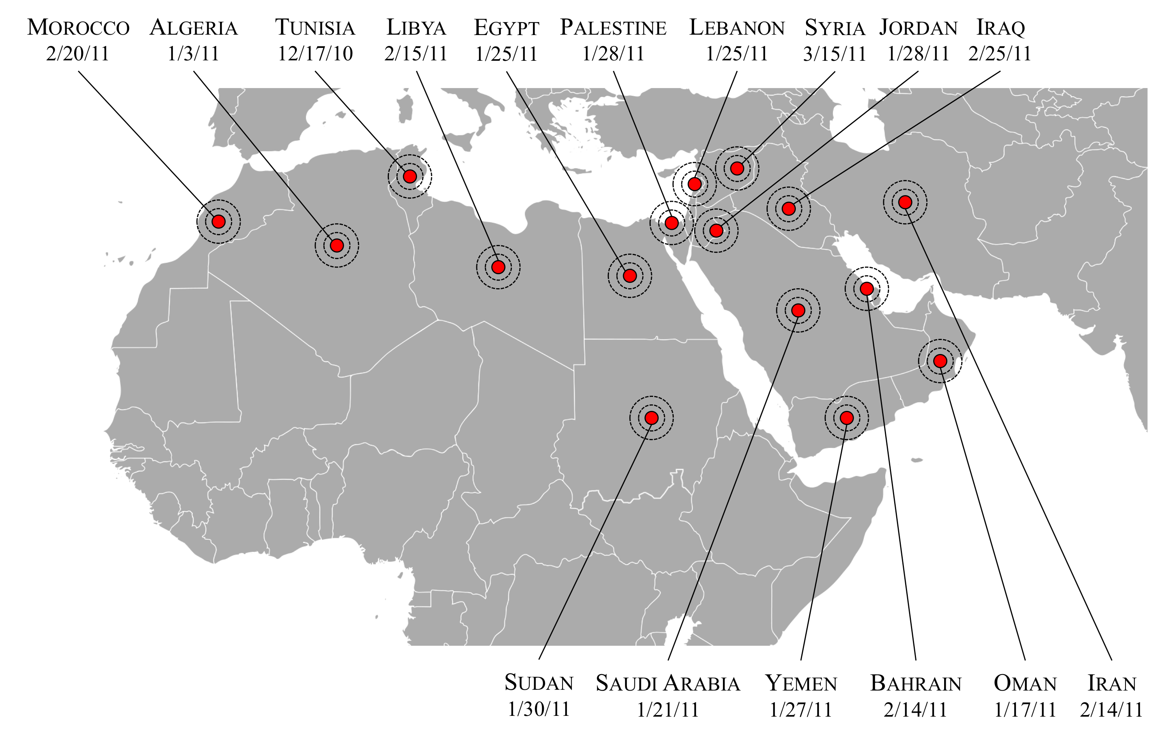
Figure 1: Protests in the Middle East and North Africa

Selection of Countries

Egypt and Bahrain provide a useful comparison when considering social media use in the Arab Spring, primarily because they represent different contexts and outcomes of the time. Egypt — a large country with a long, well-documented history of political opposition, civil society, and activism — quickly received the most attention of any country that experienced protests in 2011. Bahrain, smaller in size and population, has a less well-documented history of activism and has historically received less global attention.

For example, while Egypt’s online and offline networks were already very interconnected domestically and internationally prior to the 2011 protests, the penetration rates of Internet, Facebook, and Twitter use in Egypt were low – 39% for the Internet, 10% for Facebook, and less than 1% for Twitter. Internet, Facebook, and Twitter penetration were much higher in Bahrain in 2011(75%, 24%, and 3% respectively), yet Bahrain’s activist network truly materialized during and after the 2011 revolution, both online and offline. The difference in these media landscapes indicates that Internet penetration and social media use alone were not determinative of whether or how the social movements organized. However, viewing the change in the density of Bahrain’s activist network on Twitter before and after the protest period shows that both Internet and social media played some crucial role in the movements; we return to this point later in the report.

In many ways, Egypt’s revolution came to symbolize the Arab Spring as a whole. Images of Cairo’s downtown streets during protests in January and February would become the stock images of the Arab Spring writ large. Tahrir Square became an icon, simultaneously referencing the physical site of Cairo’s mass uprising and the goal of protestors across the Middle East and North Africa. In contrast, Bahrain received less global attention, and its mass mobilizations began after President Mubarak of Egypt had stepped down in February. The icon of Bahrain’s revolutionary movement, the Pearl Roundabout, was recognizable but faded along with prospects for meaningful political change, particularly after Gulf Cooperation Council (GCC) troops dismantled the protests in March.

Exploring Online/Offline Social Movements

The study of social movements constitutes a long line of research in the social sciences, too large to be summarized for this report. Here, we focus on work that studies how actors and participants used social media in the Arab Spring.

Scholars have started to study how digital technologies affect social movements, with an early focus on the Internet and blogs (see Garrett 2006 for a review of this literature). As activists used forums, blogs, and mailing lists before social media existed, those venues received the earliest analysis from scholars. Most of the work on the Middle East has focused on the Egyptian blogosphere and its implications for domestic politics, as it was a vibrant tool for activists well before the events of 2011.

Prior to 2011, Egypt had a vibrant, growing online space of activity focused on blogs, many maintained as side projects by journalists (Khami & Vaughn, 2011). This anti-regime use of the Internet set Egypt apart from other Middle Eastern countries, where blogs were less often used for political purposes (Radsch, 2008). In 2005 in Egypt, there were only 40 total blogs, most of which were run by young, bilingual (Arabic and English) individuals who were earlier active on online forums. These initial bloggers were political from the beginning, focusing initially on the war in Iraq; they were also divided between those seeking an international audience and others trying to create an Egyptian consciousness about issues that had not before been openly discussed, such as climate change or nuclear power (Radsch, 2008: 3-4). By 2006, activists started to realize the power of blogs, and soon the number of blogs and bloggers in Egypt was large enough (1400 in 2007) that it became impossible to describe the Egyptian blogosphere in general terms. Radsch concludes:

Over the last five years [2003-2008], blogs in Egypt have challenged the privileged role of professional journalists by giving ordinary citizens platforms for mass dissemination, whether for a moment or a lifetime. In recent years the medium has also become a form of protest and activism, a type of alternative media, and a source for mainstream media. Bloggers themselves tend to be activists and more politically influential than the average person. (Radsch, 2008: 10)

David Faris, analyzing blogs, text messaging, and crowd-sourced sites (such as Digg), in addition to Facebook and Twitter, with a focus on the April 6th movement, concludes that “social media networks” (his term) have become useful tools for activists but are not the primary drivers of mobilization. He reaches this conclusion by observing that Internet and communication technology (ICT) penetration was too low for activists to rely on digital tools completely, and the government of Egypt impeded text message services and monitored certain kinds of Internet connections (Faris, 2010: 128-136). The difficulties activists faced using these new technologies leads Faris to conclude that:

The potential of SMNs [social media networks] to ignite large-scale opposition activity in Egypt (and in places like Egypt) appears to be quite low […] SMN-mediated protest and opposition movements must be based on grassroots organizing that takes place offline. (Faris, 2010: 146-147)

Any new protest event, whether it occurs in the West or elsewhere, is violent or not, seems to inspire a study of how actors and participants used social media (usually Twitter). These studies reach two, not mutually exclusive, conclusions.

First, a consensus is emerging that Twitter is used to share information about unfolding events but not to organize and coordinate those events ahead of time. When the Group of 20 met in Pittsburgh in September 2009, actors and participants used Twitter to broadcast real-time updates of police action, allowing them to quickly change tactics in response (Earl, McKee Hurwitz, Mejia Mesinas, Tolan, & Arlotti, 2013). In Moldova, large post-election protests were held when the Communist party won that country’s 2009 general election; with the media not covering these protests, those interested quickly turned to Twitter to share and gather information (Mungiu-Pippidi & Munteanu, 2009).

While those two studies reach their conclusions using a hashtag analysis, more in-depth content analyses reach the same conclusion. A coding of tweets from protests in Thailand in 2010 finds that “the primary emphasis was on spreading information, including a rich array of localized media and information. Our dataset did not show strong instantiation of calls or appeals to action” (Bajpai and Jaiswal, 2011: 7). A similar study of tweets from Spain, Greece, and the United States of America in 2011 related to those countries’ populist protests finds that “Twitter was hardly used for logistical coordination of political actions in any of the three countries considered” and that participants increasing use social media for real-time information dissemination (Lowe, Theocharis, & W. van Deth, 2013: 13, 21).

Second, the main contribution of social media, including Twitter, is to provide online space for dissent. In the case of Iran, the online world became a place where individuals, not just activists, could express their dissatisfaction with the regime before, during, and after contested elections in 2009 (Rahimi 2011a, 2011b). This expression also occurred in Egypt, primarily through the “We Are All Khaled Saeed” Facebook page (Ghonim, 2012). Yet social media appear to serve the same function in democracies as well (Segerberg and Bennett, 2011). It is unknown, however, if the provision of online spaces contributes causally to subsequent mass mobilization.

Recent work that puts social media into the Arab Spring context argues that “cyberactivists in Egypt used new media effectively to express themselves politically, inform others of abuses by the state, organize protests and acts of resistance against the authoritarian regime, and ensure that their voices are heard that their side of the story is told" (Khamis & Vaughn 2011, pg. 22). One of the more extensive studies to date of digital media during the Arab Spring, Aday et. al’s Blogs and Bullets II: New Media and the Conflict After the Arab Spring, is an important contribution to this growing literature. They find that “new media [...] did not appear to play a significant role in either in-country collective action or regional diffusion. [...] It is increasingly difficult to separate new media from old media. In the Arab Spring, the two reinforced each other" (Aday, Freelon, Farrell, Lynch & Sides 2012, pg.21).

On the other hand, surveys of participants in Tahrir Square find that participants, not just activists, were active users of social media, with Facebook and Twitter each providing information about protests and contributing to turnout (Tufekci & Wilson 2012). Tufekci and Wilson find that 16% of protestors in Tahrir Square used Twitter and 52% Facebook as part of their daily lives; 13% specifically used Twitter to communicate about the protests, 51% for Facebook, and Twitter use made individuals more likely to protest than those who were not users (Tufekci & Wilson 2012). Faris’ work documents the emergence and evolution of counter-regime narratives from 2004 (the start of the Kefaya movement) through the resignation of Hosni Mubarak on February 11th, 2011 (Faris 2010, Faris 2013). He shows that “informal civil society” — what this report calls “actors” — used a multitude of tools to organize movements against the Mubarak regime.

These conclusions – that offline actors still need offline activity to mass mobilize and that Twitter is not used for coordination activity – are mirrored in this report. Qualitative evidence as well as content analysis shows that mass mobilization occurred through offline activity, and the online sphere primarily reflected events as they occurred offline. This report therefore contributes to a coalescing understanding of the role of social media during protests.

Defining Terms

The following terms occur frequently throughout the report. All definitions apply strictly to this report and should not be compared to their meaning in other publications.

A social movement is a collection of actors (defined below) supporting a common goal (Diani 1992 McAdam 1996). Movements can contain both formal and informal organizations, and “members” do not need to belong to either. However, members share a broad goal of working towards the new policy. Social movements can exist in any political system, though they are more likely in those with strong civil societies and protection for freedom of expression and association. Examples include the American Civil Rights movement, the Tea Party, and Falun Gong. “Movement” and “social movement” are used synonymously throughout the report. Social movement is the broadest category in this report, i.e. formal and informal organization, activists, and participants can all belong to a social movement.

A civil society organization (CSO) is either a formal or informal organization. It does not have to be one of the actors (see definition below) analyzed in this report. For example, for each country, the report looks at whether certain CSOs were mentioned by the actors, though only some of the CSOs in that analysis are also actors. This report uses the term CSO as shorthand for an informal or formal organization.

A formal organization has physical premises, official membership or employees, and is registered with the government. Al-Wefaq, one of Bahrain’s opposition societies, the Bahrain Center for Human Rights are examples of formal organizations. Social movements can encompass formal organizations or formal organizations can identify with a social movement and, through that public identity and affiliation, further shape and define it.

An informal organization has an official Twitter account but no physical headquarters or official membership. In this report, the social movements with an official Twitter account are: April 6th, No Military Trials, February 14th, and Anti-Sexual Harassment. An informal organization is a part of a social movement but is not the same as a social movement. For example, @shabab6april is the Twitter account for the April 6th informal organization, but the April 6th informal organization is part of a larger social movement comprised of youths who were working for political change.

An activist is someone who has a prominent role in a social movement as an organizer or a leader. An activist spends a large amount of his or her time on the movement and self-identifies as part of that movement. An activist can undertake many forms of activity that are not directly related to activism and so take other identities such as “blogger” or “executive”. For example, Alaa Abd El-Fattah, @alaa, is originally a software developer who used blogs to engage in activist activity. Nabeel Rajab, @NABEELRAJAB, used to run the Bahrain Center for Human Rights, a formal organization, but is also an activist because of how he directed the center and uses Twitter. Any reference this report makes to bloggers or journalists should be interpreted as synonymous with activists. For this report, most of the actors are activists.

An actor is an activist, formal organization, or informal organization involved in the one of the social movements in this report and that has a Twitter account. For example, both @Matar_Matar and @ALWEFAQ are actors; the former is an activist, the latter the Twitter account of a formal organization. This report calls a Twitter account an “actor” regardless of whether it belongs to an activist or organization.

A participant is an individual who is not an activist but is involved with Egypt’s or Bahrain’s protests, most likely as a protestor. At various points, the report explains how Twitter did not appear to mobilize “participants”, “protest participants”, or variations therefore; any phrase with “participant” refers to someone involved in the protest who is not an activist. “Non-actor” is synonymous with “participant”.

Membership in a social movement means an individual recognizes the movement’s goal or goals as in concordance with his or her own. Membership does not imply complete agreement: one can see oneself as part of America’s Civil Rights movement while not agreeing with other members on whether violent or non-violent resistance is the best course of action. Membership does not necessarily mean paying of dues, visiting a meeting site, or joining an official organization.

Online activity refers to behavior on Twitter, as that is the report’s quantitative data source. Where the report references other online behavior, such as using YouTube or Facebook, those activities are specifically referenced. In other words, generic references to online activity mean Twitter activity.

Offline activity refers to all behavior that occurs off of the Internet; it is behavior that is not Twitter, posting to Facebook, surfing the Internet, watching YouTube videos, etcetera. Use of cellular devices (voice and text) or watching satellite television, two activities the report mentions, are offline activities.

Information dissemination means the interaction between actors’ online presence and non-actors’ online presence. For example, the report shows that non-actors rarely talked about topics that actors talked about on Twitter, which suggests those topics did not disseminate from the actors to others. Similarly, we show that the actors were rarely retweeted in each country, suggesting that the content of their tweets rarely spread. In this report, the mere act of tweeting, such as sharing a photo of a protest, does not therefore count as information dissemination. Information dissemination requires non-actors identifiably engaging with actors.

Identifying Tools and Strategies

Table 1: Identifying Tools and Strategies
Actors online
Strategies | Application | Result
Encourage street action (mass mobilize) | Encourage mass mobilization with specific hashtags and topics | Mass mobilization activity at start of protests, not during
Do not operate from one physical space | Tweet from mobile phones | Increase in tweets from mobile phones during protests
Set rhetorical frames | Use movement-specific hashtags | Rhetorical frames little used outside of movement
Interact with non-movement individuals | Have content retweeted; engage in conversation with non-activists | Movement or activists rarely retweeted or mentioned in tweets
Actors offline
Strategies | Application | Result
Encourage street action (mass mobilization) | Lead initial marches, coordinate offline activity in Cairo and Manama | Successful mass mobilization
Do not operate from one physical space | Do not maintain headquarters; work with formal organizations that do have space | Difficult for state to repress the movement (state does target the formal organizations which assisted)
Set rhetorical frames | Devise chants; print fliers | Not analyzed in this report
Interact with non-movement individuals | Collaborate with other movements’ participants | Coordination and collaboration across movements, especially in Egypt

Structure of Report

The rest of the report is structured as follows. Before discussing each country and presenting evidence in support of the findings, the methodology used to generate the evidence is presented in the Methodology section. That section describes the digital case study, an innovative approach created for this report, then details the quantitative (machine learning and social network analysis) and ethnographic methods used. The following section then analyzes Egypt, the section after that Bahrain, and then the report concludes.

Each country’s section follows the same format. A brief summary of the 3 movements is given. The Mass Mobilization subsection of each country answers Research Question 1, with each of the 2nd level subsections – Moving into the Street, Complementing Offline Action, and Formal and Informal Organizations Between the Online and Offline - making a claim to support the overall finding that offline behaviors were more important than online activity. The Information Dissemination subsection does the same: each of the 3 sub-subsections makes a claim to support the overall finding that information dissemination was chiefly achieved offline, with little domestic dissemination from actors occurring.

Methodology

Introducing the Digital Case Study

Integrating Qualitative and New Quantitative Methods

The digital case study presents a methodological innovation that combines interview and participant observation methodologies from ethnography with social network analysis (SNA) and machine learning from political science. In-depth case studies can be at odds with statistical methods, which take a wider survey of data to provide insights into trends. There is thus an inherent tension between the two methodologies in terms of specificity and generalizability. However, statistical insights can contribute important insights to the qualitative study of social movement studies.

Since social network analysis and machine learning algorithms have trouble accounting for behaviors not captured by numerical data while qualitative studies are limited in their generalizability, utilizing the two approaches simultaneously can overcome some of the restrictions of each approach. For example, if only ethnographic research were used, a deep understanding for the actors in Egypt and Bahrain would be gained. There would be some generalizability of the conclusions by using more than one case, but the breadth would be constrained by the methodology employed: ethnography can only study one site at a time, and data require weeks to months of effort to collect, transcribe, and organize before they are amenable to analysis. On the other hand, social network analysis and machine learning contribute breadth by looking at the digital content of each movement in detail, but doing so sacrifices fieldwork and therefore depth. The digital tasks would prevent quantitative researchers from immersing themselves in a field site, causing them to miss behaviors not available in quantified data, e.g. all the individuals at a meeting or the significance of displaying a banned movement’s logo in public.

Contrasting four recent academic pieces with our methodology illustrates the advances afforded by the digital case study. We improve on these articles by not selecting tweets based on their hashtag, employing machine learning techniques to understand the content, and presenting social network analysis of actors. In addition to these quantitative advances, we use fieldwork and ethnographic studies to create a temporal, context sensitive analysis.

The first article to analyze quantitatively Twitter usage during the Arab Spring comes from the “New Media and Conflict After the Arab Spring” report (Aday et al., 2012). Aday et al. analyze bit.ly links shared in tweets containing the hashtags “#sidibouzid”, “#jan25”, “#feb14”, or “#feb17” in early 2011. They conclude that these links were used to spread information outside of the Middle East and North Africa and did not appear to ply a significant role in collective action of regional diffusion. This work is important because it was the first to analyze a large corpus of social media data in the context of protests, but it could not answer precise questions about on-the-ground social media use because of its research design. Relying on tweets containing certain hashtags, not reading the tweets, and, qualitatively, not connecting patterns to offline events limits the inferential reach of the report. Our report, on the other hand, focuses specifically on key actors in the protests and situates them within their countries’ large Twittersphere; looks at a representative sample of these accounts (does not select on hashtags); uses machine learning to understand the message of each tweet; and links those messages back to offline events.

The most advanced content analysis of Twitter in the context of protest movements comes courtesy of Yannis Theocharis, Will Lowe, Jan W. van Deth, and Gema M. Garcia Albacete (Theocharis, Albacete, Lowe, & W. van Deth, 2013). Analyzing Occupy Wall Street, Spain’s Indignados, and Greece’s Aganaktismenoi movements, the authors identify 16 purposes of tweets. They conclude:

Tweets diffusing content with instructions for organizing (such as requests for protest material like banners or food supplies for the occupiers) and coordinating (such as calls for changes in the pre-scheduled format of the protest march or rescheduling of a general assembly) protest action was spectacularly low, regardless of the country or type of twitterer. (Lowe, Theocharis, W. van Deth, & Albacete, 2013: 21)

We improve on their methodology in 3 ways. First, we did not select tweets on hashtags, providing a more representative sample of what occurred on Twitter; it is possible that people who use the hashtags these authors used to download tweets used Twitter differently than those who did not, a limitation that does not apply to us. Second, we use machine learning algorithms to assign categories to the tweets, whereas Theocharis et. al employ human coders to manually identify each tweet. Third, we incorporate time into our analysis. Though Theocharis et al.’ data spans multiple weeks, they present their results as a cross-section; our data encompass multiple months, and we present them at a daily level. It could be that behaviors which seem insignificant when aggregated across weeks are important on specific days, but the research design in that paper does not allow one to test if that is true.

The newest analysis of Twitter and the Arab Spring comes via a working paper from by Daron Acemoglu, Ahmed Tahoun, and Tarek A. Hassan (Acemoglu, Tahoun, & Hassan, 2014). They use the protests in Egypt to investigate the effect of domestic instability on stock returns, with a particular focus on companies connected to the Mubarak regime. In the process of showing that result, they gathered 311 million tweets from 318,477 Twitter users in Egypt. These tweets are searched for specific hashtags, uses of the word “Tahrir”, and retweets of popular opposition figures; the authors then combine these measures with counts of protest from the Global Database on Events, Location, and Tone (Leetaru & Schrodt, 2013). While their work is the most rigorous regression analysis of Twitter yet, the use of so many tweets means they cannot read them in the detail that we do or connect them back to specific actors’ offline behavior.

The fourth work comes from Jeroen Gunning and Ilan Zvi Baron; they present the best combination of qualitative and traditional quantitative work, again in the context of Egypt’s protests (Gunning & Baron, 2013a). In terms of ethnography and fieldwork, they have conducted original work in Egypt from 2011-2013. They have also undertaken the most exhaustive synthesis of secondary material on Egypt’s social movements covering the years before the revolution and the revolution itself. They then use quantitative data throughout the book to show Egypt’s deteriorating economy before 2011, changes in protest turnout from 2008-2011, and increases in ICT penetration, among other supporting arguments. The book is magisterial, but they do not incorporate machine learning analysis of tweets or social network analysis. Their focus on a longer timeline also means they do not analyze the nuances of use of social media that we do. Once again, the digital case study, by combining ethnographic, machine learning, and social network analysis over a narrow period of study, provides insights into social movements that have not been available to previous scholars.

Finally, it is worth emphasizing that this report is the first to present social network analysis of the Arab Spring (a method we describe in more detail shortly). In fact, we are aware of only one other paper that takes advantage of the follower and following nature of Twitter to make inferences, and it focuses on political ideology in industrialized democracies (Barbera, 2015). The use of social network analysis at this scale is therefore fundamentally new, both in social science and the study of social movements.

In the interest of encouraging future research that seeks to bridge the methodological divide between qualitative and quantitative approaches, we briefly outline, in Table 2, some of the key challenges we encountered and how we attempted to overcome these.

Table 2: Digital Case Study
Ethnography | Digital Case Study | Machine Learning and SNA
Population of study evolves with research project: subjects of interest might change as research continues (snowball sampling) | Define the boundaries of the quantitative population in collaboration with the population of ethnographic study | Defined population of study based on available user data; boundaries of study/population must be determined, but the available population is limited by the data set
Data gathered is specific at the point of aggregation, in the form of personal accounts and observational narratives | Use observable trends to inform ethnographic interview questions; use ethnographic themes to interrogate quantitative data | Breadth of data engenders a need to seek specificity, often through identifying trends across large quantities of data
Research questions develop with unfolding research project in the field site(s) | Develop research questions that are adaptable but provide a clear avenue for purposively exploring Twitter data | Research questions develop with unfolding research project using quantitative data, but research must begin with key questions in order to approach large quantity of data

Machine Learning and Social Network Analysis

Three Datasets

We collected three sets of data, each of which are used in different ways. While we use Twitter as our data source, it is important to remember that Twitter is one of many platforms protestors can use, and different platforms have different uses (Tufekci, 2014). Structural features of Twitter, such as the 140-character limit, default public setting of profiles, and ability to form asymmetric relationships, make Twitter more amenable to broadcasting information to large audiences. Facebook is more often used for community building, as people can join groups, compose long messages, and have greater trust in the identity of a person with whom they interact on that platform. These differences made Facebook the preferred platform for activists in Egypt before the Arab Spring (Ghonim, 2012). Other common online sites include YouTube and Tumblr.

Before obtaining and analyzing Twitter data, we consulted academic articles, non-governmental organization reports, and newspaper stories to identify important movement actors on Twitter. We identified 41, and we call them our seed users. Of these 41, only 19 were active at the beginning of 2011; these 19 form the core of our subsequent quantitative analysis.

The first set of data is almost 14 million tweets collected from Twitter’s streaming API in real time. These data were collected by Alessandro Vespignani and his Laboratory for the Modeling of Biological and Socio-technical Systems from 2010 through 2012 (Mocanu et al., 2013). He and Delia Mocanu collected 10% of all tweets every day from across the globe for a project on language use on Twitter. They were kind enough to analyze all their data from the period of interest to us and extract all tweets from the 16 countries in the MENA region. Of these tweets, 4.79 million are from Egypt and Bahrain. We then searched these tweets for the 41 seed users and found only 11. Because there were not enough seed users in the first dataset, we use it only to understand the online activity of Egyptians and Bahrainis writ large.

The second set of data comes from downloading the most recent tweets from each of the 41 seed users. Twitter only provides the 3,200 most recent Tweets. Since many of the 41 seed users were already quite active, or at least created accounts, during the 2011 events in Bahrain and Egypt, few of the tweet histories downloaded in this step span 2011; in fact, they rarely precede 2013, so this dataset is of limited use. Nonetheless, the data downloaded for the second step would be essential to understanding how these actors have used Twitter since 2013.

The second dataset also contains social network information. Once we identified these users, we worked with Twitter's Representational State Transfer Application Programming Interface (REST API) to find who they follow (their friends), who the people whom they follow follow (their friends' friends), and who follows them. We then removed duplicates from the list of followers (some people follow multiple actors in the study, so we do not need to download their information multiple times) and submitted this new list to Twitter to get more information about each follower. After this submission, we had data on almost 10 million users for when they joined Twitter, their preferred language, their self-reported location, how many people they follow, how many people follow them, and how many tweets they have authored. We use these data to understand the languages of the actors’ followers, the actors’ network, and their influence, and we can watch their networks evolve over time. Only the social network component of the second dataset is used for this report, and it informs the results shown in Figure 15 and Figure 28.

The final set of data is based on purchasing tweets from Sifter, a third-party vendor of Twitter data. Sifter charges $20 per day and up to $30 per 100,000 tweets delivered. Because we have narrow search terms - our Egyptian users with accounts before January 25th, 2011 and Bahrainis with accounts before February 14th, 2011 - we essentially paid per day for tweets. Given budget constraints, we were able to purchase tweets for the 19 seed users matching these criteria from January 11th through April 5th of 2011. This purchase gave us 58,376 tweets, every tweet from this time period for each actor we identified who had an account during this time. Because the data from Alessandro are a sample, these tweets are more comprehensive than those data from Alessandro; because of budget constraints, they cover less of a timespan.

The Sifter data is the primary dataset with which we will work because of its complete coverage of the accounts in our study. For more detail on the Sifter data, such as the number of followers, friends, and statuses for each user, see Table 3 for descriptive statistics of the users we download; we soon provide more descriptive detail on each movement and actor.

Table 3: Descriptive Statistics for Sifter Users

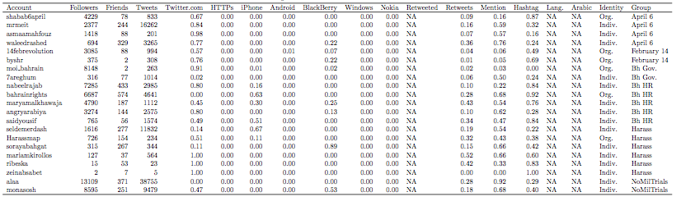

Social Network Analysis

Social network analysis facilitates investigation at multiple levels. For example, say one wants to study how social media affects activists’ ability to organize protests. Even using Twitter as a data source, a non-network study may look at what each activist has tweeted; when during the day those tweets occur; if they occur in reaction to events, are contemporaneous with them, or presage future ones; or what language activists use. While these are important and interesting behaviors, they do not provide as rich an understanding of the phenomenon in question as network analysis can. By reconceiving the individual as someone enmeshed in a series of relations with many others and measuring how those interactions unfold, network analysis permits the researcher to observe both individual-level behavior and community effects.

To continue the example, a network analysis can reveal that what may matter is not just who says what but to whom something is said, with whom those individuals talk, et cetera, and the extent to which these connection between people overlap. An activist, Activist A, who tweets frequently could initially appear to be influential, but if that person’s network connections are all connected to each other but no one else, then the activist may actually have less influence than was initially expected. On the other hand, there may exist an activist, Activist B, who connects disparate clusters of individuals and so permits information to flow between these groups of people; this activist, even if he or she tweets rarely, may have more of an impact than the first one.

To fully conceptualize actors’ social setting requires one final, broader level of analysis. Such analysis looks at each individual in the social network to reveal heterogeneous patterns of associations (communities) as well as network level statistics. Continuing the example, Activist B appears very influential because that person bridges different communities of individuals. But if those communities are themselves isolated from the larger social network—if they are activists talking with other activists but “normal” individuals are not part of their network - then those communities may have little impact on others. Or if all the individuals in a study form communities which themselves are not connected to other communities, it would not be surprising when behaviors in those communities (exercising, voting, protesting, etcetera) do not spread to other groups. In other words, to more completely understand how activists and activism work, one needs to incorporate, as much as possible, the wider social context in which that work occurs.

Networks can be directed or undirected. In an undirected network, a relationship a connection represents has to be symmetric. In a directed network, a relationship can be symmetric but does not have to be. Facebook is an undirected network because two individuals have to agree to become friends for a connection to exist between them; every connection is always symmetric because each friend can see the other’s activity. Twitter is a directed network. One user can follow another user without the latter following the former; this is why accounts for Justin Bieber or Barack Obama have millions of followers but themselves follow few accounts. In Twitter parlance, Justin Bieber has millions of followers but is only friends with whomever he also follows back.

Network statistics thus allow the researcher to measure events at three levels: the individual (micro), individual in community (meso), and system (macro). Statistics computable on a network parallel these three levels. The microlevel measures are those one usually thinks of when thinking of what to measure. They are attributes of the individuals themselves, such as age, sex, country of residence, language, income, education level, so on and so forth. They are variables that are not dependent on the network for their values.

The microlevel measures allow one to partition a network to isolate alike individuals; isolation is useful for examining how subsets of individuals differ from the larger network, which is particularly useful when those individuals are not in the same community. Microlevel measures, in conjunction with system ones, also reveal the degree of homophily within a community.

At the meso level, measures on an individual start to become determined by the individuals with whom that person is connected. The two main measures here are out-degree and in-degree. The former is the number of individuals to whom an individual is connected. The latter is the number of individuals connected to the individual.

While these measures are often called centrality measures, they fail to take into account the importance of the people to whom each individual is connected. For example, an activist who is followed by 100 people who themselves are not followed by many people will probably have less influence than one who is followed by the same number of people who are themselves followed by a large number of people. Extensions of the meso-level measures that take into account characteristics of an individual’s connections therefore provide more accurate measures of influence. It is these centrality measures that provide the best approximation of influence in a network.

At the macro level, one can start to detect communities. While the specific definition of a community varies from algorithm to algorithm, the general idea is that a community is a collection of individuals more connected to each other than would be expected by chance. If a network exhibits little separation, it could contain only one community; a network where individuals exist in isolation from each other will have as many communities as it does members.

Unfortunately, the size of Twitter and restrictions the company imposes on data collection limit our ability to measure influence using more than number of friends and followers: we cannot measure centrality directly or detect communities in a meaningful way. Specifically, Twitter limits how often a user can request data (usually 15 times per 15 minutes) and how much data is returned per request. Twitter also provides only the 3,200 most recent tweets per account, which limits how far back in time a researcher can see for popular accounts. These limits make it difficult to fully reconstruct a social network or obtain historical tweets.

To partially reconstruct our users’ social network, we construct two networks and limit the extent to which we crawl those networks. For the follower network, we only look out to one degree, i.e. we do not download the followers’ followers since doing so would take too long. For the friend network, we download the friends and the friends of friends. There are almost 19 million second-degree friends, but eliminating duplicates reduces that number to 9,000,000. It took almost 10 days to download just the lists of these friends of friends and another 5 days to download profile information for each of the second-degree friends. We stopped at the second-degree because of time constraints. With these two networks, we can then reconstruct the reciprocal network out to one degree. This sampling strategy is called breadth-first search (BFS).

Because one cannot calculate communities from one-degree network data, we create a rough definition of community to allow us to visualize the activists’ networks. We assert that two individuals belong to the same community if they use the same language (their Twitter profile language setting) and follow the same activists. This reduces our millions of individuals to 200-600 communities, depending on the time period. It also allows us to quickly visualize the social network and its change over time. Grouping by language also provides insight into the international appeal of the seed users, as there are many communities whose language is not English or Arabic (the two primary languages of the seed users).

Content Analysis

While network position is important, it is impossible to have influence on Twitter if one does not tweet. To understand how activists use Twitter, we therefore perform two kinds of content analysis. First, we read each tweet for the hashtags it uses. Authors of tweets use hashtags to associate, and engage, with larger conversations on Twitter (A. Bruns & Burgess, 2011). Second, we use a supervised learning approach to create a topic model. This model allows us to understand meaning that are not easily encapsulated in a text, for example whether a tweet supports protestors, is against them, helps them coordinate upcoming events, etcetera.

Using Hashtags

We first read each tweet for the hashtag(s) it contains. Because tweets are restricted to 140 characters, it is difficult to convey subtlety or express multiple thoughts. Their meaning is therefore highly correlated to the hashtag(s) used, so reading the hashtag(s) provides much of the meaning of the tweet itself.

This is especially true for the least frequently used hashtags; saying a hashtag is frequently (not frequently) used is almost identical to saying the tweet to which it is attached is oriented towards a large (small) topic. Often-used hashtags, such as #egypt or #feb14, could be aimed at spreading information on upcoming protests, discussing the state’s response to these events, voicing disagreement with protestors, or any of a number of other topics broadly related to the protests. On the other hand, less used hashtags, such as #postegyptianrevolutionsocialtrends or #freeamr, may be about very specific events or topics. For example, #postegyptianrevolutionsocialtrends, a hashtag exclusive to the Anti-Sexual Harassment movement, is used to talk about changes in gender norms and political participation; #freeamr, from the No Military Trials movement, references a specific individual but has subsequently been used to draw attention to other individuals Egypt has arrested. Though these topics have some resonance outside of the social movement groups in which they originate, they are used much less in the general population. If they are about very specific topics, there are fewer people affected by what the hashtag references, and there should therefore be fewer uses of it amongst non-actors.

Reading hashtags also provides access to broader sets of meaning than the supervised topic model approach described below. With supervised approaches, one has to know the possible meanings of tweets before the tweets are coded as being about a topic. The results are therefore restricted to the knowledge brought to the project, and this knowledge will be constrained by how much one has read the tweets being coded. But the point of automated coding is to not read every tweet, so trying to find tweets with rare meanings using supervised approaches will be very inefficient or fail.

On the other hand, reading hashtags is easy and unconstrained: the same lines of code will extract however many hashtags are in any tweets, and one can then analyze all the hashtags extracted. The researcher is not restricted to searching for specific hashtags, so content will make itself clear that the researcher was not expecting ahead of time. Analyzing the extracted hashtags is how we find the hashtags that are common within a movement but uncommon outside of it and common within the movement and outside of it.

Finally, reading each tweet and extracting its hashtags requires much less computation than reading each tweet and assigning it a topic, for three reasons. First, all hashtags can be extracted with one read of the tweet. Assigning a tweet to a topic requires as many reads as there are topics: the statistical models determine whether the tweet belongs to X or not X, not whether it belongs to X, Y, or Z. If one has 10 possible topics, each tweet therefore needs to be read 10 times. Second, creating topic models requires the tweets to be cleaned (detailed below), an extra step of processing not needed when selecting hashtags. Third, the statistical model to infer meaning is much more complicated for topic models than for hashtags. For topic models, even the simplest algorithms use the entire tweet to infer meaning; more complicated algorithms assume structure in the data that require calculation for each tweet. With hashtag analysis, however, the assumption is that the presence of the hashtag(s) is presence of meaning, that is that there is a perfect correlation between the use of a hashtag and the intent of that tweet.

Topic Models

The problem with relying on hashtags is that the researcher has to surmise meaning from the tag, and the tag can be attached to texts with wide ranging meaning. To more precisely measure meaning, one has to create a topic model. A topic model is a statistical algorithm that determines how features of a document—words, sets of words, syntax, et cetera—correspond to the topic of the document.

There are two approaches to creating a topic model: unsupervised and supervised. In the unsupervised approach, one takes a collection of documents, tells the computer to how many categories the documents belong, and the computer sorts the documents into those categories depending on a loss-minimization criterion. The number of categories is arbitrary, and the researcher has to test different numbers to find which appears to best divide the documents into natural categories. The researcher then has to interpret the sorting of the documents to understand what real-world topic the groupings represent.

The second approach is supervised. In this approach, a subset of the documents, the training set, is known to belong to a category or categories in which the researcher is interested. The categories are usually known because humans have read and coded each document. The computer creates a model that relates the features of the documents to each category. This model is then applied to the rest of the documents, those not included in the training set. For each document, the model guesses to which category it is most likely to belong. For more detail on both approaches, see Grimmer & Stewart 2013.

We have used a supervised learning model for this project. We chose this model for three reasons. First, the level of interpretation required of unsupervised approaches leaves results of those models much more suspicious. Papers with those approaches often get lost in interpreting exactly what the categories represent, not what those categories and their change mean for the research question. Second, even if the interpretation of each category is not contentious, the number of categories is. There is no clear rule to distinguish between choosing 5, 10, or 100 categories. While the supervised approach also relies on choosing a number of categories, that decision is driven by theory, the researcher’s contextual knowledge, and an iterative reading of the documents. Third, supervised learning allows the researcher to define the categories in which one is interested. Unsupervised approaches require the researcher to fit a collection of documents to a category, whereas the supervised approach fits categories to a document. The latter is therefore best when one knows for what one is looking, such as tweets coordinating protest, talking about state’s actions, or other protest topics. Because we knew the document categories in which we were interested, we chose a supervised learning approach.

Upon choosing a supervised approach, one then chooses the type of model. The model is the algebraic representation of the relationship between the document features and the category of the document. Some of the common models include Naïve Bayes, logistic, artificial neural networks, and support vector machines. We tested Naïve Bayes (NB) and support vector machines (SVM), ultimately choosing SVMs for their robust performance and ability to efficiently work with high dimensional data.

We trained two models, one for Egypt and another for Bahrain. Though each country speaks Arabic, the dialects and vocabulary used during the protests differ. While we could have fit one model to encompass both countries, such a model would be less precise than creating one per country. For each model, we randomly selected 3,000 tweets to hand code for the training set. In Egypt, these 3,000 come from the 3.7 million tweets from Alessandro. In Bahrain, 1,500 come from the Sifter data, 1,500 from the 1 million Alesssandro tweets. We did not use training tweets from the Egyptian Sifter data because we had not purchased the data before coding started; we still found enough tweets in our coded categories to convince us the sampling strategy is valid. Each country’s 3,000 are split evenly between Arabic and English tweets.

We had the coders identify if a tweet belongs to any of the following categories:
- Protest coordination
- Protest information
- Anti-protest
- State response
- Pro-regime
- Anti-regime
- Corruption
- Democracy
- Economic security
- Political but not about protests
- About Morocco
- About Algeria
- About Tunisia
- About Libya
- About Egypt
- About Jordan
- About Saudi Arabia
- About Yemen
- About Oman
- About Bahrain
- About Qatar
- About the United Arab Emirates
- About Iraq
- About Syria
- About Kuwait
- About Lebanon
- Agreement with foreign policy
- Disagreement with foreign policy
- Seeking foreign support
- Directed at a foreign audience
- About non-Arab Spring foreign events
- About an event tomorrow
- About an event in a week
- About an event in a month
- Religion
- Sports
- Pop culture
- Coordination not about protest
- Anything else.

A tweet can belong to as many of these categories as fit; in practice, about 75% fit in the “anything else” category.

We then used Python’s Natural Language Toolkit (NLTK) to prepare the 6,000 tweets for analysis. For text analysis, it is important to normalize each document, which means performing certain operations on each word to remove idiosyncrasies across documents. Normalization includes removing stopwords (common words such as “and”, “the”, “is”, &c that are so common they do not distinguish documents), lemmanizing words (converting related words to their common stem, e.g. “stopped”, “stopping”, and “stoppage” all become “stop”), converting all words to lowercase, and removing punctuation and symbols. NLTK provides stopwords for English; for Arabic, we borrowed a custom stopword dictionary of 275 words used to code Facebook posts of the April 6 movement (Hanna, 2013). Once we normalized each training set, we could be confident that the content of each tweet is removed of enough idiosyncrasies so as to provide enough information to the support vector machine to allow it to make predictions.

We then performed the same steps on the full Bahrain and Egypt data, saving these cleaned datasets for use after creating the models.

After cleaning the tweets, we then use Python’s scikit-learn library to build the support vector machine. In text classification, the variables are words, and the number of variables is equal to the number of unique words found across all documents (tweets). Two problems arise: common words will be overrepresented, and there will be thousands of variables, increasing computation time and the possibility of overfitting. To counteract these, we build a Term Frequency – Inverse Document Frequency matrix, which creates weights for each word based on how often it appears and in how many documents; low weights are given to frequent words in many documents, high weights to frequent words in few documents.

We then created 30 support vector machines for each country’s training data. Each SVM uses 95% of the 3,000 tweets to build a model and tests the accuracy of the model on the remaining 5%; this process is repeated 30 times, each time on a random 95%, and the results are averaged to create a final model for each country. We run multiple models on random samples of the data because tweets belonging to our specific categories are rare, so running one model risks missing these tweets and creating a poorly fit model. We specifically chose 30 through trial and error, as fewer models are still imprecise but more start to require too much computation time. The resulting model is called an ensemble model because it is assembled from multiple other ones.

This ensemble model was created for 13 categories. Of the original categories, we create a model for protest coordination, protest information, the state’s response, religious tweets, sports tweets, tweets about pop culture, and tweets about events happening the next day. We also created a category called “Protest Support” for any tweet that is about protest coordination, protest information, corruption, democracy, events happening tomorrow, or contains anti-regime sentiment. Another category is “Protest Against” for a tweet that is anti-protest or pro-regime. Every tweet that is about Arab Spring events is grouped into a category called “Foreign Arab Spring”. A category called “Political Not Arab Spring” is for political tweets not about the Arab Spring and tweets about foreign countries not about the Arab Spring. We then group pop culture and sports tweets into the “Leisure 1” category; we add religious tweets to create the “Leisure 2” category.

Having an ensemble model for each category, we load the entire cleaned dataset created earlier. We then use each ensemble model on each tweet to predict if the tweet belongs to one of the 13 categories. In other words, each tweet is analyzed 13 times and can belong to up to 13 categories. The dataset with each predicted category is our final dataset that we use for later analysis. Sample tweets for each category are shown in Table 4.

Table 4: Sample Tweets Based on Content Model
Category | Description | Example
Protest coordination | A tweet about where or when a protest is happening or who is attending the protest | “March start @ 3PM to roundabout” - @byshr, 02.25.2011  “@Marrvie at Al Tahrir square #Jan25 http://twitpic.com/3tbyfm” - Egypt, 01.25.2011
Protest information | A tweet about ongoing protest events, such as where people are marching | “Police Checkpoint at Pearl roundabout #feb14 #Bahrain http://yfrog.com/h4064nj” - Bahrain, 02.14.2011  “PUBLISH THE VIDEO PLEASE: Lulu Roundabout protest in Bahrain - The End Part III http://www.youtube.com/watch?v=ULTzx7HiYI0 #bahrain #feb14” – Bahrain, 02.18.2011
State response | A tweet about how the state is responding, such as making arrests or cutting the Internet | “Saloum city people are being shot at by police and its getting pretty violent #jan25” – Egypt, 01.27.2011  “Over 20 police jeeps heading towards #bfh” – Bahrain. 02.14.2011
Religious | A tweet about religion or containing a religious phrase | “There is no power but from God to the concerned people that live in the Arabic countries and may the Lord have mercy on us.” – Egypt, 01.24.2011  “Group…Wednesday night prayer beseeching God bless your parents…” - @14febrevolution, 03.22.2011
Sports | A tweet about sports, such as a soccer game | “4 hours of top english football #nowplaying” – Egypt, 09.18.2011
Pop Culture | A tweet about music, television, books, or movies | “Ron Weasley is trending! I love Harry Potter stuff being TTs :)” – Bahrain, 02.13.2011
Next day | A tweet that mentions any event happening tomorrow, protest related or not | “@arabist: new tunisia govt tomorrow (i hear min finance interior gone) rt @arouabensalah: #ttn l'annonce du nouveau gouvernement demain” - @alaa, 01.25.2011  “I don`t know . . .But I am having a very positive energy to fight tomorrow with my boss!” – Egypt, 02.05.2011
Protest Support | A tweet that coordinates or supports protest or is against the state | “We are more powerful than the dictator. "The ruler can only rule with the consent and cooperation of the ppl" Robert Helvey” - @angrayarabiya, 02.13.2011  “Excited about tomorrow, wouldn't be able to join #25Jan, but if anything it will definitely shake the system a tiny bit. Much needed.” – Egypt, 01.24.2011
Protest Against | A tweet that supports the state or is against protests | “It is not good without your protection of your land, and their protection! All of them. [heart emooji] Kingdom and the King “ – Bahrain, 02.17.2011  “Oh merciful god that Bahrain and its Sunni people love, oh god, if this was a test of understanding, we will persevere” – @7areghum, 03.03.2011
Foreign Arab Spring | A tweet that discusses protests in a different country | “@anwarshaikh46 this is not egypt, but a dictator is a dictator. Egypt is not Tunisia either, but being inspired by them they had a victory” - @angryarabiya, 02.22.2011  “RT @Lady_Gabina: Gaddafi is caught between a Tunisian rock and and Egyptian hard place #Libya #Feb17” - @alaa, 02.16.2011
Political Not Arab Spring | A tweet that is about local political events such as the economy or domestic security | “EGYPT: Feared ex-minister denies corruption charges http://dlvr.it/JM2z7 #AFP” - Egypt, 03.05.2011
Leisure 1 | A tweet about sports, pop culture, daily life | “@forsoothsayer so u too can multitask? we must be a rare breed judging by how ppl worry football will delay revolution “ - @alaa, 01.23.2011  “Money is of no value; it cannot spend itself. All depends on the skill of the spender.” – Bahrain, 03.14.2011
Leisure 2 | A tweet about sports, pop culture, daily life, or religion | “rt @avinunu: direct negotiation way reach solution match utterly condemn resort football” – @alaa 01.21.2011  “Just finished watching the movie. Ahh. #ilove” – Bahrain, 02.13.2011

For Bahrain, we obtain very high precision for protest coordination and protest support tweets. Our precision for Bahraini protest coordination tweets is 100%, which means that all of our test set tweets that our model thought were protest coordination were actually protest coordination. For pro-protest, the precision drops to 62.5%. Our model performs less well on recall (the percent of tweets about a topic that we correctly identify as being about the topic). Our model only catches 4.5% of all Bahraini protest coordination tweets and 16% of the pro-protest ones. The large difference between precision and recall is a standard trade-off: by being very accurate (conservative) with our model, we are often too conservative and miss many tweets that should be labeled protest coordination or pro-protests.

Our model for Egypt is follows the same trade-off. Of the protest coordination tweets the model thinks are about protest coordination, 57% are (the precision measure); the precision is perfect for pro-protest tweets. The trade-off arises again: we recall 15% of the protest coordination tweets but only 2% of the pro-protest ones.

Ethnographic Analysis

The goal of ethnographic fieldwork is to map the “terrain of struggle” and to re-contextualize social media within the exigencies of a particular political, social, and economic environment. Ethnographic perspectives “from below” help to parse the complex relationship between individual agency and technological mediation. Specifically, ethnographic methods mitigate against the limitations of techno-centrism by:

- not privileging digital content over the lived, everyday experiences of people;
- contextualizing digital content within particular spaces and times;
- moving away from a fixation on political agendas and outcomes to the exclusion of other motivations, practices, and repertoires;
- interrogating the ordinariness of media usage in everyday life.

For these reasons, interview data can be essential to understanding media use and particularly how those uses become revolutionary.

The qualitative fieldwork component is intended as a method for better understanding the offline political context and how actors perceive their relationship with their online networks. The online and the offline are overlapping and intersecting zones, but they are not necessarily coterminous. Examining the relationship between these zones and the blurred boundaries between them should be the goal of any study on digital activism. In many ways, the Arab Spring highlights the necessity of this dialectical approach and demands a more critical reflection on these complex online-offline networks.

Qualitative research methods contribute new insights to research into ICTs by investigating users’ motivations, behaviors, feelings, environmental influences, and perceptions (Sade-Beck, 2004). The technologies of everyday life, from mobile phones to the Internet, are embedded in specific contexts and material conditions that influence both users and the technologies themselves (Sassen, 2002, 266-68; Tawil-Souri, 2012, 91-92). Although exploring the diverse products of technologically mediated communication can reveal highly useful information about how ICTs are used, it can tell only part of the story. Many studies of technologically mediated behavior incorporate mixed-method approaches in order to move away from techno-centric perspectives by situating technology use within social, political, and economic contexts (see, for example: Aouragh & Alexander, 2011; Aouragh, 2011a; El-Ghobashy, 2011). Particularly in cases of political events, such as the Arab Spring, fieldwork and qualitative interviews can help to contextualize ICT usage within specific communities, spaces, and times.

Semi-Structured Interviews and Fieldwork

The qualitative research for this study was conducted in Egypt (3 weeks in November 2014) and Bahrain (3 weeks in September and October 2014) and consisted primarily of in-depth semi-structured interviews and participant observation.

Semi-structured interviewing involves creating a battery of open-ended questions to be answered by the interviewee. Some of these questions will be interviewee-specific and others will be more general (such as: “When did you get involved in protests on the street in 2011?”). The open-ended nature of these questions allows the interviewee to be an active participant in shaping the interview, and interviews are often quite conversational. Semi-structured interviews often allow for unexpected revelations, new information, and deep personal accounts that are richer than what might be attained by asking a proscribed set of fixed questions (Dicicco-Bloom & Crabtree, 2006).

Interviewees were selected using snowball sampling, whereby one contact or interviewee would recommend other friends and colleagues for interviews. This type of sampling by personal referral is common in research that aims to reach “marginalized” or “hidden” populations (Cohen & Arieli, 2011), which can include political activists and protesters who face legal and physical repercussions under authoritarian regimes. Snowball sampling is also useful for establishing trust is important to conducting interviews and further research (Atkinson & Flint, 2001). In the context of Egypt and Bahrain, mutual trust between interviewer and interviewee is particularly important, given the high stakes of political activism between 2011 and today.

Participant observation offers an opportunity to gain even greater familiarity with the field site and interviewees’ experiences. Participant observation occurs when a “researcher spends considerable time observing and interacting with a social group” to “unearth what the group takes for granted, and thereby reveal the knowledge and meaning structures that provide a blueprint for social action” (Herbert, 2000, 551). In this case, Kira spent 6 weeks, 3 weeks per country, among actors and participants in the social movements discussed in this study. For many digital actors, their online activity is very much a part of their offline lives: unearthing the “everydayness” of social media use in times of revolution and the “revolutionary” elements of social media use in the everyday is one of the distinct challenges of online/offline qualitative research.

Snowball sampling in conjunction with semi-structured interviews and participant observation provide both the means of reaching an interconnected network of activists and the flexibility to apply insights gained throughout the fieldwork and interviewing processes to later experiences and interviews. Indeed, qualitative research invariably requires researchers to “use what they learn from day to day to guide their subsequent decisions about what to observe, who to interview, what to look for, and what to ask about” (Becker, 2009, 547). In this way, the semi-structured interviews can evolve over the course of the fieldwork. Table 5 and Table 6 provides more detail on the interviews.

Table 5: Interview Procedure
Semi-structured interviews are designed to provide both researcher and interviewee a great deal of flexibility in discussing topics as they arise in conversation.

Structure
- The structure comes from a list of topics or questions that the researcher outlines in preparation for the interview, but the interview is intended to be conversational.

Questions and Themes
- Sample questions might include:
- Tell me about your involvement in political activism; how did you get started?
- How did your political engagement change before and after 2011?
- Tell me about your personal use of social media? Cell phone?
- In what ways do you coordinate with other activists on the ground and online?
- Questions vary interviewee to interviewee and exist to guide, but not limit, the conversation.

Dealing with Deviations and Distractions
- Deviations and tangents are welcome, as they often lead to insights about the way the interviewee thinks about their daily life and the issues of interest to the researcher.

Following up
- The interview is often not an isolated encounter. Interviews are often iterative and longitudinal, and the researcher maintains a relationship with interviewees.
- The researcher-interviewee relationship often leads to opportunities for participant observation.

Table 6: Sample Interview Questions
Question | Purpose
In your own words, tell me about your work and your involvement in political activism. | Although Kira often has some familiarity with an informant, from background research or earlier conversations, it is crucial to have him/her explain how they see their role in relation to their political activity.
Before February of 2011, what kinds of political activities were you engaged in? Did you know about the large protests that were about to take place? | These are big questions that open the door to more specific ones, based on the interviewee’s response. If an informant “knew” or had a sense about the upcoming events, this opens up questions about how they knew, what they did when they first heard about the protests, were they instrumental in organizing any activities themselves, etc.
Tell me about your relationship with the February 14th Coalition. Who were they, and did you know anyone involved? | The February 14th Coalition is an umbrella term that covers multiple groups involved in the ongoing revolution. It is loosely or hardly organized, so this question is intended toward both understanding how to make sense of the “coalition” and also how this very online collective is truly understood/known/recognized in the offline.
How did you and other activists/journalists/protesters coordinate during the 2011 events? And now? | This question helps to open up a conversation about mass mobilization, which might mean online or offline, or both. It is open-ended so as not to guide the response. It also takes a comparative perspective, inviting reflections on what has changed. This historical comparison can help an interviewee to focus on and more clearly distinguish between then and now. Also, since the 2011 events are in the past, many people are eager to talk about the now, and spending too much time in the interview emphasizing 2011 can be frustrating (or even insulting) to an informant.
How important was social media to what happened in 2011? | This question is another broad prompt, aimed at gleaning reflections and perceptions about social media. Often, it serves as a good segue to the following question.
Tell me about your personal use of social media. Are you on Facebook, Twitter? How have you used it, and has your usage changed over time? | The individual user’s perspective is crucial to understanding how and why certain platforms or digital strategies are used. When multiple informants have similar stories, it starts to weave a narrative about how digital communications are significant in this particular context. Again, using the “then and now” framework helps the informant to tell a clearer story about their digital practices in 2011 compared to now.

The qualitative analysis in this study comes from six weeks of participant observation and fieldwork and 30 interviews conducted with actors and participants in Egypt and Bahrain.

Interviews
 | BAHRAIN | EGYPT
Female | 9 | 8
Male | 8 | 5
Total | 17 | 13

In Bahrain, interviewees were actors from a number of organizations represented in the report’s Twitter sample, including: Bahrain Center for Human Rights, Bahrain Youth Society for Human Rights, Al-Wefaq, and Waad. In Egypt, interviewees had been actors in each of the 3 movements identified for the country.

One goal in conducting interviews was to find overlap with the identified nodes in the Twitter analysis. We did speak to specific actors present in our Twitter sample; however, given the sensitive nature of the in-depth interviews, participants will be made anonymous, and responses will not be linked to their real names. Although the real Twitter identities of the actors in our sample are included in this report, as this information is publicly available, interviewees will be referred to by pseudonyms, as coupling recent interview data with past Twitter activity may put activists at risk.

Challenges and Limitations in the Field

Mounting political repression has forced many activists into hiding, sent many others to prison, forced a number to leave the country entirely, and left others with a degree of apprehension and suspicion. As a result, many of the social movements discussed in this report do not really exist (organizationally, spatially, ideologically, or otherwise) in the way that they did in 2011 and 2012. This challenge makes actors an even harder-to-reach population as time progresses.

Surveillance and security are a concern, not only for the activists and interviewees themselves but for researchers as well. Intervening years and political developments have made the Arab Spring a deeply contentious topic, whose historicization is much debated. As such, research into Arab Spring events is highly politicized, creating a tense environment for academic enquiry into the unfolding political situation.

The passage of time also poses certain challenges in interviewing as well. Interviewees have a harder time recalling past events, particularly given the sheer number of political changes that have taken place since 2011. Recounting past activities and events is always challenging, and it is a difficulty that confronts any recording of oral history. In this case, the recent history of the Arab Spring is complicated by the preoccupation of many revolutionary participants with the ensuing aftermath—arrests, detentions, raids, and even deaths of colleague and friends, among other disruptive personal and political events.

Case Study: Egypt

Calls for protests to occur on January 25th began on Facebook and Twitter and coincided with National Police Day. Demonstrations swelled enormously after Friday prayers on January 28th, following a government shutdown of Internet and many telephone services that morning. Despite police crackdowns on the growing protests, thousands of people occupied Cairo’s Tahrir Square, peaking at an estimated 200,000 people (Schachtman, 2011). The first phase of Egypt’s revolution culminated on February 11th, with the resignation of President Hosni Mubarak, who ruled Egypt for over 30 years. Following Mubarak’s removal from power, the Supreme Council of the Armed Forces, under the leadership of Field Marshal Mohamed Hussein Tantawi, took control of Egypt’s government.

Since January 25th, 2011, Egypt has transitioned through five governing regimes, and protests and demonstrations have continued throughout. The political, social, and economic changes that have taken place over the past four years are significant. Although we focus on events in 2011 in this report, history has pressed on in what many people consider Egypt’s ongoing revolutionary struggle. It is crucial to understand the “revolution” as an historical moment, borne out of a long trajectory of political, economic and social developments and exerting powerful forces on an unwinding and uncertain future.

Many accounts and timelines of the Egyptian revolution have been published, but we introduce a brief timeline of key revolutionary events in Figure 2. It is representative but certainly not comprehensive.

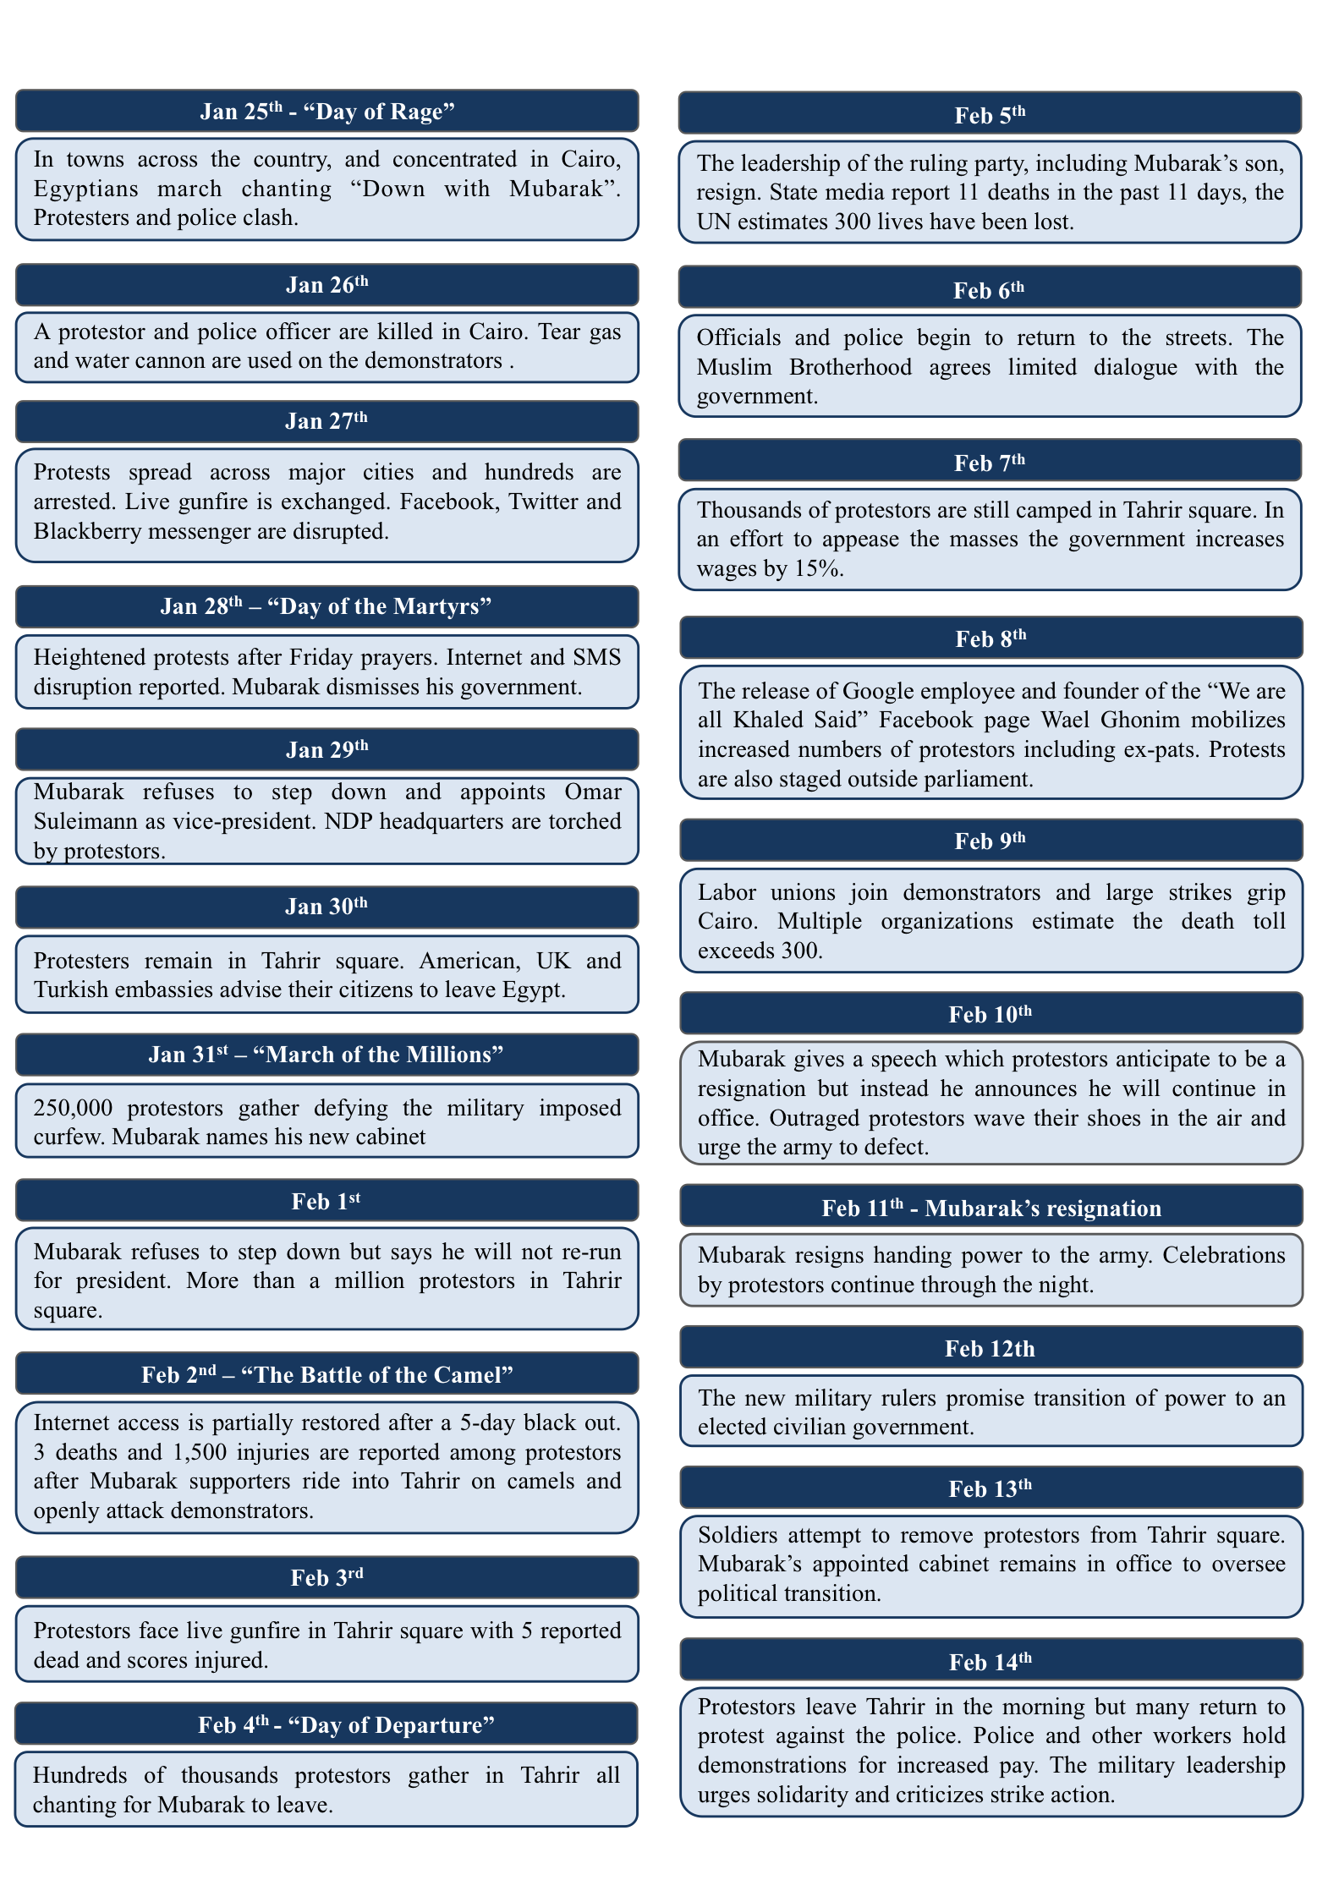
Figure 2: Timeline of the 2011 Egyptian Revolution (18 Days) [Figure reproduced with permission from author.]

Movements

The 2011 mass mobilization did not occur in a vacuum. Many of the key political issues at stake and the tools and strategies employed by actors had become part of contentious political life in Egypt decades earlier. Here, we briefly trace the origins of the social movements we examine in an effort to provide contextual and historical references.

Movements were chosen on two criteria. First, we wanted to select movements that had traditionally been marginalized in their societies prior to 2011. For example, in Egypt, April 6th is primarily composed of youth, and Anti-Sexual Harassment is organized predominantly by and on behalf of women. Second, we wanted to select movements that coalesced at different times. As we explain below, April 6th existed since 2008, No Military Trials tackled a longstanding issue but came into existence with this name after Hosni Mubarak stepped down on February 11th, 2011, and the Anti-Sexual Harassment groups became active even later as a result of increasing public awareness of sexual assault at protests. Importantly, from a methodological perspective, each movement involves individuals who were on Twitter before the protests started, allowing us to see when individuals transition from tweeting as individuals to tweeting as parts of a social movement.

April 6th Youth

The April 6th Youth group began in 2008 as an expression of solidarity with workers at the Misr Spinning and Weaving Company in Mahalla al-Kubra who had called a strike action for April 6th of that year. The widespread protests that took place that day were the product of both long simmering economic grievances and the new communications channels available to articulate them. The Mahalla workers had staged several strikes in the early 2000s, but in 2007, “strike leaders explicitly framed their struggle as a political contest with national implications” (Beinin, 2009, 84). Digital communications technologies, such the Egyworkers blog and Facebook pages, played an important role in mobilizing people around the strike (Faris, 2010). Supporters called for a “Day of Anger” when they organized solidarity protests, language that would be applied to calls for mass mobilization in January 2011.

April 6th and workers’ movements more broadly also drew from the legacy of recent democracy movements and a culture of street protest that had been revitalized with movements in support of the Second Palestinian Intifada in 2000 and in opposition to the Iraq War in 2003 (El-Mahdi, 2009). Many early members of April 6th came from the now fragmented Kefaya (“Enough!”) movement, which peaked in 2004 and 2005. In fact, Mohammed Adel, a key founder of April 6th along with Ahmed Maher, had been active in and gained organizational experience from Kefaya.

The government response to April 6th protests before 2011 was always severe. Actors were arrested and protesters beaten, tear-gassed and shot (Human Rights Watch, 2008). The intersecting experiences of coordination online, mass mobilization in the streets, and confrontation with security forces were formative.

For the Twitter analysis, we isolated several individual accounts associated with activism in the April 6th movement, based on a combination of news reports, personal accounts, and interviews conducted in the field.

April 6th Movement Twitter Accounts
waleedrashed | This is account for Waleed Rashed, one of the founders of the April 6th movement. At one point, he was a banker, and he is currently a graduate student. His account is primarily in Arabic, and he joined on September 1st, 2008.
AsmaaMahfouz | Asmaa Mahfouz is one of the founders of the April 6th movement. She gained widespread notice for a video she posted on YouTube a week before January 25th, 2011 exhorting individuals, especially men, to protest on January 25th. She tweets in Arabic, and she joined Twitter on December 1st, 2008.
GhostyMaher | This is the account of Ahmed Maher, a founder of the April 6th movement. His tweets are in Arabic, and he joined Twitter on May 1st, 2008.
aleprily | This is the personal account of Amr Ali, a leader of the April 6th movement. He was the group’s public works and community operations director for most of 2011, and he has a career as an accountant. He joined Twitter on June 1st, 2009.
shabab6april | This is the official Twitter account for the April 6th movement. Its tweets are primarily in Arabic, and the account was created on June 24th, 2009.
mrmeit | This is the account of Mohammed Adel, a co-founder of the April 6th movement. He joined Twitter on July 1st, 2009 and tweets in Arabic.

No Military Trials

The #NoMilTrials campaign began in 2011 as a contemporary, media-savvy incarnation of a longstanding political cause. In the days after the Egyptian revolution, the campaign’s slogans (“no military trials” and “ban military trials”) were popularized as social media hashtags (#NoMilTrials and #BanMilTrials). The hashtags and the recognizable #NoMilTrials logo (the Arabic word, “no”) proliferated both online and offline, as stickers, banners, t-shirts, and signs appeared at street protests.

The campaign had its roots in an historical movement against military trials for civilians. In response to changing political conditions, it would materialize in force and subside at intervals. Military trials for civilians have existed and been used since the beginning of the Egyptian republic (and indeed, have their roots in colonial judicial practices), but the legal status of the military court system has varied somewhat over time (Reza, 2007, 504). The controversy around this issue stems from the fact that civilians referred to the military court system are not entitled to due process of law and can be detained indefinitely and without charge as well as subjected to extrajudicial interrogation and torture (Farhang, 1994). The referral of civilians to military courts or tribunals evolved historically as part of the legal framework governing states of emergency (Albrecht, 2005), and at the time of the 2011 revolution, Egypt had been in a continuous declared state of emergency since 1981. During times of emergency, the state can suspend certain civilian rights as necessary in the interest of combating terrorism.

During the later part of President Mubarak’s rule, the referral of civilians to military courts was, in part, a regime response to the increasing independence and activism of the judiciary (Moustafa, 2003). In the 20 years prior to the revolution, the Egyptian judicial system provided opposition causes the most opportunity for success, so challenges to the regime increasingly took the form of lawsuits (Albrecht, 2012; Moustafa, 2003). The Muslim Brotherhood was the most common target of the military justice system, and Muslim Brotherhood members regularly faced military trials under the auspices of fighting terrorism. In the 1990s, the Mubarak regime launched a crackdown on Muslim Brotherhood members, who were referred in large numbers to military tribunals, along with journalists and other political activists (Brownlee, 2002; Mahmoud, 2011; Reza, 2007, 546).

The global war on terror in the early 2000s further legitimized these practices by providing justification for extrajudicial methods for dealing with the threat of terrorism (Brownlee, 2002), and when the Muslim Brotherhood won a substantial number of seats in parliament in 2005, they made ending the emergency law a top priority (Meital, 2013). Many disparate activist factions united around this cause, and there were protests and sit-ins throughout 2005 demanding an end to the emergency law (Abdelrahman, 2014, 37; Whittaker, 2005). The emergency law was ultimately renewed, but the debate around the issue prompted Mubarak to promise constitutional amendments addressing it. In 2007, the Egyptian constitution was amended to include (among many other new articles) Article 179, allowing crimes of terrorism to referred to any court at the discretion of the regime (Brown, Dunne, & Hamzawy, 2007; Reza, 2007, 541). This was a significant blow to the campaign against the emergency law and military trials for civilians, making permanent the “emergency” that had justified this shadow judicial system.

When the 2011 events took place, the battle against military trials for civilians had thus been raging in the background for decades. Events following Mubarak’s ouster would reignite popular dissent on this issue and provide the impetus for the 2011 movement against military trials. The moment was right for #NoMilTrials to become a central revolutionary demand; the application of military justice for civilians and military-inflicted violence against civilians in the immediate aftermath of the revolution shattered many people’s burgeoning hope for a new, democratic leadership in post-Mubarak Egypt.

On the Facebook page for #NoMilTrials, the group describes itself as “activists, lawyers, representatives of the legal community, and journalists, formed after the sit-in in Tahrir Square was forcibly dispersed on 9 March 2011” (NoMilTrials, 2011). That day, less than one month after Mubarak relinquished the presidency and under the interim leadership of SCAF, the military violently dispersed a sit-in in Tahrir Square, and protesters reported being beaten and tortured inside the Egyptian Museum, which is adjacent to Tahrir Square (Stack, 2011). Female protesters were subjected to widely criticized “virginity tests”(Freedom House, 2012; Rizzo, Price, & Meyer, 2012a). In February, many people greeted the army with enthusiasm, and chants of “the army and the people are one hand” rang through Tahrir Square. Within the first month of SCAF rule, belief and trust in the army were crumbling as abuses against protesters continued.

For the Twitter analysis, we isolated several individual accounts associated with activism in NoMilTrials, based on a combination of news reports, personal accounts, and interviews conducted in the field.

No Military Trials Twitter Accounts
alaa | This is the account of Alaa And El Fattah, an Egyptian activist and software development. His sister is Mono Seif, owner of the @Monasosh account. His tweets are a mixture of Arabic and English, and he joined on March 3rd, 2007.
Monasosh | This is the account of Mona Seif, an Egyptian activist who is one of the founders of the No Military Trials movement. Her account is a mixture of English and Arabic, and she joined Twitter on July 1st, 2007.
NoMilTrials | This is the Twitter account of the No Military Trials movement. Its tweets are in Arabic, and it joined Twitter on July 7th, 2011.

Anti-Sexual Harassment Campaign

The campaign to end sexual harassment in Egypt’s streets evolved directly out of the experience of (primarily) female protesters getting harassed and assaulted at demonstrations after the 2011 revolution. The widely publicized violent sexual assault on CBS correspondent Lara Logan on 11 February 2011 was only the beginning of many horrific accounts of sexual harassment and violence perpetrated against participants at protests for the next few years. But sexual harassment, like nearly all of the grievances that gained popular support in the aftermath of the 2011 revolution, had been an issue of concern for human rights and women’s rights groups for years. Campaigns combating sexual harassment surged in the early 2000s, as a result of high profile sexual harassment incidents (Rizzo, Price, & Meyer, 2012b).

Protests against the Mubarak regime following the 2005 parliamentary elections, including ones outside of the Journalists’ Syndicate, saw serious cases of sexual assault, linked to the rise of baltagiyya, or hired thugs, used by the Interior Ministry as an unofficial extension of the police state (Langohr, 2013). Incidents during celebrations for Eid al Fitr in 2006 and 2008 drew attention to sexual harassment in the streets (Rizzo et al., 2012a; Skalli, 2013), and in 2010, women’s groups advocated for a sexual harassment law that ultimately did not pass (Ebaid, 2013). Throughout this time, a number of organizations were working actively on the ground to address this issue, including Nazra for Feminist Studies, the Nadeem Center, the Egyptian Center for Women’s Rights, and others.

The Anti-Sexual Harassment campaign has made some limited political gains since 2011. In 2014, interim president Adly Mansour approved a new anti-sexual harassment law, after consulting over 20 organizations lobbying the government on the issue (Al Jazeera, 2014). And some prosecutions for sexual assault have taken place, with severe sentences (Wardany, 2014). However, sexual harassment continues to plague Egypt’s streets.

For the Twitter analysis, we isolated several individual accounts associated with activism in the Anti-Sexual Harassment campaign, based on a combination of news reports, personal accounts, and interviews conducted in the field.

Anti-Sexual Harassment
Seldemerdash | The Twitter account of Sara Eldemerdash, a Cairo based activist. She is a creator of the HarassMap organization, founded ma3looma.net, a website for youth sexual education, and most of her tweets are in English. She joined Twitter on October 1st, 2008.
SorayaBahgat | Soraya Bahgat founded the Tahrir Bodyguard organization. She is a human resources executive for a multinational corporation and is Egyptian and Finnish; most of her tweets are in English. She joined Twitter on March 1st, 2009.
harassmap | This account is the Twitter arm of the HarassMap organization. HarassMap is a non-profit launched in 2010 to combat sexual harassment in English, and it plays a central role in changing norms and mapping where harassment occurs. Most of its tweets are in Arabic, and it joined Twitter on March 3rd, 2009.
MariamKirollos | Mariam Kirollos is a founder of the Operation Anti- Sexual Harassment/Assault group. Most of her tweets are in English, and she joined Twitter on February 2nd, 2010.
Ribeska | Ribeska is the account for Rebecca Chiao, a co-founder of HarassMap. She is educated in the West and is very inactive on Twitter. She joined Twitter on April 1st, 2010.
ZeinabSabet | Zenab Sabat, based in Cairo, is a researcher at the Global Development Network and is the founder of Tahrir Bodyguards - Dignity Without Borders. She studied at Cairo University and then received a Master’s in France. She joined Twitter on January 1st, 2011.
TahrirBG_DWB | This is the account for the Dignity Without Borders group, a women’s rights organization that has grown out of the Tahrir Bodyguard network. The account primarily uses English, and it joined Twitter on November 27th, 2012.
OpAntiSH | This is the account for the Operation Anti-Sexual Harassment/Assault group. Its main purpose is to patrol large public gatherings, primarily in Tahrir, in order to prevent or interrupt attacks on women. This account primarily tweets in Arabic, and it was created on November 30th, 2012.
TahrirBodyguard | This account, which is not very active, focuses on rescuing victims of sexual assault during attacks. Users can tweet this account to report ongoing assaults. It was created on July 31st, 2013.

Mass Mobilization

Moving into the Street

The first claim we make in support of the finding that mass mobilization occurred primarily through offline activity is that qualitative evidence shows that actors were essential for mass mobilization, but content analysis of actors’ Twitter activity suggests Twitter had little impact on mass mobilization. Actors’ offline mass mobilization strategies focused on getting enough people into the street on January 25th to provide an incentive for others to join. Physically occupying Tahrir Square then facilitated further coordination between social movements and encouraged people who never protested before to join. Twitter was little used during the main protest period in Egypt, and few participants report first hearing about protests on Twitter.

The congregation of people in and along roads leading toward Tahrir Square provided an opportunity for experienced activists and newly mobilized protesters to meet one another and share information and advice (Gunning and Baron 2013, pg. 170). Although many long-time activists knew one another and had been involved in Egypt’s earlier waves of protest, many had not necessarily met before. The physical communion of protesters all gathered together in one place provided an unprecedented opportunity for introductions and direct, face-to-face communication, which was critical to deal with interruptions to technological communication and the unpredictable, rapid actions of security forces (Khalil, 2011).

The revolutionary moment provided opportunities for longtime activists and first time participants, longstanding grievances and new campaigns, to converge. The April 6th movement was already a familiar protest presence, and April 6th activists congregated together and marched with flags (a black square with a clenched fist painted in white) and wore April 6th t-shirts to protests. They had a well-established Facebook presence and a community of supporters and experienced protesters who joined the January 25th mass mobilization from the beginning (Wolman, 2011). April 6th activists used social media initially, seeing and sharing the call for protests on January 25th, but once protests were underway, they used any communicative method available to them—cell phones with SMS, voice calls, word of mouth, and Twitter and Facebook.

Activists quickly assumed leadership roles in the street. Individual activists, not all associated with the three movements in our study, first focused on street-level negotiations with police commanders and then shifted to higher-level negotiations once protestors were firmly in control. In clashes with police, both on the 25th and 28th, street-level negotiations would occur between protest leaders and police commanders. Though there is no evidence that these negotiations led to less violence or a change in tactics, they reveal that those who were key organizers became essential for engagement with state and protest actors as well (Khalil 2011, pgs. 148, 174).

Figure 3 shows the count of tweets by movement and account that are in support of the protests, as determined by our support vector machine. Each movement is most actively tweeting in support of the protests just before the protests and at their start, but they quickly decrease their tweet rate. We take the decline in tweet frequency as evidence that Twitter was not a key strategy for mass mobilization for the movements here.

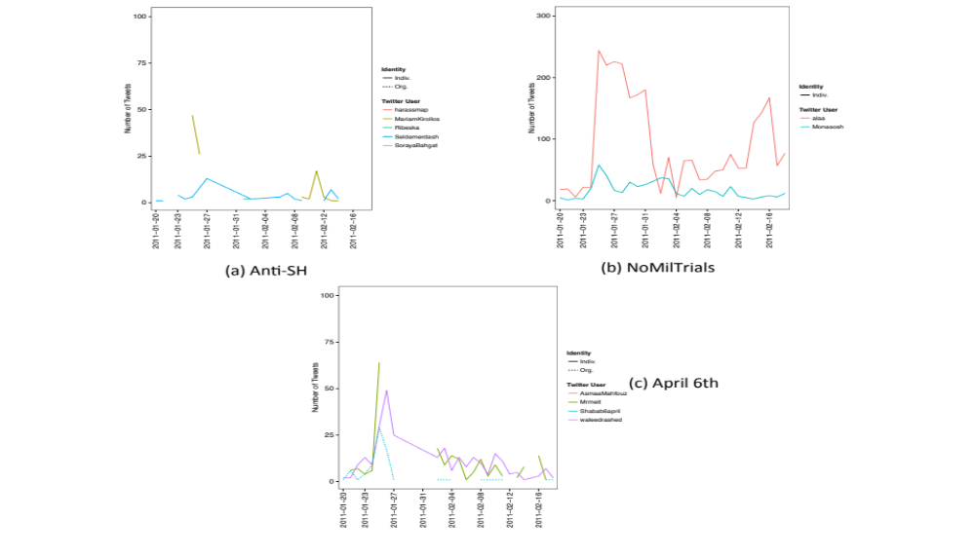
Figure 3: Tweets in Support of Protest, Egypt

We observe the same pattern when we look at the tweets coordinating protest. Because coordination is a key element of mass mobilization, we expect these tweets to become perhaps more relevant during the protests themselves than tweets simply expressing support for protests. As Figure 4 shows, this is not the case. As in Figure 3, actors, especially @alaa, are coordinating protests in high volume, but this behavior quickly dies down. We take this quick decrease as further evidence that actors in this study did not use Twitter for mass mobilization.

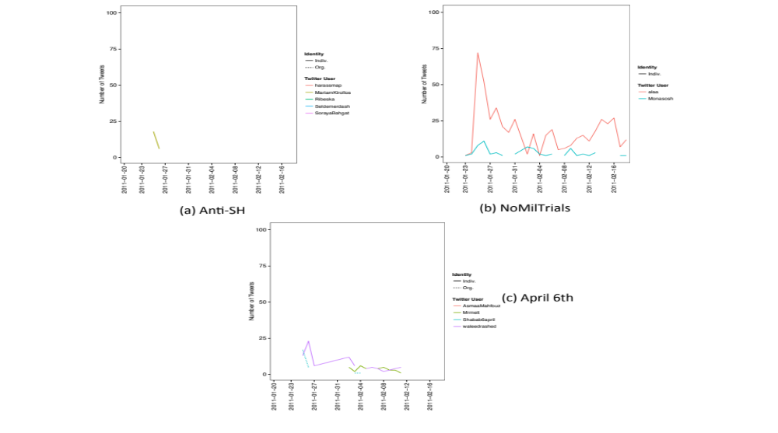
Figure 4: Tweets Coordinating Protests, Egypt

Moreover, this decline in attempts to mobilize mirror a broader decline of Twitter usage amongst the actors once protests started (see Figure 6). In the next section, we explore this decline in more detail.

Memoirs, interviews, and secondary accounts of Egypt’s 18-day protest period provide evidence to support the claim that Twitter was not used for mass mobilization. For example, in the immediate aftermath of January 25th, many activists focused on acquiring supplies for future interactions with riot police. Some would visit sporting goods stores to purchase swim goggles, bandanas, as well as gloves and pads; the goggles and bandanas would slow the effects of tear gas, while those wearing gloves and pads (on their arms) would be responsible for throwing tear gas canisters away from protestors (Khalil 2011, pgs. 157-158). Others worked with the Hisham Mubarak Law Center to track arrests of protestors, work for their release, and meet them with useful supplied and cash upon their release (Khalil 2011, pg. 157). Once the full occupation of Tahrir Square began, the logistics of providing food and medical supplies became an even more pressing issue, and many activists focused on this, using personal networks to get supplies quickly and without much unwanted attention (Khalil 2011, pg. 239). Spending time on these offline behaviors would necessarily have limited the amount of time actors could spend on Twitter to engage in mass mobilization.

Survey evidence also supports the claim that Twitter was not important for mass mobilization. Text messaging and face-to-face communication were the primary methods by which individuals learned about the protest (Tufekci and Wilson 2012). Forty-six percent of the respondents in Tufekci and Wilson’s survey report using text-messaging services to communicate about protest, eighty-two percent the phone, and ninety-two percent heard about the protests on satellite television. Fewer than one percent of participants reported having first heard about the protests through Twitter. Nonetheless, there is slight statistical evidence that people who used Twitter to communicate about protests were more likely to attend protests on January 25th, though only for those who had not previously attended a protest. Taken together, the evidence suggests that technology helped potential participants learn about the protest, but Twitter was not a widely used tool.

When battles between protesters and security forces broke out on January 28th on the October 6 and Kasr al-Nil bridges, which feed into Tahrir Square, activists were preoccupied with being on the front lines, and their social media activity decreases (Khalil 2011, pgs. 171-191). The street, rather than the Internet, became the site of political and physical contestation.

Twitter was more widely used by protesters than the Egyptians population overall. According to Tufekci, sixteen percent of Cairenes reported using Twitter, with 13 percent saying they used it to communicate about protests. Women were slightly more likely than men to use Twitter, and this difference is statistically significant. Despite the relatively high rate of Twitter usage among these respondents, every other communication medium, except for blogs, were used more frequently to talk about protest. And though roughly fifteen percent of the respondents used Twitter, only five percent used it to disseminate photos of the protests. Though Twitter played a small role, its role was out of proportion to its prevalence amongst Egyptians. The number of respondents reporting to have first heard about protests through Twitter was so small that it cannot be considered evidence for mass mobilization.

Complementing Offline Action

The second claim we make in support of the finding that mass mobilization occurred primarily through offline activity is that social media provided the ability for actors to translate offline events into online information. Qualitative data shows that activists’ mobility in the streets allowed them to record and photograph events and abuses, publish news and updates, and communicate with others not in the same physical space. Quantitative evidence shows that a higher percentage of tweets come from mobile devices during the protest period than before or after, suggesting that Twitter, and mobile communications technology more generally, complement activists’ mobile behaviors.

The April 6th movement was active online, on Twitter and Facebook, in the days leading up to protests in January; as shown in Figure 6, it produced more tweets than Anti-Sexual Harassment but fewer than No Military Trials. In 2010, the death of Khaled Said, a young Egyptian killed by police outside an Internet café in Alexandria, inspired the creation of a memorial Facebook page. The page would become one of the most active online forums for political dissidence, attracting many young people who were new to politics and protest (Preston, 2011). As the “We are All Khaled Said” Facebook page began to attract attention and followers, the then-anonymous activist behind the page began communicating with April 6th founder, Ahmed Maher. The two began coordinating protests and discussing their political interests, and by January 25, April 6th and “We Are All Khaled Said” had launched an aggressive online campaign for protests on police day (Wolman 2011). To guarantee that people would come out and join them, organizers made personal calls and sent messages alongside the online posts, suggesting that offline interactions were still needed to buttress online activity.

The Anti-Sexual Harassment campaign has benefitted from the crowd documentation of sexual harassment and assault using mobile media devices. Although they do not produce many videos themselves, many Anti-Sexual Harassment groups use media content uploaded to Facebook, YouTube, Twitter, and other platforms by other users. Langohr (2013) documents some coordination with the media collective Mosireen, known for providing recording, editing, curating and archiving services to many movements and groups since 2011. Video evidence has bolstered Anti-Sexual Harassment campaigns in helping to convince a wider audience that sexual harassment is a serious and very real issue.

The NoMilTrials movement also shows how online tools complemented offline activity. Like many movements, NoMilTrials did not have a single headquarters or meeting place, preferring to embrace non-hierarchical organization and the spontaneity of congregating at protests. For NoMilTrials, their Internet sites served as a kind of online meeting place, the first (but not only) port of call for planning and spreading the word about upcoming events. NoMilTrials supporters still relied heavily on offline communication channels for their street activities, however. Mobile phones aided coordination, and activists used voice call and SMS trees to communicate with one another.

At its inception and throughout its campaign, NoMilTrials utilized social media to forward its cause. The use of mobile phones and cameras for recording protests, violent crackdowns and abuses made video footage and photographic content available for corroborating NoMilTrials claims. The group produced YouTube videos and used others’ videos to present evidence of military violence, and they worked with other media collectives, including ‘Askar Kazeboon, Tahrir Cinema and Mosireen. The witnessing and recording of protest events made possible by new technologies and social media helped sustain the momentum of the revolutionary moment and provide evidence of alleged human rights violation (Allmann, 2014).

Activists with NoMilTrials emphasize the importance of mobile media making and sharing. NoMilTrials regularly integrated online content into their offline protests and demonstrations. Using projectors, cables, screens, and speakers volunteered by protesters other groups, like Mosireen, NoMilTrials protests often featured live screenings of crowd-sourced video documenting military abuses, compilations of photos and video set to music, and other pro-revolution content available on sites like YouTube. “You can create political events simply by having a screening,” said Samir, an activist with Mosireen, who participated in #NoMilTrials events. Screenings would take place both at large demonstrations and in local communities. “Part of it is to show that the people who care about these things are from these neighborhoods. They aren’t far away in Tahrir Square,” he explained. In this way, the #NoMilTrials campaign recognized the need to bring online material into offline spaces, to expose passersby and other protesters to the broad array of digitally produced and distributed content. They quite literally brought the Internet into the street.

As participants moved into Tahrir Square, their communication needs became distinctly mobile. For coordinating on the go, cell phones were essential. With over a 100 percent penetration rate in Egypt in 2011, cell phones were far more ubiquitous than Internet access, so information about protests, marches, attacks, and maneuvers were best transmitted by phone (when there was signal) (Tufekci & Wilson, 2012). Concerns about safety and security also made cell phones and face-to-face communication crucial. Would-be participants were convinced to join marches and meet friends in Tahrir Square by receiving personal invitations via call or SMS, and the ability to stay connected on the go provided an additional degree of security (Allmann, 2014). April 6th members reported feeling more inclined to join protests when they received encouragement from close friends and family either by phone or by word of mouth. This sentiment reinforces the point made in the previous section, that strong, personal ties matter most for mass mobilizing people for street protest.

To understand how actors utilize social media platforms to amplify and enhance their street activities, we looked at how actors accessed Twitter. Figure 5 shows the percent of the three movements’ tweets that come from mobile devices. The middle section, between January 25th and February 12th, corresponds to the peak period of protests. The horizontal dotted lines correspond to each movement’s average percentage of tweets from a device for the period. NoMilTrials, especially @alaa, engages in the highest levels of mobile communication, but the Anti-Sexual Harassment and April 6th movements start becoming mobile early in the protests.

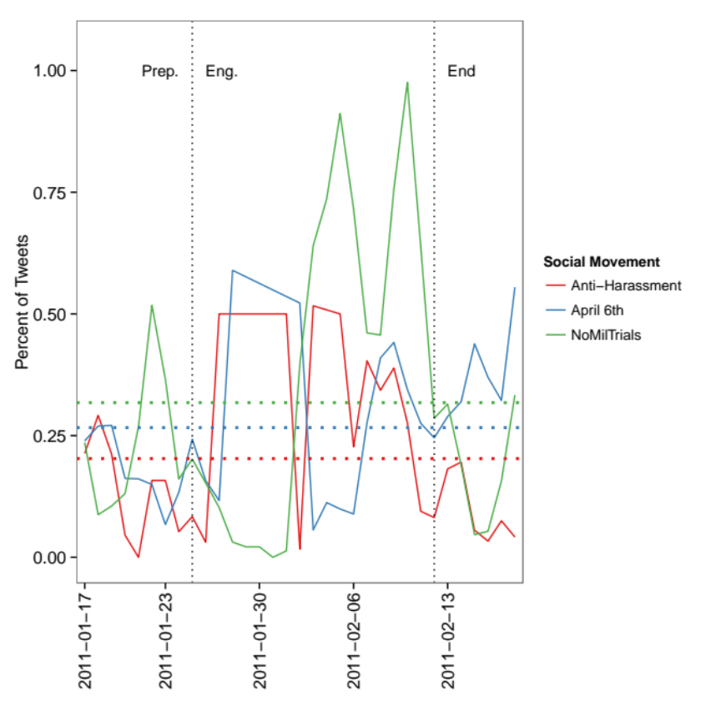
Figure 5: Percent of Movement Tweets from Mobile Device

In Figure 5, two main patterns emerge that suggest that Twitter complemented actors’ mobile tactics. First, NoMilTrials tweets much more frequently from mobile devices starting in early February. This increase coincides with a decrease in tweet frequency, as seen in Figure 6. Second, April 6th and Anti-Sexual Harassment have more consistent levels of tweeting from mobile devices, though they tweet from mobile devices at higher rates during the main protests than before or after. Though tweet frequency and mobile percentage are high at the end of January, both movements significantly reduce their tweet production for most of the protest, yet those tweets that do occur are more likely to come from mobile devices. Though circumstantial, we interpret the decrease in tweet frequency but simultaneous increase in mobility percentage as suggestive of actors tweeting while involved with the protests in the street.

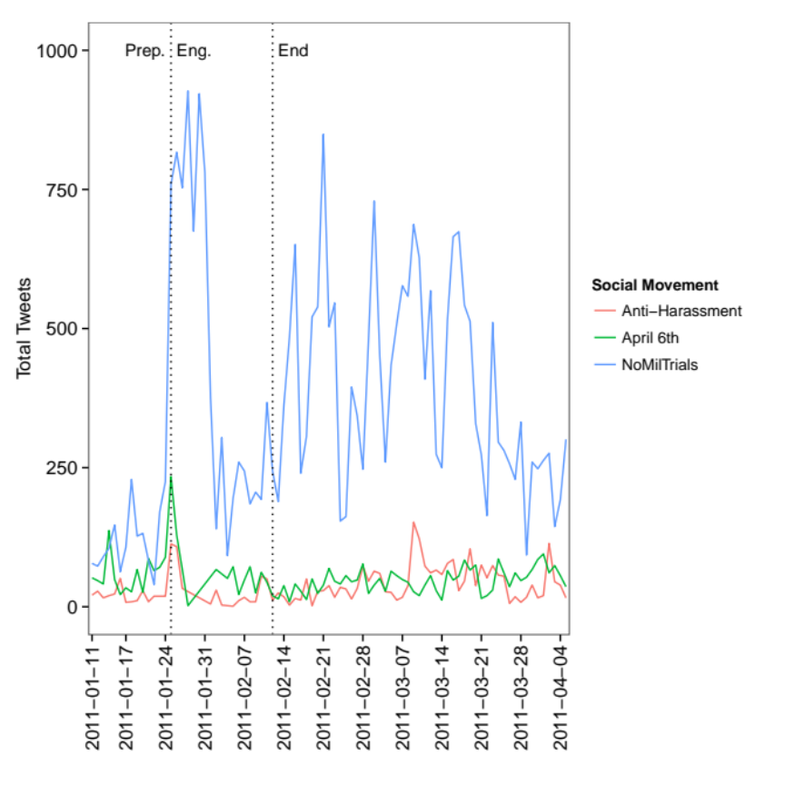
Figure 6: Tweet Production by Movement, Egypt
Though it appears that Twitter complemented actors’ mobility, the figures in the Mass Mobilization section show that we could not determine the content of the mobile tweets. The hashtag and content model analyses do not show a clear rise in subject matter that coincides with the increase in mobility. It is possible that the topics of mobile tweeting are the same as non-mobile tweeting, but future investigation is required to determine if the content of mobile tweets differs from non-mobile tweets.

While we have not been able to determine the content of tweets from mobile devices or whether that content differs from that of non-mobile ones, the experience of the Anti-Sexual Harassment actors suggests how Twitter can complement movement behavior. Tahrir Bodyguard, a group that aims to both end sexual harassment and protect one another during protests, began with a Tweet by Soraya Baghat that publicized her location, out of concern for her safety (Langohr, 2013). Tweeting about one’s location has since become a common safety tactic, not only to publicize where and when someone is protesting or marching but also to invite others to join for safety and support. In addition, one can tweet to @harassmap, which joined in 2009 and is the official account of the Anti-Sexual Harassment actors, about a harassment as it happens, and volunteers will try to locate and rescue the tweet’s author. This particular usage – specific tweets used to mobilize volunteers for a narrow action – is the clearest evidence we found of any connection between Twitter and any mobilization. Because the participants mobilized were few in number in response to these tweets, we intentionally call this phenomenon “mobilization” and not “mass mobilization”.

In addition to the importance of physical locations for information dissemination, actors quickly learned how to use cell phones to spread information. According to Mona El-Ghobashy, activists used online platforms to spread misinformation as well as accurate information in an effort to confuse security forces, relying on mobile phones, landlines, and word of mouth to convey the correct information about routes, meeting places, and strategies (El-Ghobashy, 2011). By recognizing the strategic affordances of different communications platforms, protesters could divide their communicative activities, ensuring that the most sensitive information could be conveyed through the most verifiable and reliable medium. In addition, the on-the-ground usage of online and offline communications strategies allowed actors to bridge the digital divide separating people with regular Internet access from those without it. Online information was regularly transmitted by SMS, voice calling, and word-of-mouth to users with different degrees of Internet access (Allmann, 2014).

Formal and Informal Organizations Between the Online and the Offline

The third claim we make in support of the finding that mass mobilization occurred primarily through offline activity is that formal and informal organizations interacted much more offline than online. Qualitative evidence shows that, especially through the Hisham Mubarak Law Center, CSOs were important actors for other movement actors. Yet this importance is not reflected in Twitter data, except when a few accounts mention a police raid on February 2nd.

The interaction of formal organizations and spaces with social movements provided important offline support to the actors and participants. First, CSOs provided physical spaces for meeting during the protests; they were recognized, familiar locations for congregating. April 6th, for example, had created an effective communications infrastructure, but the movement actors required places to meet offline as events unfolded on the streets. Second, these CSO hubs created an opportunity for information exchange. CSO employees could assist in legal matters and even source important resources (medical supplies, etc.), while protesters could exchange information about street tactics (from coping with tear gas to creating ad hoc phone trees of contacts). Third, they provided a target for police crackdowns while preserving the fluidity and horizontality of the protest movements, which could more easily evade detection.

The Anti-Sexual Harassment movement is made up of a wide array of interrelated but distinct groups, with unique agendas united under the banner of ending sexual harassment and assault. These include Tahrir Bodyguard, OpAntiSH, HarassMap, the Imprint Movement, Shoft Taharrosh, and others. Although those groups work on the anti-sexual harassment agenda and benefit from communicating with and learning from established organizations like those discussed above, these groups have distinct leaders and organizational structures. “We were incubators of all the Op-AntiSH movement and we provided platforms for individuals to host events,” said Hoda, formerly a member of the Egyptian Initiative for Personal Rights. As in the cases of the April 6th movement and NoMilTrials, CSOs like EIPR provided important spaces and organizational experience for issue movements that would thrive in the first two years after the revolution. Because these groups rely on dedicated volunteers that participate in training programs, their membership tends to be committed to one particular campaign, though they will likely follow updates and information shared by other groups under the Anti-Sexual Harassment banner.

Because #NoMilTrials focuses on legal issues and the military court system, lawyers were influential members (many of whom had been working on these issues for some time in their professional lives). In law offices and human rights CSOs throughout Cairo, #NoMilTrials stickers and posters were plastered on walls and computers, and even now, they can be spotted on the odd computer case in a café or peeling off of downtown walls.

Despite the clear offline importance of certain CSOs for the movements in our study, we find little evidence of this offline behavior in our online data. To make this claim, we identified several prominent CSOs based on their inclusion in Western news articles about crackdowns in Egypt on civil society as well as our ethnographic knowledge. These are the Hisham Mubarak Law Center (not on Twitter), the Egyptian Initiative for Personal Rights (@EIPR), the Egyptian Center for Economic and Social Rights (@ecesr), the Arabic Network for Human Rights Information, the Cairo Institution for Human Rights Studies (@CIHRSOffice), the El Nadeem Center for Rehabilitation of Victims of Violence (@elnadeem), the Association for Freedom of Thought and Expression (@afteegypt), and Nazra for Feminist Studies (@NazraEgypt).

We then analyzed the Sifter data to see if those accounts were retweeted or mentioned by the Egyptian actors in our study. These results are presented in Table 7.

Table 7: Egyptian Activists Referencing Egyptian CSOs
CSO | Mentions | Retweets
@afteeegypt | 0 | 0
@cihrsoffice | 0 | 0
@ecesr | 4 | 4
@eipr | 17 | 5
@elnadeem | 54 | 29
@nazraegypt | 4 | 3

The most mentioned and retweeted account is for the El Nadeem Center, which does not figure prominently in the personal accounts we gathered. As 38,026 tweets come from the actors, these numbers are very small, and this initial investigation suggests that there was little online interaction between the formal CSOs and the actors we studied here.

Table 8: Egyptians Referencing Egyptian CSOs
CSO | Mentions | Retweets
@afteeegypt | 0 | 0
@cihrsoffice | 0 | 0
@ecesr | 2 | 4
@eipr | 6 | 4
@elnadeem | 28 | 14
@nazraegypt | 3 | 1

Whatever online interaction existed between actors and CSOs, even less existed between non-actors and these identified CSOs. Table 8 shows how often non-actors in our data reference these same CSOs. The non-actors reference the CSOs at much lower rates. The absolute number of references are slightly lower for non-actors, but non-actors have 7.45 times as many tweets in this period than the actors, 416,144 to 55,849.

The Hisham Mubarak Law Center received a great deal of Twitter attention when it was raided on February 2nd, 2011 (the day of pro-Mubarak rallies across Cairo and an assault on Tahrir Square). @mrmeit, a founder of the April 6th movement, and @shabab6april, the official account of the movement, used the words ‘mobarak’ or ‘hisham’ 142 and 140 times, respectively, on that day. The hashtag ‘#mobarak’ was one of the top 25 hashtags for April 6th, and it is used almost exclusively around February 2nd. The only English tweets using ‘mobarak’ or ‘hisham’ come from @alaa or @monasosh, both key figures in the No Military Trials movement.

Using Twitter to discuss offline events at the Hisham Mubarak Law Center is the only instance we found, however, of large-scale interaction of informal and formal organizations online. Even then, “interaction” is a strong word, as the HMLC did not maintain a Twitter account.

It is worth nothing that while many established, but loosely organized, movements took center stage during the early days of Egypt’s 2011 revolution, other longstanding CSOs and political groups hesitated. Individual members of human rights organizations, labor unions, and religious societies, like the Muslim Brotherhood, participated early on, but these groups only officially joined the mass mobilization later (Khalil 2011). For example, the Muslim Brotherhood announced its support in anticipation of Friday protests in January 28th (Mekhennet & Kulish, 2011), and labor unions, for instance, joined formally in February, just before Mubarak stepped down (Beinin 2011).

Information Dissemination

Building to Protest: Egypt’s Media Landscape

The first claim we make in support of the finding that information dissemination occurred primarily through offline activity is to take note of the low levels of Internet and Twitter penetration in Egypt. With less than a majority of Egyptians on the Internet, and even fewer on Facebook and Twitter, the impact of online media would be limited from the beginning.

By 2010, Egypt had experienced important developments in communications technology. Internet penetration was increasing, and nearly everyone in Egypt had a cell phone, as shown in Figure 7. While Internet penetration has risen steadily in Egypt since 2009, Figure 7 shows that penetration in 2011 was only around 33-39%, not even half of the Egyptian population. In contrast, cell phone penetration was already around 100 percent by 2011, much higher than the Internet (International Telecommunications Union, 2014). Although some cell phone users were using “smart” phones with Internet access, the majority did not have Internet-enabled phones (Egyptian Ministry of Communication and Information Technology, 2012).

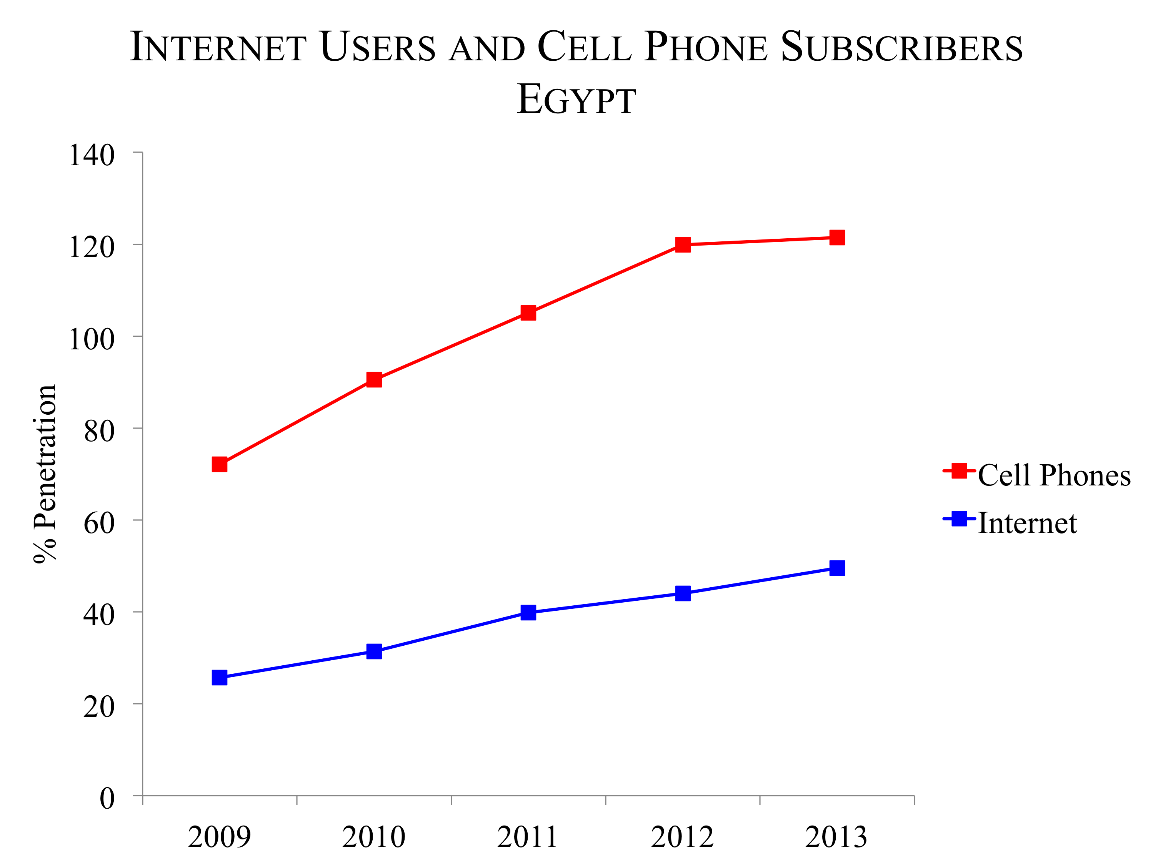
Figure 7: Internet and Cell Phone Penetration in Egypt, 2009-2013 [Data from the International Telecommunications Union Statistics. Figure reproduced with permission from author.]

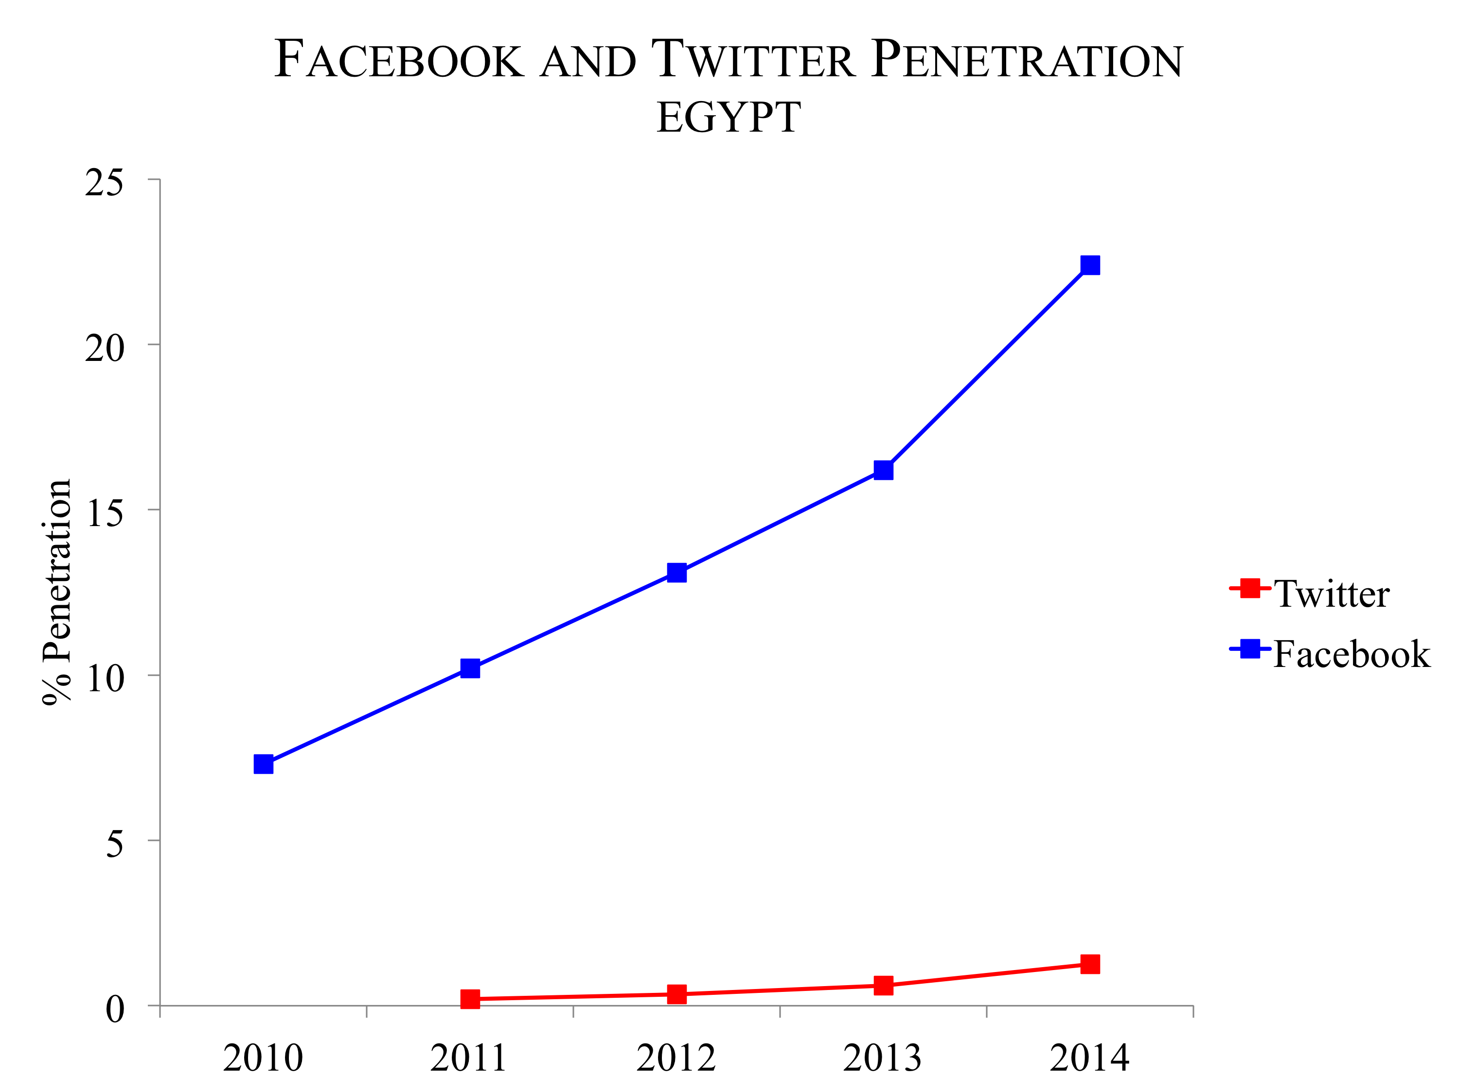
Figure 8: Facebook and Twitter Penetration in Egypt, 2010-2014 [Data from the Arab Social Media Report. Figure reproduced with permission from author.]

The penetration statistics shown in Figure 7 and Figure 8 reinforce the importance of the digital case study. The low rates of penetration, especially of Twitter, limits an exploration of digital content as a method for understanding the Egyptian revolution. New media, including online platforms like Twitter, played a role in the evolution of Egypt’s 2011 revolution, but online activity can only provide a limited window into the dynamics of protest and social movements. At the time, only around 33-39% of Egyptian people had access to the Internet, and only 0.2% were using Twitter (Dubai School of Government, 2011).

In some ways, an exploration of the role of Twitter is inherently an analysis of how an otherwise extraordinarily unpopular platform contributed (in important ways) to an overwhelmingly popular revolution. The Internet had limited reach, meaning that mass mobilization would have to occur beyond this medium alone.

Offline and Online Dissemination

The second claim we make in support of the finding that information dissemination occurred primarily through offline activity is that physical spaces were the primary means of information dissemination. Qualitative data show that movement actors used formal organizations’ offices and large public gathering to spread information about protests, while quantitative data shows that the actors’ attempts to spread their conversation topics online failed.

Physical locations provided important opportunities to disseminate and share information. Tahrir Square is located at the heart of Cairo’s densely urban downtown, where many CSOs, mosques, and government buildings are clustered. These environments close to the center of protests frequently feature prominently in the dialogue on Twitter. A nearby mosque became an ad hoc hospital, and it is common to see tweets discussing casualties, local places to send or find the wounded, and calls for support in the form of supplies and personnel.

Protesters also made regular use of CSO offices, with those offices becoming hubs for coordination, communication, and resources. Several of these CSOs, including the Hisham Mubarak Law Center (HMLC), were long-time centers of activism, legal advice and intellectual communities opposing the regime. On February 2nd, police raided the HMLC, arresting activists and lawyers, in a heavy-handed acknowledgment of its contribution to the ongoing unrest (Amnesty International, 2011). This event also appears in the Twitter data in the form of users, especially @alaa and @Monasosh, using the #mobarak hashtag to coordinate offline activity before and during the protests and then, on February 3rd, live-tweeting the raiding of the offices. Moreover, uses of #mobarak are much rarer outside of the actor circles, revealing how Twitter can be used to understand cross-cutting, simultaneous movements operating during the revolution.

Without a central headquarters and with a changeable base of supporters—outside of the regular activists and organizers, like Mona Seif (@monasosh) and Alaa Abdelfattah (@alaa)—#NoMilTrials often coordinated protests with other groups and other scheduled demonstrations. The co-sponsorship of protests became a common mass mobilization tactic in the immediate post-revolution period. As a result, #NoMilTrials protests often included representatives and media content from many other groups, particularly since lawyers and other legal professionals who were particularly involved in activism around the issue of military trials were also deeply engaged with the many other human rights issues that had come to light since the revolution. For example, in 2012, the Egyptian military raided residents of the army owned Qursaya Island in the Giza governorate, claiming that they were residing there illegally. The raid resulted in deaths and injuries, and the subsequent legal case on behalf of Qursaya residents became a unifying issue for the Egyptian Initiative for Personal Rights and #NoMilTrials. “For the Qursaya island case in Giza, we coordinated with NoMilTrials because it involved the military. We were both there covering it, tweeting, and things like that,” said Sara, an EIPR employee. On a case-by-case basis, issue groups like #NoMilTrials partner with CSOs and other campaigns to forward a cause.

For Anti-Sexual Harassment campaigns, crowd-sourcing of information relied heavily on local, personal networks. Most groups use crowd-sourcing strategies to gather information about occurrences of sexual harassment, their locations, and other data on sexual harassment issues. Harass Map collects an extensive amount of data on sexual harassment through an online form on their website, a telephone hotline, and a text message service. Hotlines are a common tool for Anti-Sexual Harassment groups, and activists who answer the calls try to document reported cases of assault with a degree of accuracy and consistency. All Anti-Sexual Harassment campaigns engage a group of organized volunteers and a small group of dedicated members, many of whom train to deal with the traumatic and often violent experiences of sexual assault victims. The Shoft Taharrosh campaign, a coalition of groups including Fouada Watch and the Appropriate Techniques for Development Center (ACT), trains mostly young men to intervene if they see sexual harassment or assault taking place in the street.

Harass Map demonstrates one way offline information dissemination is more important than online. Offline, the group trains teams of volunteers to canvass local communities, asking them about their sexual harassment awareness and encouraging businesses to commit to being “sexual harassment-free zones” by signing a pledge. Teams are made up of people from local communities, which Mina says are crucial. “We try to recruit volunteers from the area so that they are from that place and always give the sense of being familiar,” she said, speaking from her experience working on the media team at HarassMap. Local context is important in dealing with sexual harassment issues, making activism on the street more important than activism online. While the Internet helps to connect actors and unify groups around the Anti-Sexual Harassment cause, and even helps to aggregate crowd-sourced video and survey data about sexual assault, group members assert that their most important work is face-to-face, in the street, and on the hotlines.

To complement the ethnographic findings, we undertook two Twitter-focused analyzes to understand how information disseminated from the movements to Egyptians. In the first analysis, we analyze the topics most important to each movement and their patterns of use within the movement (as manifested on Twitter) and among Egyptian Twitter users at large. In the second, we look at the topics unique to each movement and compare their usage within the movement (as manifested on Twitter) and outside of it among Twitter users in Egypt. We find few similarities between the actors we studied and other Twitter users, suggesting little information dissemination on Twitter between the movements and Egyptians on Twitter more broadly. This finding reinforces the gulf between offline and online behavior.

To understand information dissemination, we determined the top 25 hashtags used by each movement. We then checked if the movement’s hashtags were used by at least one other movement or the Egyptian Twitter population more broadly. If it was used by one of these other populations, we discarded it, leaving us with only those hashtags used exclusively by each movement.

The results of the common hashtag analysis are presented in Figure 9, Figure 10, and Figure 11. These figures compare the hashtags that were used by everyone in Egypt on Twitter to the hashtags used by the movements we examined. Egyptians display three peaks of online activity corresponding to the start of protests, attacks on Tahrir Square, and Mubarak’s resignation, a clear echo of offline events in the Twitter space. The actors we identified, on the other hand, only display one spike in online activity, at the start of the protests in late January. While these actors’ accounts are active, using the common movement hashtags after January 25th, they are never as active as they were during the initiation of protests.

Activists and other Egyptians on Twitter have different preferences for using certain hashtags. Throughout the 18 days, the actors prefer #jan25 to #egypt, whereas the general population adopts #egypt almost immediately after Mubarak’s resignation. In addition, the general population starts to use #tahrir in large numbers at the beginning of February, yet no movement uses it with any frequency.

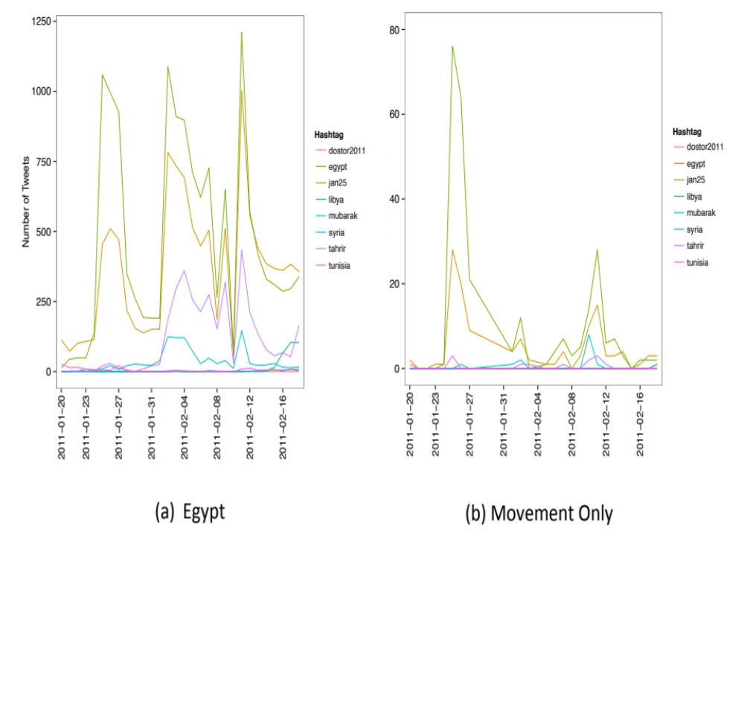
Figure 9: Anti-Sexual Harassment, Common Hashtags

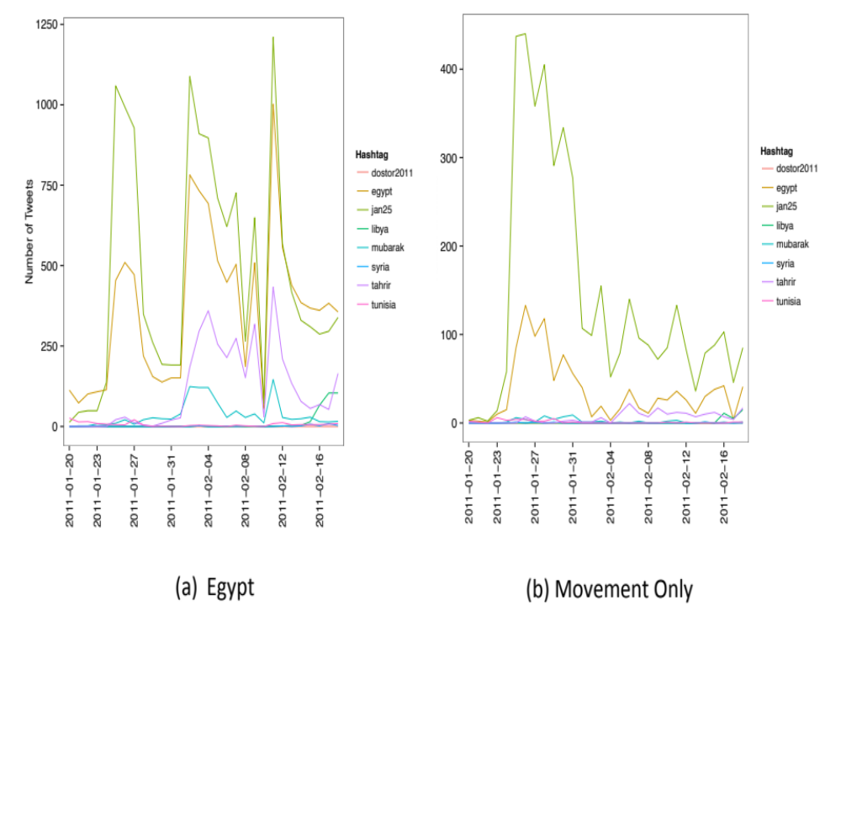
Figure 10: NoMilTrials, Common Hashtags

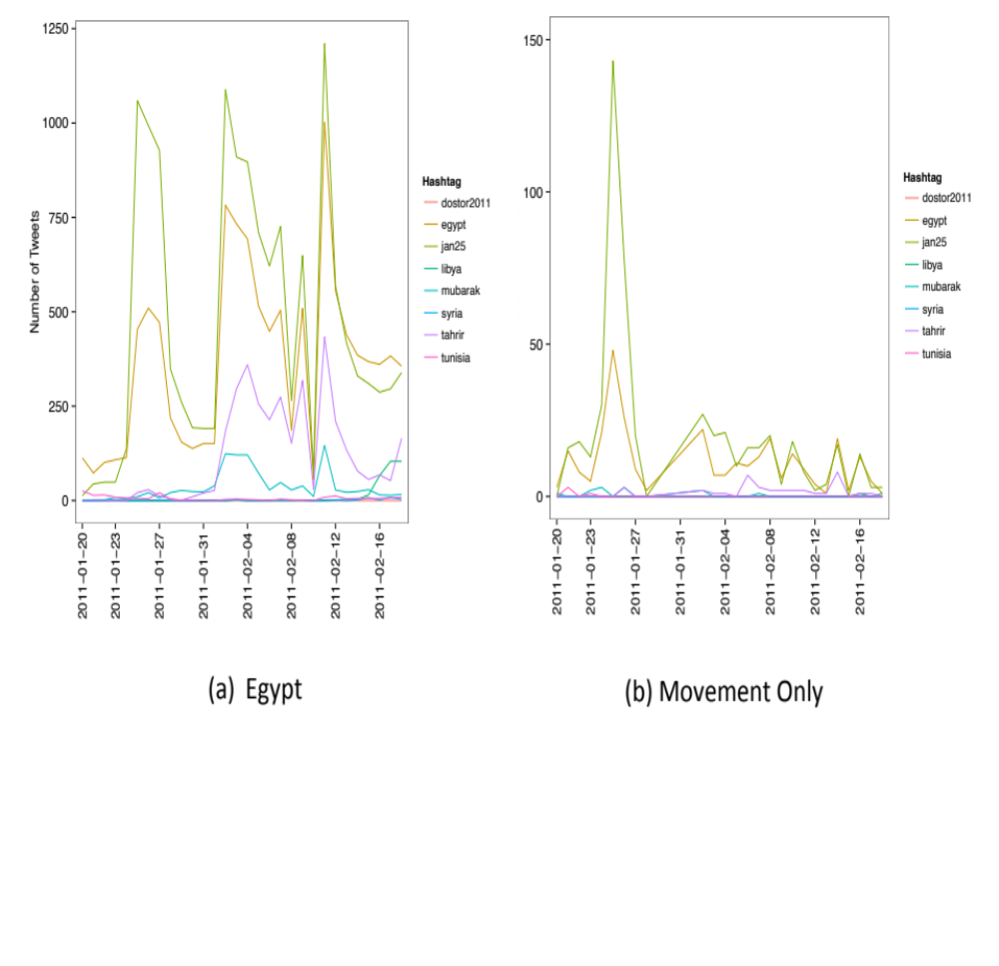
Figure 11: April 6th, Common Hashtags

Looking at the hashtags unique to each movement, there is a marked difference again between the movements we look at and Egyptians at large. No hashtag topic that is unique to each movement finds traction outside of the movement on Twitter. We take this disconnect as evidence that the way these movements shared information resulted in limited dissemination to the larger population (A. Bruns, Highfield, and Burgess 2013; A. Bruns and Burgess 2011).

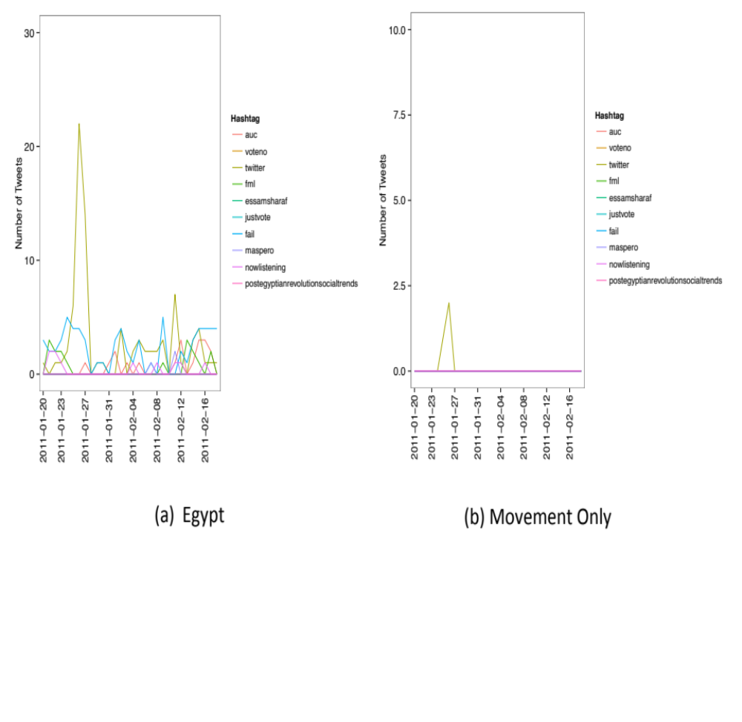
Figure 12: Anti-Sexual Harassment, Unique Hashtags

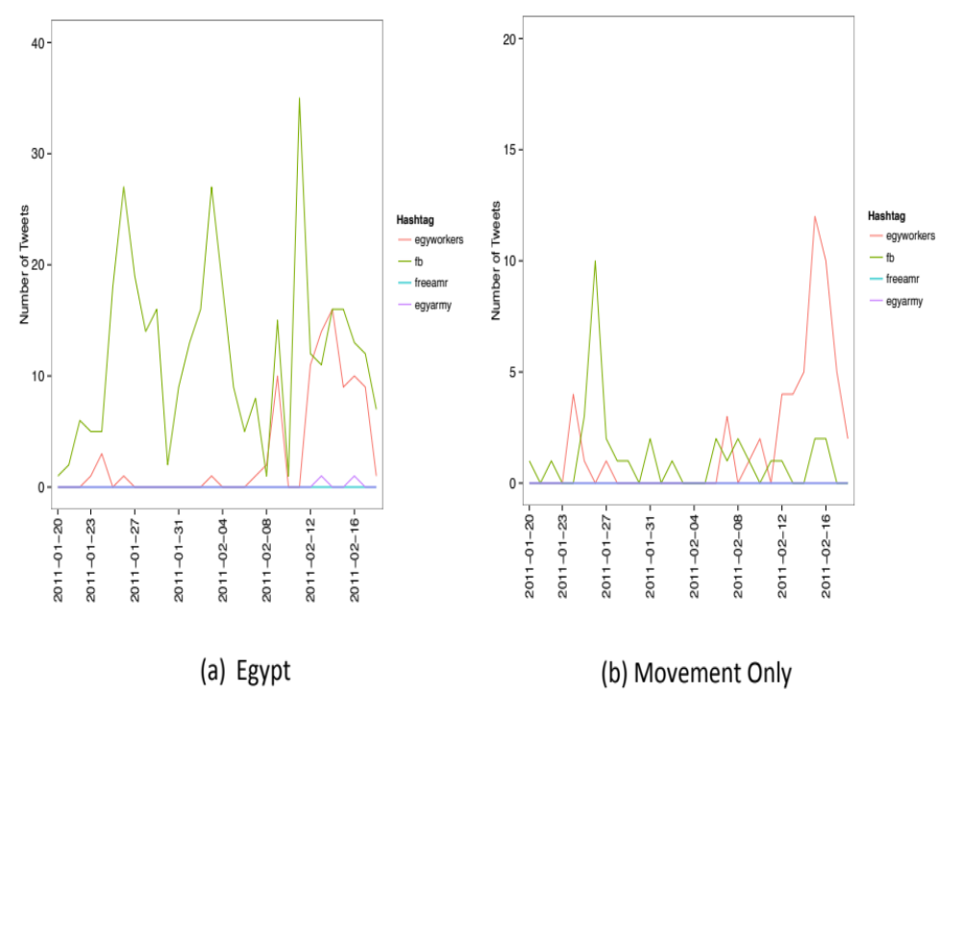
Figure 13: NoMilTrials, Unique Hashtags

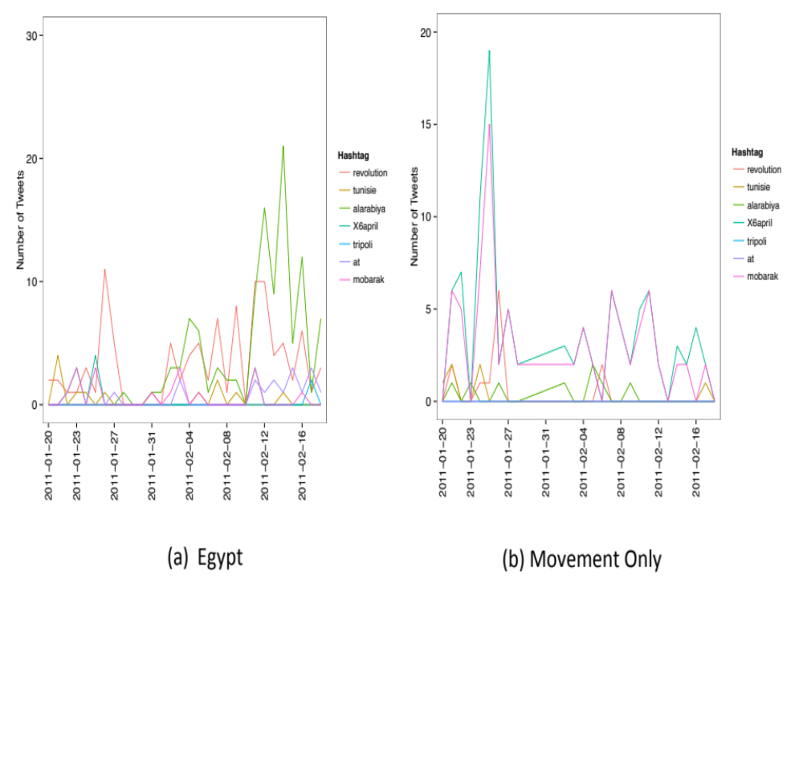
Figure 14: April 6th, Unique Hashtags

Domestic and International Audiences

The third claim we make in support of the finding that information dissemination occurred primarily through offline activity is that there was little interaction online between movement actors and accounts on Twitter not affiliated with the movements. Seeing little interaction provides further evidence that little dissemination from movement actors to others occurred; otherwise, we would observe more mentions and retweets of the actors’ Twitter accounts. An investigation of the actors’ follower network also reveals that a large percentage of each movement’s followers are most likely not based in Egypt; this evidence suggests that Twitter could have been used more to disseminate information internationally than domestically, a finding in line with certain works on Twitter and the Arab Spring (Aday et al., 2012, Starbird and Palen 2012).

One way to measure information dissemination is to see if actors are retweeted or mentioned by other Egyptian Twitter users. We call either behavior an example of interaction, and more interaction suggests more information dissemination from an account. We measure interaction with online domestic audiences by seeing how often the actor Twitter accounts are retweeted or mentioned in Egypt. To measure international audiences, we look at tweets from Bahrain to see if the mention or retweets the Egyptian activists or organization accounts. The results are presented in Table 9.

Table 9: Egypt, Non-Activists' Interaction with Activists, Domestic and International
Activist or Org. | Mentions – Egypt | Retweets – Egypt | Mentions - Bahrain | Retweets - Bahrain
@alaa | 1662 | 237 | 245 | 65
@asmaamahfouz | 32 | 0 | 0 | 0
@harassmap | 8 | 2 | 0 | 0
@mariamkirollos | 6 | 1 | 0 | 0
@monasosh | 356 | 113 | 5 | 0
@mrmeit | 53 | 14 | 0 | 0
@ribeska | 0 | 0 | 0 | 0
@seldemerdash | 77 | 4 | 0 | 0
@shabab6april | 22 | 3 | 0 | 0
@sorayabahgat | 0 | 0 | 0 | 0
@waleedrashed | 23 | 1 | 0 | 0
@zeinabsabet | 0 | 0 | 0 | 0

There were 38,026 tweets from the actors and 416,144 from Egyptians during the 3 months of this study. The numbers presented above therefore suggest the accounts in this study were rarely retweeted or mentioned by Egyptians. Though there appears to be little interaction, when Egyptians do engage with the accounts, it is more likely to be through mentioning the account than retweeting it. Mentioning on Twitter signifies a more serious relationship than retweeting, so it is possible that there are strong ties between the activists or organizations and some online Egyptians.

Except for @alaa, the Egyptian actors and CSO accounts interact rarely with Egyptians on Twitter. Just as few of the movements’ hashtags are used outside of the movement, few mentions or retweets of movement accounts occur outside the movements. While interaction is different than information dissemination, the low level of both further suggests a disconnect between the movements and Egyptians.

While we did not have time to explore international retweets and mentions, some of the accounts do have an audience in Bahrain. @alaa is the leader, but @monasosh and @elnadeem are also mentioned in Bahrain (141,589 tweets). Proportional to how many tweets come from Bahrain during this study, @alaa is retweeted almost as much there as in Egypt. How actors may broker information between countries is an underexplored area in empirical studies of protest and merits further attention.

In another attempt to understand international audiences, we try to identify whether or not followers are potentially in the same country as the account(s) they follow. We approximate “country” through language (there are too many unique self-reported locations to be group based on user-reported location). To do this, we gathered the list of each account’s followers, kept only those active before a certain date, and grouped followers by whether they follow the same account(s) and have the same profile language on Twitter. The results for Egypt are shown in Figure 15; each circle represents a community of accounts that has the same language and follow the same account(s), and the circles are sized by number of people in the community. The actor nodes are labeled with their names.

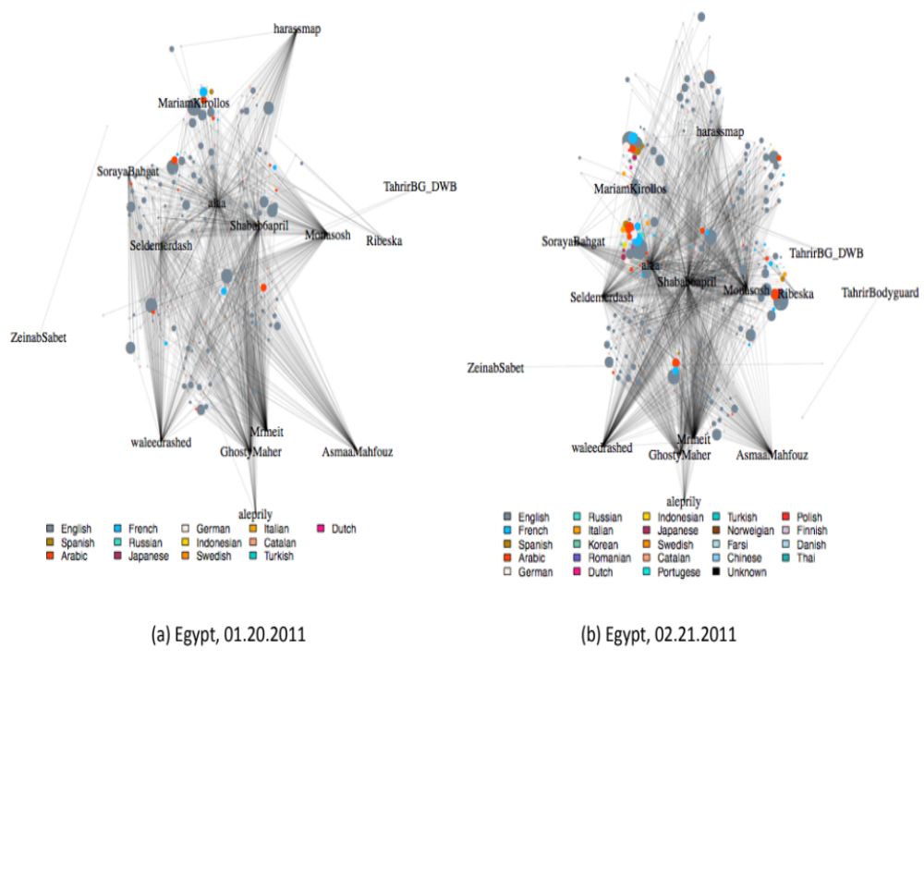
Figure 15: Egypt Follower Network

The key takeaway from Figure 15 is that the largest communities have English as their account language, with French and Arabic the next most common languages. There are then 20 other languages, from relatively common ones such as Russian, Indonesian, or Japanese to little-used ones such as Danish, Finnish, or Catalan, that follow the actors. Though we do not record the number of members in each community, it is clear there is a sizable number who do not speak English or Arabic. Since this network represents the people who receive information from the actors (the actors’ followers), we interpret this as evidence that information was disseminated internationally.

Figure 15 is at best a very rough approximation of international audiences. It is common for users in Egypt to use English on Twitter, so belonging to an English speaking community in this graph does not clearly mean that one lives outside of Egypt. We could have used an account’s time zone in conjunction with language and whom an account follows to create more communities, but doing so would have made the graph even more crowded with nodes. Due to resource constraints, we could not conduct a hashtag analysis for the international audience, so we cannot tell if the topics used by the movements are picked up by the international audience. Moreover, many countries speak the same language, such as Bahrain and Egypt with Arabic, so it is more accurate to say that we measure linguistic follower communities and assume that accounts without Arabic as their primary language are outside of the Middle East.

Case Study: Bahrain

By February 14th, 2011, when actors and participants took to the streets in downtown Manama, the Arab Spring had already begun to affect other Arab states. Elsewhere, Tunisian president Ben Ali had fled his country following protests that began in December, President Hosni Mubarak of Egypt had stepped down under pressure from large-scale protests in Tahrir Square, and protests were rocking many other countries in the region. The mass mobilization of people into the streets was inspired by these regional upheavals, as the momentum of the transnational Arab Spring suggested to actors and participants that this could be an important political window of opportunity (Mohammed & Zill, 2012).

Young people online began discussing a protest for February 14th, the 10th anniversary of the National Action Charter. The charter promised wide-ranging political reforms, including the re-establishment of an elected parliament (C. Kerr & Jones, 2011; Ulrichsen, 2012). It came to symbolize empty promises when the subsequent 2002 constitution established a bicameral legislature with an appointed upper house that enjoyed substantially greater powers than the lower, elected house (Niethammer, 2006; Peterson, 2009).

On February 17th security forces seized control of the Pearl Roundabout, resulting in several deaths and many injuries (Al-Wasat, 2011). In response to this attack on the protest camps, legislators from the Al-Wefaq Society, the largest opposition bloc in Parliament, resigned (Bassiouni, Rodley, Al-awadhi, Kirsch, & Arsanjani, 2011). Tens of thousands of people marched on the Pearl Roundabout during the following days (Katzman, 2012), and they were met with police barricades, tear gas, and live ammunition.

On February 19th, King Hamad’s son, Crown Prince Salman, ordered the withdrawal of troops and security forces from the roundabout, allowing protesters to re-establish their camp and voice their demands (Chulov, Finn, & Dehgha, 2011). However, the regime called for a pro-government rally outside the Sunni Al-Fatih mosque only a couple days later (C. Kerr & Jones, 2011), resulting in a large pro-government protest that heightened sectarian tensions between the ruling family, supported by the country’s Sunni minority, and the Pearl Roundabout protesters, overwhelmingly representing the Shia majority. Protests on February 22nd were the largest to date, and by the end of the month, King Hamad was forced to offer some limited concessions in an effort to appease protesters (Joyce, 2012). However, the protests continued into March. On the 14th of that month, forces from Saudi Arabia and the United Arab Emirates were deployed alongside Bahraini security forces to squash the ongoing protests (BBC News, 2011). Throughout this period, arrests and detentions of activists, including online activists, took place (Coyne, 2013).

Smaller protests, as well as arrests of activists and protesters and police crackdowns on demonstrations, have continued ever since (Nyathi, 2013). On March 18th, security forces demolished the Pearl Roundabout. The government subsequently established the Bahrain Independent Commission of Inquiry to investigate events of February and March 2011 and address concerns that serious human rights violations had occurred, and a national dialogue was held to allow political groups to voice their grievances. These efforts made limited progress toward reconciliation, reparation, or reform, and, amidst continuing protests, many consider the Bahraini uprising ongoing (Jones, 2012).
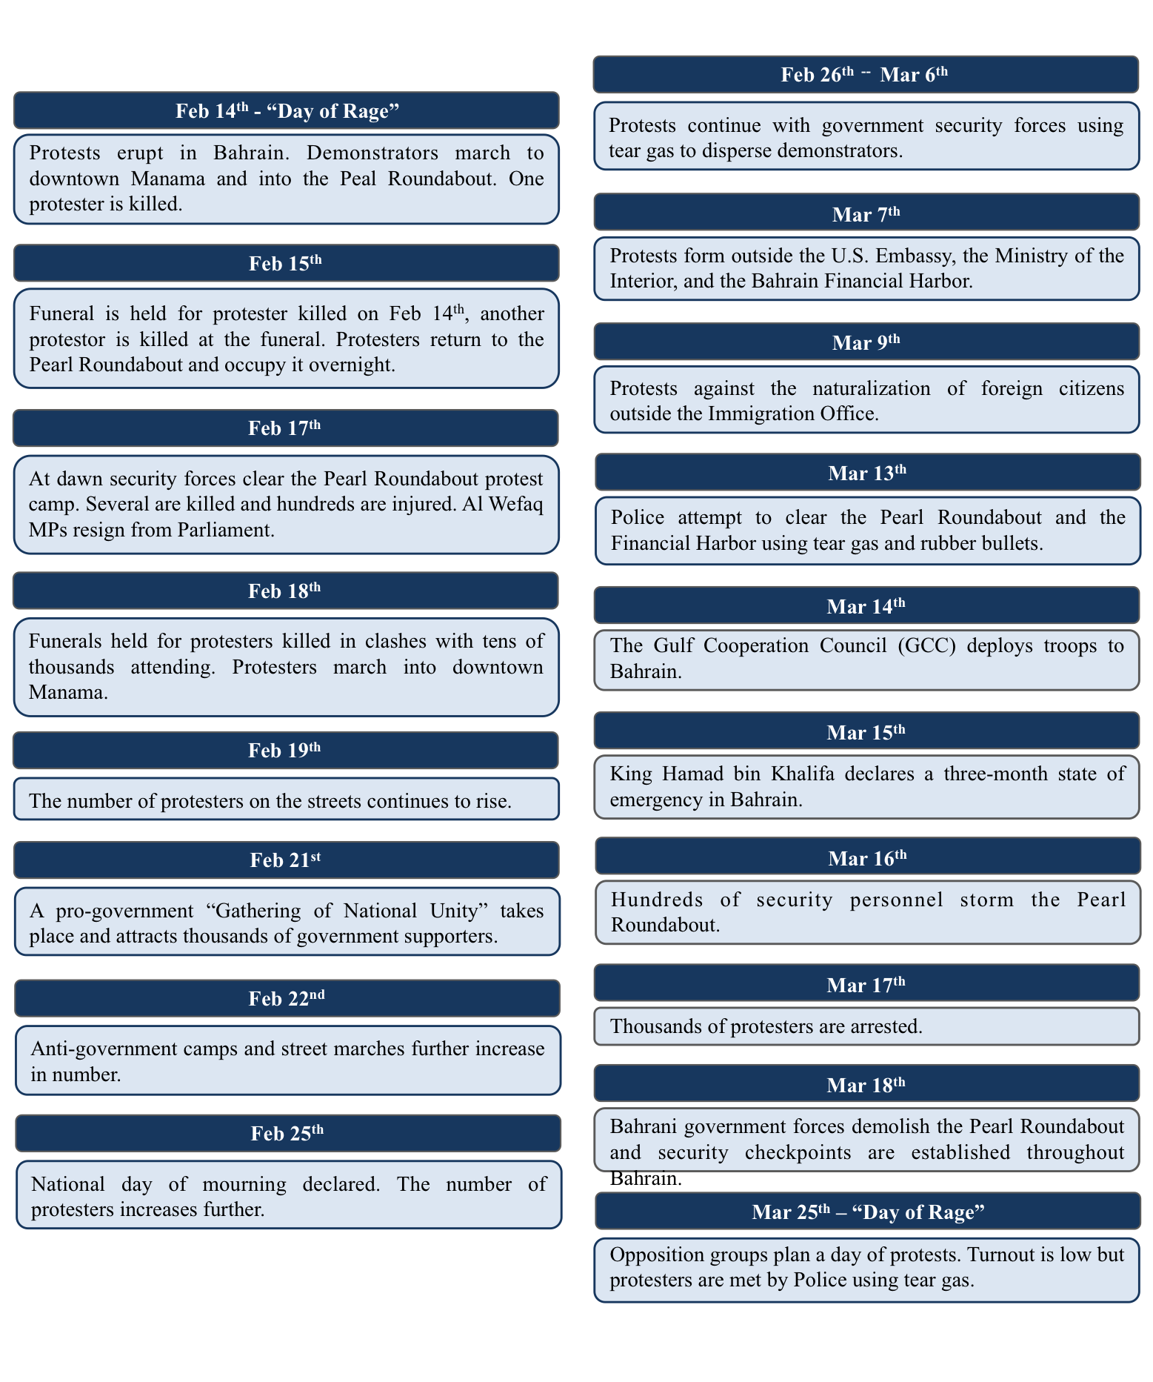
Figure 16: Timeline of the Uprising in Bahrain [figure reproduced with permission from author]

Figure 16 provides an overview of Bahrain’s uprising timeline. It is not exhaustive in its description of events, but it provides some context for the uprising.

Movements

As in Egypt, Bahrain’s 2011 popular uprising stemmed from longstanding grievances and benefited from the experience of activist organizers who had become important political leaders since the National Action Charter reforms.

Movements in Bahrain were chosen for similar reasons as in Egypt. We selected the February 14th movement because it is composed primarily of youth. The February 14th Youth, human rights movements, and opposition societies became active in protests at different times, with the former not gaining a major Twitter presence until weeks into Bahrain’s protests while the latter was active on Twitter throughout. We considered the women’s rights movement but did not include them because most of its actors have no Twitter presence.

(Il)legal Opposition

Opposition parties are constrained by restrictive associational laws in Bahrain. The most active opposition parties are Al-Wefaq, a Shia Islamic society, and Wa’ad, a leftist, mostly secular society. Both were formed during the years of political opening at the beginning of King Hamad’s rule (Al-Wefaq in 2001 and Wa’ad in 2002), when the promise of political participation offered an opportunity for organizations to coordinate. The leadership of both of these groups was made up primarily of returning exiles—the Shia opposition in the case of Al-Wefaq and the socialist and nationalist opposition in the case of Wa’ad.

Political parties are prohibited by law, but political societies are permitted under the Law for Political Societies (Law No. 26/2005). The law includes restrictions similar to those in the Law of Associations, where the government reserves the right to deny or dissolve societies, and societies cannot be based on shared characteristics such as class, religion, or sex. According to human rights watch, seven opposition societies had been allowed to register under the law by 2013 (Human Rights Watch, 2013). The precarious and legally vulnerable position of political societies has resulted in serious operational challenges. In 2010, the government arrested many activists and leaders of unregistered societies and shut down websites of registered groups as well (Human Rights Watch, 2010). In reaction to the uprising in 2011, the Bahraini government closed Wa’ad and arrested the group’s leader, Ibrahim Sharif, who remains in prison (Al Jazeera English, 2011; AlShehabi, 2014). During the run-up to national elections in November 2014, a court banned the Al-Wefaq society for three months (BBC News, 2014).

Like human rights organizations in Bahrain, political societies operate at the discretion of the government. Bahrain’s political opposition was rejuvenated by the return of exiles in the early 2000s, but the leadership of the country’s opposition societies has faced a new wave of crackdowns. By 2011, Bahrain’s established opposition groups had been operating for roughly a decade, built on a leadership base that had decades more experience in Bahraini politics.

For the Twitter analysis, we isolated several individual accounts associated with activism in the Al-Wefaq society.

Shia Legal Opposition
Matar_Matar | This is the account for Matar Ebrahim Ali Matar, a former politician of the Al-Wefaq party who resigned at the start of the Bahrain protests. This account is primarily in English, and it was created on December 31st, 2008.
ALWEFAQ | This is the primary account of the Alwefaq National Islamic Society, the main opposition party in Bahrain. It tweets in Arabic, and it was created on November 26th, 2009.
JawadFairooz | This is the personal account of Jawad Fairooz, a former Member of Parliament for the Alwefaq National Islamic Society party who resigned en masse with his party. He tweets in Arabic and joined Twitter on June 1st, 2011.
WefaqGS | This is the account for the Secretary General of the Alwefaq party, thought it is unclear if it tied to the individual (Ali Salman Ahmed Salman) or position. It tweets in Arabic and joined Twitter on July 1st, 2011.
AlWefaqEn | This is the English account of the Alwefaq National Islamic Society. It was created on February 20th, 2012.

Human Rights
Bahrain’s human rights community, comprised of national organizations, institutions in exile, and individuals, was active long before the uprising in 2011. The most prominent organizations included the Bahrain Center for Human Rights (BCHR) and the Bahrain Human Rights Society, both of which have Twitter accounts that we analyze. Other organizations, mostly based abroad, also make up an important extension of Bahrain’s domestic human rights movement; examples include Bahrain Watch, the Bahrain Human Rights Observatory, and the Bahrain Institute for Rights and Democracy.

BCHR was founded by a group of activists, including Abdulhadi Al Khawaja and Nabeel Rajab, both of whom participated in the 2011 protests. The Al Khawaja family had been living in exile and returned to Bahrain in 2001 as part of the “general amnesty” offered to exiles (Beaugrand, 2008). In 2004, Al Khawaja was arrested for speaking out against the prime minister, and the government dissolved BCHR (Human Rights Watch, 2004). Both Al Khawaja and Rajab were subsequently arrested several times, and Rajab was subject to a travel ban in 2010 and again in 2011 (Bahrain Center for Human Rights, 2010). Al Khawaja was beaten and arrested in 2011 for his involvement in the Bahraini uprising, and has remained in prison since then (International Federation for Human Rights 2011). Rajab was arrested in 2012 for his participation in the uprising and again in 2014 for a tweet (Amnesty International 2014). Al Khawaja’s two daughters, Maryam and Zeinab, have also been involved in BCHR. Zeinab was arrested in 2012 for participating in protests, and in 2014 she was sentenced to three years in prison for tearing up a picture of the king (Frontline Defenders, 2012, 2014). Maryam was arrested in 2014 when she tried to return to Bahrain to visit her father in prison (Bahrain Institute for Rights and Democracy, 2014). Since 2004, BCHR was kept alive informally through the efforts of the Al Khawajas, Rajab, and others, who continued to campaign for human rights in and out of prison and exile.

The challenges faced by human rights groups stem from Bahrain’s domestic law on forming civil society organizations. The Law of Associations (Law No. 21/1989) places tight restrictions on NGOs and civil society groups, dictating that they must not be “political” in their agenda or practices. In effect, the law allows the government to arbitrarily reject applications for official status (as in the case of BYSHR), take over or dissolve organizations (as in the case of the Bahrain Human Rights Society), and prohibit groups from coordinating with foreign organizations or receiving foreign funding. A draft 2012 update of this law promises more restrictions (Human Rights Watch, 2013).

Before 2011, most human rights organizations had been forced to dissolve or relocate abroad, and their leadership had years of experience in the arbitrary enforcement of association laws. As a result, the organizations themselves were primed to be information hubs rather than physical meeting places, and their active members were in a position to bridge the narratives of long-standing grievances and newly ignited rage.

For the Twitter analysis, we isolated several individual accounts associated with activism in the human rights movement.

Human Rights
NABEELRAJAB | This account belongs to Nabeel Rajab, the president of the Bahrain Centre for Human Rights. While his profile description is in English, he tweets in Arabic. He joined Twitter on April 13th, 2009
MARYAMALKHAWAJA | This is the Twitter account for Maryam al-Khawaja, a Co-Director of the Gulf Center For Human Rights. She became the acting President of the Bahrain Centre for Human Rights (which her father co-founded) since the arrest of Nabeel Rajab. Most of her tweets are in English, and she joined Twitter on July 1st, 2009.
SAIDYOUSIF | This is the account of Said Yousif Almuhafda, a Vice President at the Bahrain Center for Human Rights. He identifies his current location as Germany, and most of his tweets are in Arabic. He joined Twitter on September 09th, 2009.
angryarabiya | This is the account of Zainab al-Khawaja, a human rights activist whose father was President of the Bahrain Center for Human Rights. Her tweets are in English, and she joined on February 3rd, 2011.
Zamahdy | This is the Twitter account of Zahra Mahdy. She works at the Bahrain Center for Human Rights. She tweets in Arabic and has been a member since October 04th, 2011.
MohdMaskati | This is the Twitter account for Mohammed Al-Maskati, the current president of the Bahrain Youth Society for Human Rights. It is primarily in English and was created on July 1st, 2011
BahrainRights | This is the official account of the Bahrain Center for Human Rights. Its tweets are a mixture of Arabic and English, and it joined Twitter on August 08th, 2009.

February 14th Youth Coalition

The February 14th Youth Coalition is made up of a variety of groups and individuals who participated in protests in February 2011. Little is known about the coalition and its membership, as the group prefers to maintain anonymity and often avoids media interviews or attention (Jones, 2012), relying heavily on social media to publish statements and announce protests without a singular headquarters or centralized leadership (Jones & Shehabi, 2012).

The coalition emerged out of events in 2011 and the success of the protests that began on February 14th. The icon of the coalition, a fist raised in front of the Pearl Roundabout monument, is readily adopted by youth throughout the country for protest banners, anti-regime graffiti, and social media posts. Because the coalition is very loosely organized and anonymous, the boundaries and definition of the coalition are constantly in flux and elusive. Its significance stems from the way that its name and iconography are freely shared and adopted.

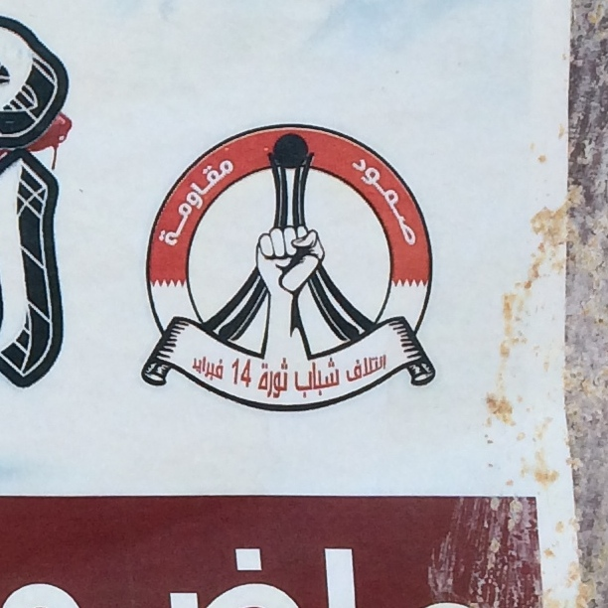
Figure 17: February 14th Youh Coaltiion Logo, on poster in Manama, 2014 [photo credit: K. Allmann]

In the aftermath of 2011, the February 14th Youth Coalition has remained active online, posting on Facebook, Twitter, and YouTube, and managing WhatsApp lists that disseminate information. However, its presence in the street is more fragmented; protests occur in local towns and villages, particularly in Shia communities, and turnout is often (though not always) small. The group’s social media helps to connect these demonstrations—to unite them in one media space (February 14th Youth pages and lists) when they might not be physically proximate in the streets.

For the Twitter analysis, we isolated several individual accounts associated with activism in the February 14th Youth.

February 14th Youth
byshr | This is the account for the Bahrain Youth Society for Human Rights. It tweets primarily in Arabic and was created on July 1st, 2007.
14febahrain | This is an account devoted to spreading news related to the February 14th protests. Its tweets are in Arabic, and it was created on June 1st, 2009.
14FebBHN | This is a more radical account committed to protests in Bahrain. Its tweets are in Arabic, and it joined on May 1st, 2010.
Feb14Media | This account is a news aggregator and diffusor for February 14th groups. Its profile is in Arabic and English, but its tweets are primarily Arabic. It joined Twitter on February 13th, 2011.
14FebRevolution | This account is primarily in Arabic and was created on March 8th, 2011.
Feb14MediaEN | This is an English version of @Feb14Media and was created on May 1st, 2011.
COALITION14 | This is another account devoted to organizing and disseminating information about February 14th events. This is the Twitter page linked to from the Wikipedia page for the youth group Coalition Youth of 14 Feb Revolution. It was created on May 24th, 2011 and is in Arabic.
press14feb | This is another account devoted to the Bahrain protests. It is in Arabic and was created on June 1st, 2011.
Coalition14EN | This is the English version of @COALITION14. It was created on April 1st, 2012.

Mass Mobilization

Movement to the Street
For Bahrain, the first claim we make in support of the finding that mass mobilization occurred primarily through offline activity mirrors the claim made for Egypt. Although news about the protests was circulating on social media, offline experiences, such as seeing protestors march through streets, were more important than Twitter in encouraging mass mobilization.

Qualitative data show that the call for protests, as in Egypt, began on social media, and initially the turnout was relatively small. A group calling itself the February 14th Youth coalition issued a list of political demands online through Facebook and called for protests on February 14th, the anniversary of Bahrain’s National Action Charter. Protestors made their way onto the streets and were met with an aggressive response from security forces using tear gas, rubber bullets, and birdshot (Bassiouni et al., 2011). The clashes between protesters and security personnel resulted in many injuries and one death, a development that sparked national outrage. Thousands of protesters took to the streets on 15 February, making their way to the Pearl Roundabout in downtown Manama and marching in mourning for the funeral of the fallen protester (C. Kerr & Jones, 2011).

Security forces interrupted the mourning procession, another person was killed, and news of the death brought even more people into the streets. Protesters set up a camp in the Pearl Roundabout, echoing the tactics of protesters in Tahrir Square, demanding justice for those killed and a new constitution with provisions for a representative government (International Crisis Group, 2011). King Hamad responded, unexpectedly issuing an apology and promising an investigation (Bassiouni et al., 2011).

Seeing protesters take to the streets as the popular demonstrations continued attracted others to join. Protesters often marched miles from outer neighborhoods into the center of Manama, disrupting traffic and drawing attention with chants; working from the periphery to the city center in the same strategy Egyptian activists had followed. Protesters’ movement on foot allowed others to join as marches passed by and took time. Urban Bahrain is characterized by busy streets, highways, and boulevards, designed for vehicular use to the exclusion of pedestrians in many cases; as a result, protests on foot interrupt the ordinary flow of everyday life. Seeing, reading, and hearing about this disruption in the streets and online prompted many people to call friends and family, asking where to go and what was happening. Although no one we interviewed could say with any specificity where they heard about it, the consensus was that protests were heading to Pearl Roundabout.

The importance of the human rights movement to the Bahraini protests is evident in Figure 18, which is based partly on analyzing the human rights actors’ Twitter content. The human rights movement constantly sent tweets in support of protests and did so at higher rates, and more frequently, than even the February 14th Youth accounts (see Figure 18). They were active before the protests, whereas February 14th was not, and their online activity is spread across many more accounts, both individuals and a formal organization. While @alaa in the NoMilTrials movement is the most active of any individual account, the human rights campaigners are the most active on average across any movement.

As protests began in mid-February 2011, the official opposition societies were not directly involved. Having chosen to participate in the 2010 parliamentary elections, Al-Wefaq held 18 seats in the council of representatives and did not immediately join the demonstrations, as they would be in a position to negotiate as events unfolded. According to Al-Wefaq leaders, they did not expect the popular protests and initially stood back to allow the youth to voice their concerns. However, when security forces used lethal force against protesters, the society decided to formally resign from parliament and join the growing movement in the street. In other words, only the human rights and youth movements, and actors involved with them, encouraged mass mobilization at the start of protests.

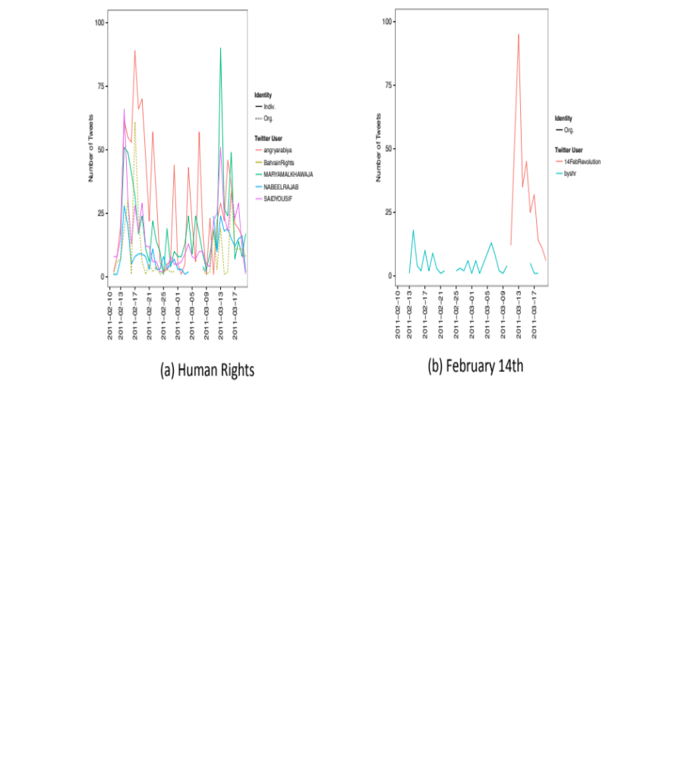
Figure 18: Tweets in Support of Protest, Bahrain

Though the human rights and youth movements were important mass mobilizers, according to the ethnographic evidence, quantitative analysis suggests they did not use Twitter to mass mobilize. Neither Bahraini movement engaged in protest coordination, as Figure 19 shows. The silence of the human rights group is especially striking in light of their online activity supporting protest. Figure 18 shows that the human rights movement did engage in large amounts of protest support tweet production, in contrast to every other movement analyzed here.

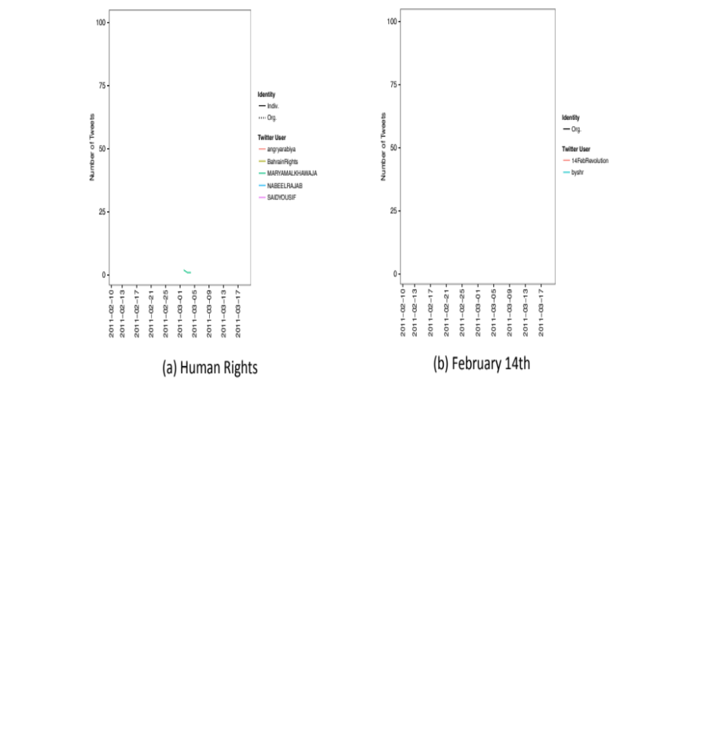
Figure 19: Tweets Coordinating Protest, Bahrain

Complementing Offline Action

The second claim supporting the finding that mass mobilization in Bahrain occurred primarily through offline activity parallels the one made in Egypt. The actors appear to produce more tweets when they are not producing them via cell phones: when tweet production is lowest, more of those tweets are from cell phones. We interpret this pattern as suggesting that actors tweet as part of protest events. Ethnographic work corroborates this inference, as it shows that actors used online tools, including Twitter, to complement their mobility in the streets.

To be clear, the claim here, as in the Egypt chapter, is not a claim on information dissemination. In the next section, we show that actors do not appear to have had much influence on non-actors on Twitter, as they are rarely retweeted or mentioned and their conversation topics are rarely used by non-actors on Twitter. The claim here is that Twitter complements the actors while they are in the street, as it allows them to convey what is happening in near real-time. Twitter allows actors to try to disseminate information, but it does not mean the information spreads.

We conducted the same mobility analysis for Bahrain as we did for Egypt, looking at the device usage for actors using Twitter. The results of this analysis are shown in Figure 20. As in Egypt, the mobile tactics of the movements are clear in the spikes above the average level of mobility observed during the main protest period. Both movements exhibit higher percentages of tweets from mobile devices, with very large single-day jumps occurring at the start of the protests.

Unlike Egypt, mobile tweeting decreased from both movements over the course of the main protest period. For example, the No Military Trials movement had its highest level of mobility starting in the 2nd of February, towards the end of Egypt’s main protests. In Bahrain, however, the Human Rights and February 14th movements initially produced a majority of their tweets from mobile devices. The February 14th movement switched away from mobile tweet production by the 2nd week of protests, while the Human Rights group waited one more week to do the same.

We were not able to determine offline causes of the switch away from mobile tweeting. The leaders of February 14th are intentionally anonymous, and the Human Rights actors in our study were all in jail or exile by the time fieldwork commenced. There does appear to be some negative correlation between tweet quantity and frequency of mobile tweeting: both movements tweet less frequently at the start of protests than during the weeks of March 6th and March 13th, and those periods of less tweeting are associated with more tweets from mobile devices. Figure 21 shows each movement’s total number of tweets per day during this study. The February 14th movement becomes most active towards the end of the first phase of protests, which coincides with a large drop in the percent of tweets from mobile devices. While the Human Rights group does tweet often at the beginning of protests and has a high initial mobility percentage, the trough of tweets corresponds to a peak in tweets coming from mobile devices. Though circumstantial, these correlations suggest that actors may be tweeting from protest sites.

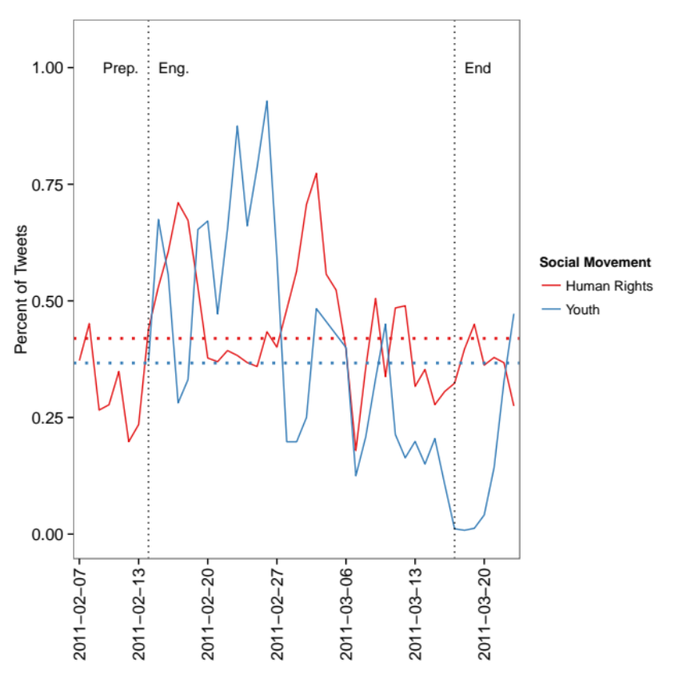
Figure 20: Bahrain, Mobility

Qualitatively, Bahraini actors augmented their offline protest activities by “moving” between offline streets to online spaces, as in Egypt. The February 14th actors in particular posted photos and videos on Facebook and Twitter to provide citizen-reported coverage of the growing protests. Human rights organizations also sent crowd-sourced images and video to their online networks as protests continued in the streets. Video footage and photos proved crucial in the early days of protests in conveying evidence of what was happening in the street, as other media outlets did not cover initially the protests. The ability of actors to post footage and updates from the street brought the street online.

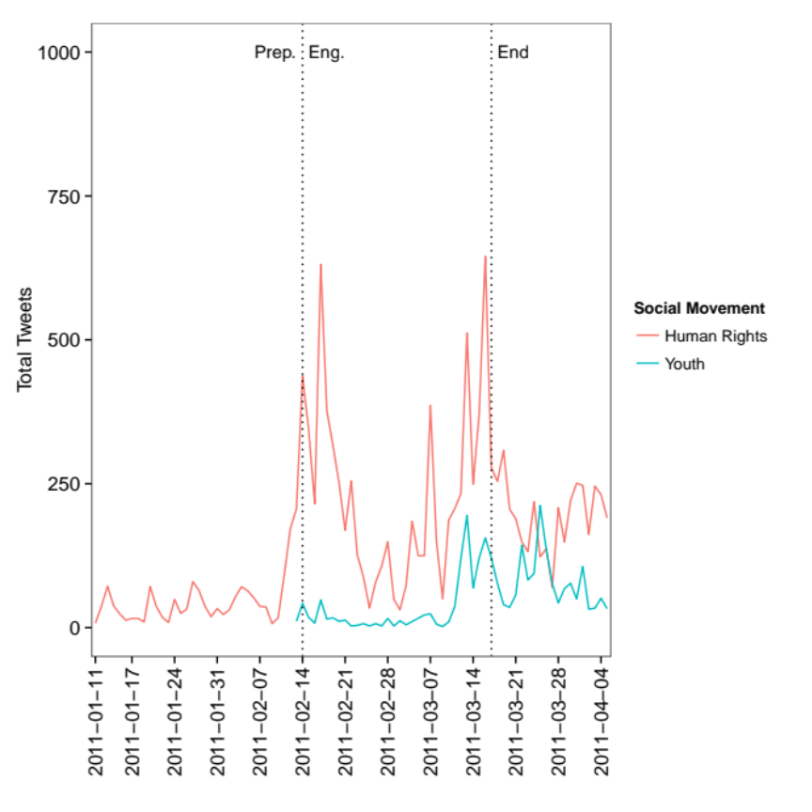
Figure 21: Bahrain, Tweet Production by Movement

Formal and informal organizations

We find the same evidence in Bahrain regarding the role of formal and informal organizations as we did in Egypt. This section thus makes the third claim in support of the finding that mass mobilization occurred primarily through offline activity: As in Egypt, CSOs, especially those associated with the human rights movement, were important actors in mass mobilization. Also like Egypt, the Bahrain movement actors evidence little online interaction with CSOs. The results that follow provide further evidence that, like in Egypt, offline interactions of formal and informal actors were not replicated online.

Political societies (including Al-Wefaq) and human rights organizations (including BCHR) began actively supporting the protests after they had begun to swell in the streets. In the case of the human rights organizations, they were neither direct instigators nor organizers of the February demonstrations. However, once protests began, they became tremendously important – as information hubs, eye witnesses, observers, resources, and figureheads.

Initially, protests were distinctly independent from organized political societies or other civil society groups. However, once demonstrations grew and organized groups threw their support behind the protesters, the familiar elite of Bahrain’s oppositional politics began to take center stage. Political figures returning from exile gave speeches in the Square, and opposition leaders also made public statements in the street (Fuller, 2011). Members of Al-Wefaq, arguably the most active and involved organized society to join forces with the popular uprising, maintain that the February 14th Youth have always been independent of institutional politics. While the coalition and Al-Wefaq do meet with one another, February 14th has neither been eclipsed nor subsumed by the political society. Their relationship, borne out of their interaction in the roundabout in February and March 2011, is certainly one of collaboration, but not total co-optation. However, Al-Wefaq, and to a lesser extent other organized societies and groups, do play an important role in the aftermath of 2011 and the sustainability of the February 14th Youth.

The organizational structure of the opposition societies made them natural leaders of the intensifying anti-regime movement. Because many grievances voiced by the February 14th protesters were rooted in social, economic and political inequalities suffered by Bahrain’s Shia population, Al-Wefaq’s membership and constituents identified with the protests, and Al-Wefaq became a far-reaching and popular broadcaster of information. Ultimately, Al-Wefaq’s sympathies with protesters’ demands came into conflict with the society’s willingness to participate through established political channels. When the king created a “national dialogue” in July 2011 for political actors to voice concerns and pave the way toward a post-uprising reconciliation, Al-Wefaq faced criticism for participating, even though it withdrew after a couple of weeks (S. Kerr, 2011).

To measure the interaction between movement actors and CSOs, we identified several prominent CSOs. These CSOs were chosen based on their inclusion in a U.S. State Department memo from 2009 that summarizes the state of Bahrain civil society; it identifies 12 major CSOs. The 12 are the Bahrain Center for Human Rights (@BahrainRights), the Bahrain Youth Society for Human Rights (@byshr), Bahrain Human Rights Society (not on Twitter), the Bahrain Human Rights Watch Society (not on Twitter), Bahrain Transparency Society (its president, @AbdulnabiAlekri is on Twitter, but the organization does not have an account), Migrant Workers Protection Society (@mwpsbahrain, 0 tweets), Bahrain Women’s Union (@BAHWU), Bahrain Women’s Society, Supreme Council for Women (@Scwbahrain), Bahrain Businesswomen’s Society (not on Twitter), Bahrain Youth Forum Society (not on Twitter), and the Environmental Friends Society (not on Twitter).

Table 10: Bahraini Activists Referencing Bahraini CSOs
CSOs | Mentions | Retweets
@abdulnabialekri | 0 | 0
@bahrainrights | 276 | 221
@bahwu | 0 | 0
@byshr | 32 | 17
@mwpsbahrain | 0 | 0
@scwbahrain | 0 | 0

Table 10 shows that none of the major CSOs not affiliated with the actors in this study were discussed by the actors in this study. @BahrainRights is the main human rights CSO and was included in our study; @byshr is the only formal organization with some affiliation with the youth movement, and it was in the study. These two CSOs are therefore part of the core social movement networks, and those networks appear to not interact online with any of the other major CSOs in Bahrain.

Table 11: Bahrainis Referencing Bahraini CSOs
CSOs | Mentions | Retweets
@abdulnabialekri | 0 | 0
@bahrainrights | 130 | 13
@bahwu | 0 | 0
@byshr | 10 | 0
@mwpsbahrain | 0 | 0
@scwbahrain | 0 | 0

Table 11 shows which of the CSOs were mentioned and retweeted amongst the non-actor Bahraini population. As in Egypt, the CSOs are mentioned nd retweeted much less outside their movement than within it. There were 17,823 actor tweets (the Sifter dataset) and 141,589 non-actors (the Alessandro data), yet @BahrainRights is mentioned half as much and retweeted 17 times fewer amongst the non-actor population; @byshr is 3 and an undefined amount (not retweeted at all). This difference is even sharper than in Egypt, though we have not investigated possibilities for why CSOs in Bahrain are even less resonant for non-actors than their counterparts in Egypt.

Finally, we find no evidence of offline CSO events influencing actors’ online production the way the raid of the Hisham Mubarak Law Center did in Egypt. We did not conduct a thorough content analysis of the tweets that reference @BahrainRights or @byshr, but they do not occur around a singular event to the extent that the tweets about the Law Center in Cairo do.

Information Dissemination

Building to Protests: Bahrain’s Media Landscape

The first claim we make in support of the finding that information dissemination occurred primarily through offline activity is to take note of the low levels of Internet and Twitter penetration in Bahrain. Though higher than in Egypt, they still do not encompass the entire population, with Twitter not being used by more than 5% of Bahrainis. As in Egypt, the limited penetration of the Internet and Twitter would limit the impact of online media.

As in Egypt, Bahrain had seen decades of protest movements and political tensions between opposition groups and the ruling regime. These political developments occurred within a broadly repressive political system, outlined earlier, and a rapidly digitizing media landscape, which we discuss here. Before 2011, Bahrain had experienced a growth in information and communication technology use; cell phones were widely used, and Internet penetration was among the highest in the region. In addition, the Bahraini government launched an ambitious e-government initiative in 2007 to provide government services online, centralize and publish national data, and track and monitor government operations (United Nations, 2010). It now even offers smartphone apps as part of an increasingly extensive e-government system, made effective by the accessibility of Internet connectivity.

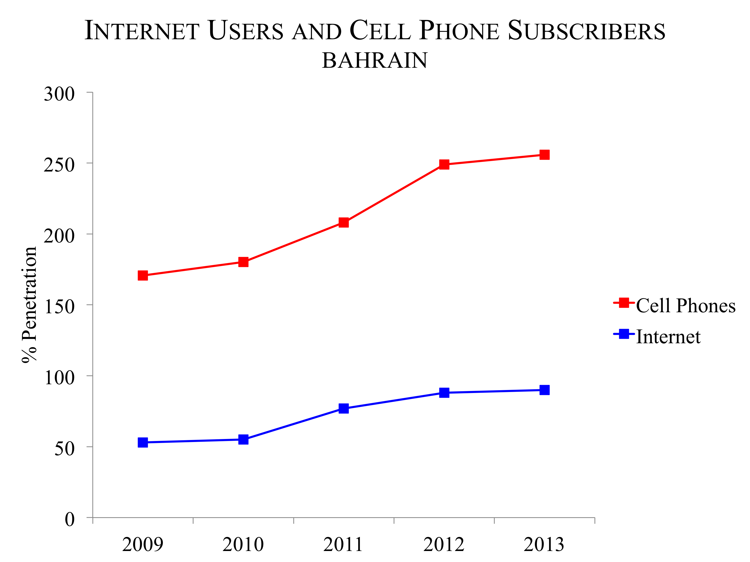
Figure 22: Cell Phone and Internet Penetration in Bahrain, 2009-2013 (ITU statistics)

It is apparent from Figure 22 that cell phone penetration surpasses 100 percent and Internet penetration is very high, nearing 100 percent (International Telecommunications Union, 2014). Widespread access to the Internet means that Internet activity is a reality of everyday life for most Bahrainis.

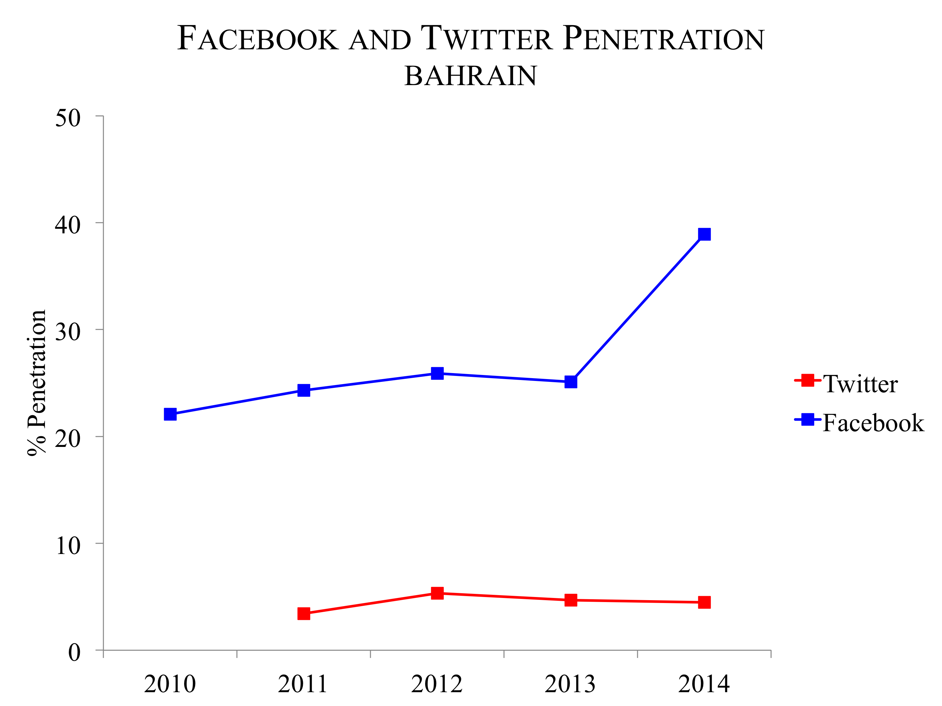
Figure 23: Twitter and Facebook Penetration in Bahrain, 2010-2013 (ASMR statistics)

Figure 23 shows the penetration rate of the social media platforms Facebook and Twitter in Bahrain between 2010 and 2014 (Dubai School of Government, 2011). Facebook penetration exceeds Twitter penetration in 2011 by a large margin, at around 24 percent compared with Twitter at around 3 percent. Twitter penetration is higher in Bahrain than in Egypt, but it is still extremely limited. As in Egypt, mass mobilization for the protests within the country in early 2011 would have to occur beyond these social media platforms alone.

Offline and Online Dissemination

As in Egypt, the second claim we make in support of the finding that information dissemination occurred primarily through offline activity derives from qualitative and quantitative evidence. Qualitative data show that offline actions, such as presence at protests or established relationships between actors, were a key factor in information dissemination.
Yet the ethnographic evidence does not match behaviors observed on Twitter. Online, we observe the same patterns in information dissemination in Bahrain as we found in Egypt: except for the human rights movement’s common hashtags, there does not appear to evidence for online domestic dissemination of information.

Key individuals in the human rights community became information hubs during the protests, gathering and disseminating information, mostly as a result of their being physically present at the demonstrations and in the Pearl Roundabout. Several of the most prominent Twitter users from the human rights community had never been so active. The affiliation of these key people, such as Nabeel Rajab and Maryam Al-Khawaja, with the human rights movements amplified their account of events and their message.

Al-Wefaq, in particular, became a hub for information gathering by any means possible—online or offline. Many protesters identified with Al-Wefaq because they are recognized as Shia representatives in the Sunni-run state. Although the leadership of Al-Wefaq, and indeed, other opposition societies, did not play a substantial role in instigating protests on social media or otherwise, they did benefit from the production of social media content. Tweets of events and mobile phone images and video were gathered as evidence of police brutality. The human rights wing of Al-Wefaq aggregates, sorts, and utilizes a vast archive of multi-media documentary evidence.

The close-knit nature of Bahraini political activism facilitated coordination across actors. As discussed in the introduction to Bahrain’s social movements, strong personal ties connect much of Bahrain’s Sunni human rights advocates and Shia opposition. The cross-cutting relationships become apparent in interviews with activists from different groups; they share information, strategy, and even familial ties. One Waad member, for instance, explained how useful personal accounts and testimonies of physical abuse collected by Al-Wefaq have been in documenting human rights abuses.

Aggregating digital content and personal narratives in order to document protest events and police abuses quickly became a significant online activity for both individual activists and CSOs, the human rights community in particular. A desire to report unfolding events became a key concern of movement members, and experienced activists (affiliated with Al-Wefaq and the human rights groups) provided not only opportunities to collect this content in one place but also a megaphone for sharing that content domestically and internationally. In fact, the February 14th collective has continued an aggressive media campaign online and via SMS.

When looking at the hashtags common to both movements and the larger Bahraini population, the online activity of the human rights movement becomes apparent. Whereas the movement uses its unique hashtags in specific bursts, giving the appearance of not being active after the start of the protests, Figure 24 shows that the movement was much more active with more general hashtags. Indeed, before February 18th, it uses #bahrain almost as often as the rest of Bahrain, despite representing just a few accounts, and it uses #feb14 more than the rest of the country on certain days. Both the movement and the rest of the country decrease their online activity after the initial crackdown and increase it prior to the arrival of Gulf Cooperation Council forces, climaxing with those forces crossing the King Fahd Causeway from Saudi Arabia. Finally, though #un, #saudi, #humanrights, and #14feb are common hashtags, they are not used nearly as frequently as the other three.

The most noticeable feature of the youth movement, which coalesced around organizing protests, is its late use of hashtags, both those unique to it and those used throughout Bahrain. While 13 of the movement’s 25 most common hashtags were only used by it, they were used in Bahrain much earlier and more consistently than within the youth movement. For the general population, #unitebh and #btv are most commonly used, with #unitebh skyrocketing after the crackdown on the main protest site at the Pearl Roundabout and #btv referencing events on Bahraini television. #unitebh is used only 12 times during this period amongst the actors. The most popular hashtags for the youth movement, #daih and #karzakan, are never prominent in the greater population. The same is true #14febrevolution, the group’s third most common hashtag and a variant of #14feb that never spread outside the youth movement. Interestingly, the movement does not devote attention to the intervention of the Gulf Cooperation Council, which clearly occurs with the elevated usage of #kuwait among the larger populace.

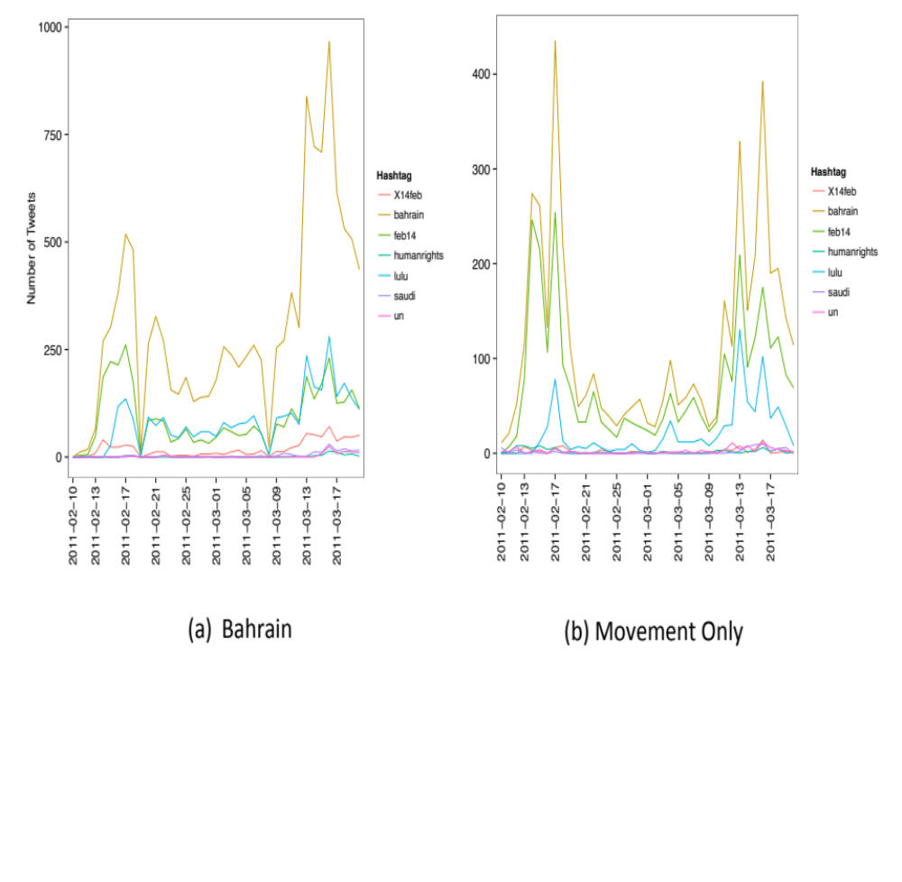
Figure 24: Human Rights, Common Hashtags

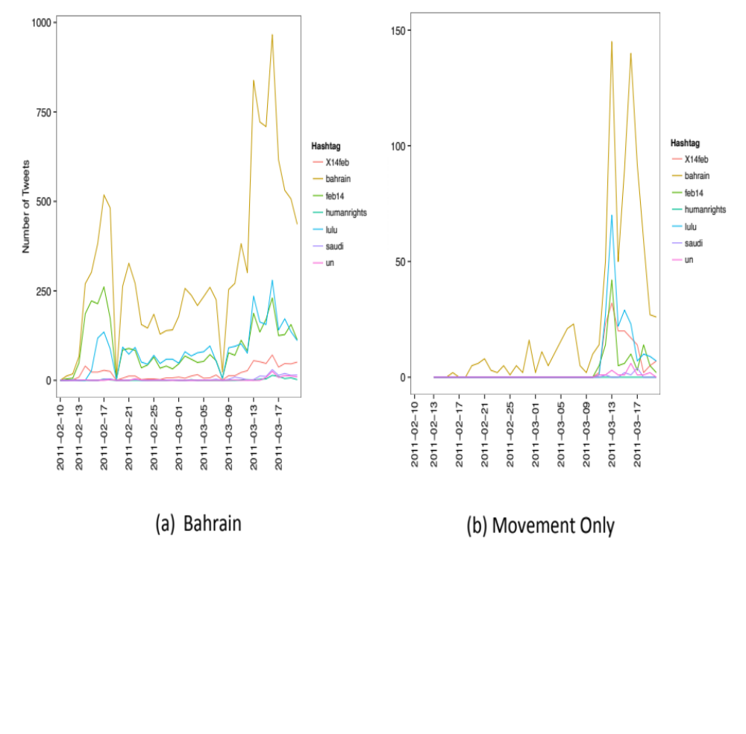
Figure 25: Youth, Common Hashtags

The hashtags unique to the human rights actors on Twitter suggests a difference between the communicative priorities of the actors and other Bahraini Twitter users in general.

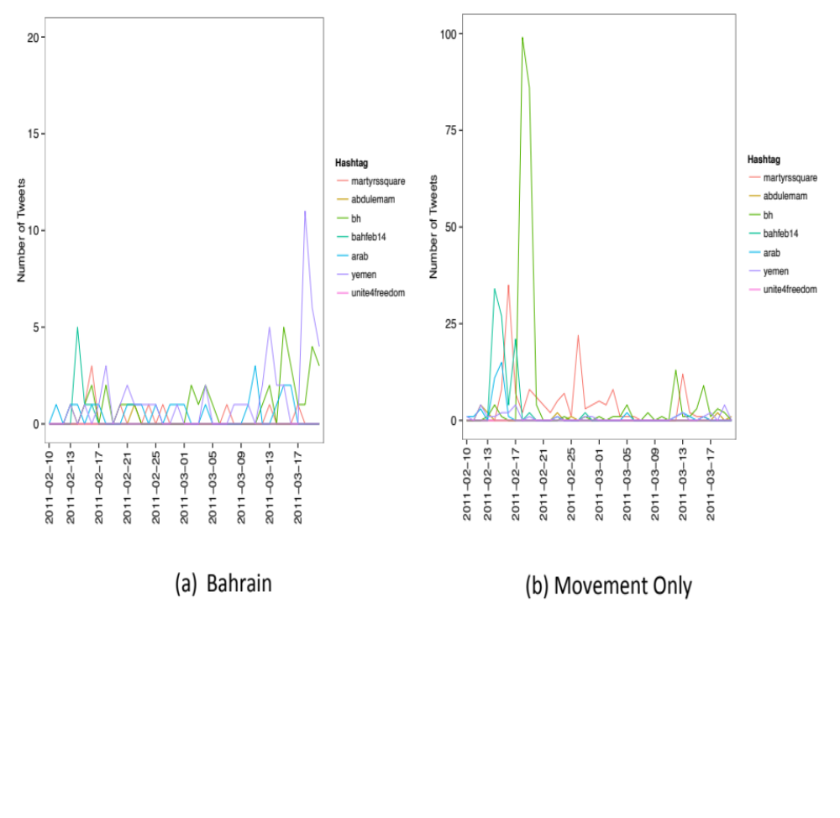
Figure 26: Human Rights, Unique Hashtags

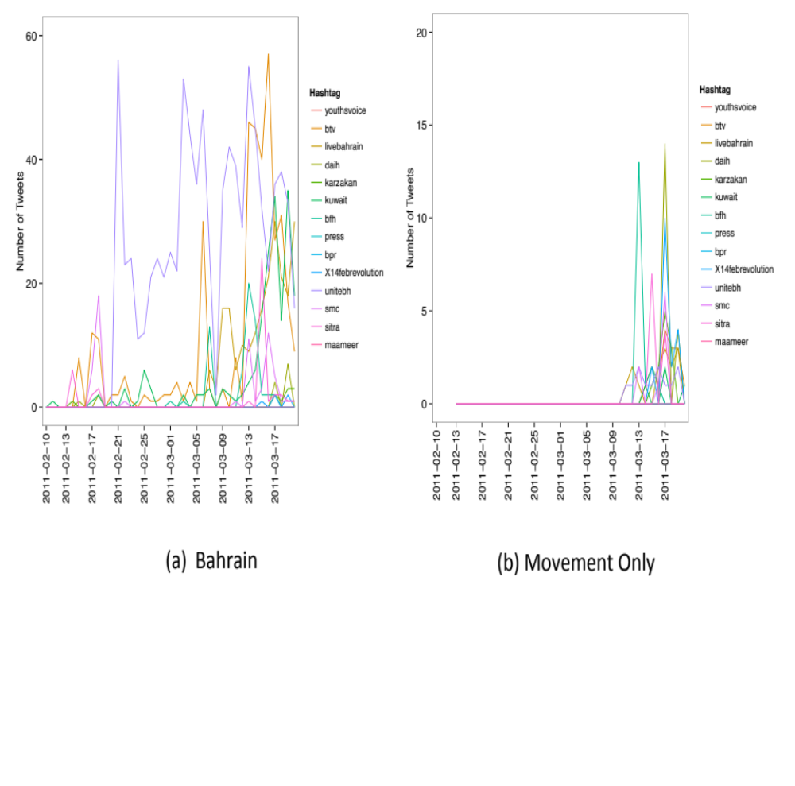
Figure 27: Youth, Unique Hashtags

The human rights movement, centered on the Bahrain Center for Human Rights, has fewer unique hashtags than the February 14th Youth, and those hashtags are used even less often than those of the youth movement. For example, the most common hashtag in the movement, #bh, is only the most frequent one for one day amongst the greater population, and it never receives the huge surge in attention given to it by the human rights movement just after the Pearl Roundabout crackdown on March 13th. The divergence is also evidenced in the online activity of the two populations: the human rights actors are most active with their unique tweets at the beginning of the protests, but they soon use them in very small quantities. But of the hashtags unique to the actors, #yemen receives the most attention from Bahrainis, and it does so in the middle of March, as protests picked up there; the human rights actors only use the tweets twice, on March 12th and 19th, though it is used in the same manner as the rest of Bahrain uses it.

This divergence could partly be explained by language. One feature that does not appear in this figure is the language distribution, and of all the movements analyzed for this chapter, the Bahrain Human Rights one is the one that uses English the most. Most of HR tweets are in English, with Arabic tweets coming from @saidyousif. Indeed, the vast majority of Arabic tweets for the movement are from one user @saidyousif, the Vice President of the Bahrain Center for Human Rights (he currently lives in Germany).

Figure 26 provides a unique glimpse into the emergence of hashtags and when they do and do not become popular. The 2nd and 3rd most common hashtags for the human rights movement, #martyrssquare and #bahfeb14, respectively, gain no traction amongst the larger Bahraini population. The group uses #bahfeb14 to spread news about protests, but they use it less and less frequently starting on February 16th (and never use it after February 27th). By that point, it had become clear that the main protest hashtag was #feb14 (which the movement also used, in the same manner as #bahfeb14). #martyrssquare is used 10 times outside of the movement but 150 within it, and it used in the same way others use #feb14 or #bahrain: to share information about protests and the government’s response to them. Finally, it should be noted that each of these hashtags are used primarily by one individual, @saidyousif for #bahfeb14 and @maryamalkhawaja for #martyrssquare.

Domestic and International Audiences

This section provides the third claim about Bahrain in support of the finding that information dissemination occurred primarily through offline activity. In the previous section, we showed how the interaction occurred offline and online (through content analysis); here we measure interaction based on retweets and mentions. As in Egypt, there was little interaction between actors and non-actors on Twitter. The actors’ follower network also shows that a large percentage of each movement’s followers probably do not reside in Bahrain.

Just as we did in Egypt, we measure interaction with online domestic audiences by seeing how often the actors and organization Twitter accounts are retweeted or mentioned in Bahrain. To measure international audiences, we look at tweets from Egypt to see if the mention or retweets the Bahraini actors accounts. These results are presented in Table 12.
Table 12: Non-Activists' Interaction with Movements, Domestic and International
Activist or Org. | Mentions- Bahrain | Retweets - Bahrain | Mentions - Egypt | Retweets - Egypt
@14febrevolution | 67 | 18 | 0 | 1
@angryarabiya | 145 | 20 | 9 | 8
@bahrainrights | 130 | 13 | 0 | 2
@byshr | 10 | 0 | 0 | 0
@maryamalkhawaja | 149 | 37 | 1 | 1
@nabeelrajab | 347 | 71 | 6 | 6
@saidyousif | 24 | 13 | 1 | 0

In comparison to the actors in our study from Egypt, the Bahrain actors are mentioned and retweeted often by the domestic audience. Whereas in Egypt many actors are barely retweeted or mentioned, every actor in Bahrain is mentioned, and everyone but @byshr is retweeted. This is more often because the average count of retweets and mentions per user is roughly equivalent as in Egypt (except for @alaa and @monasosh, who are mentioned and retweeted much more), but Bahrain has 1/3 the tweets (141,589 to 416,144).

The Bahraini actors are also engaged by Egyptians much more than the Egyptian actors are engaged by Bahrainians. Table 9 shows that only @alaa was retweeted in Bahrain (5 times), and only him and @monasosh were mentioned in Bahrain (245 and 5 times, respectively). All but one of the actors from Bahrain that we analyze are mentioned or retweeted in Egypt, though none on the scale of @alaa by the Bahrain audience.

To analyze the international audience, we replicate the network analysis performed for Egypt. Figure 28 shows that, like for Egypt, the main audience, judging by language, was English-speaking, with Arabic and English in second place.

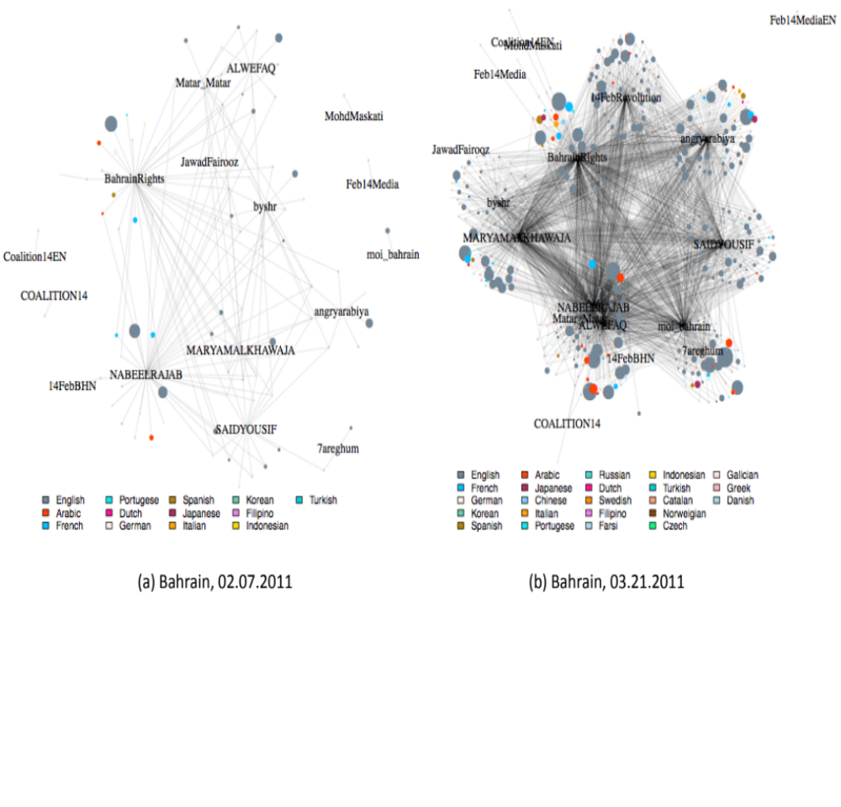
Figure 28: Bahrain Follower Network

The same inferential cautions hold here as they did for Egypt. The nodes are not as obviously international as they are in the retweets and mention analysis in the previous section, though less widely spoken languages, such as Thai or Finnish, are highly likely to belong to non-Bahrainis.

The sparse following network of the Bahraini actors and formal organizations further reinforces the idea that there was greater integration between those accounts and other Bahrainis, at least online. The Bahraini network is much sparser (few communities and few members in those communities) than the Egyptian one before each country’s respective protests, and English appears even more dominant than after the main protests. So the Bahrain online network has fewer members and produces fewer tweets than the Egyptian equivalent, yet the Twitter accounts for the activists and formal organizations are mentioned and retweeted as often as Egyptian actors are in Egypt. Yet though Bahraini actors were interacted with more intensely than their Egyptian equivalents, the interaction is still too low to suggest widespread information dissemination.

The human rights actors in Bahrain had already established connections with the international community, not only as a result of their work on human rights but also because the founders and members of these organizations had spent significant time living abroad. The Bahrain Center for Human Rights, for instance, frequently operates out of Copenhagen, where the Al-Khawajas spent time in exile. Although life in exile is presents challenges for creating sustained political change at home, it gave the human rights community in Bahrain a unique connection to the outside world, making it an ideal broadcaster of domestic events to a wider audience.

Conclusion

Ethnographic accounts of the Arab Spring tend to minimize the importance of social media for protest. Studies from a quantitative background tend to emphasize the importance of those same media over other, offline strategies for mass mobilization. By combining the two forms of analysis, we interrogate both conclusions. The digital case study, the name given to our methodology, allows us to see how online and offline activities affected each other, letting us understand the importance of each in relation to the other. In Table 13, we summarize our results.

Traditional methods of movement organizing - meeting in person to strategize, building coalitions over years, spreading information by word of mouth - were not supplanted by Twitter. While actors and participants in Egypt and Bahrain did use Twitter, often frequently, Twitter was one tool in each movement’s arsenal. The way they used it also limited its impact on protests. Movements used it less once protests started, and when they did use it they were unlikely to talk about the same topics that non-movement actors, “normal” citizens, found important.

The efficacy of Twitter was limited by many factors. Most importantly, it requires high levels of cell phone penetration, especially of smartphones, which was not the case in Egypt. Twitter was also a new tool in 2011 for people without an activist background, meaning the reach of those who used it was limited by the size of their audience. These structural difficulties mean that the activities that movements displayed on Twitter resonated mostly within each movement. There was little interaction between the movements online and non-movement individuals online, in marked contrast to offline behavior.

Table 13: Lessons Learned - Mass Mobilization
Claim | Evidence | Section in Report | Research Question
While initial calls for mass mobilization occurred on social media in both Egypt (Kulna Khaled Said Facebook page) and Bahrain (February 14th Youth), once street protests commenced, mass mobilization strategies moved heavily into the street, promoted by face-to-face connections and the coverage of events on traditional (satellite TV) media. | - Content analysis of tweets show lots of pro-protest and protest coordinating tweets at start of protest but very few after.  - Interviewees report being motivated to join protests by personal calls and messages, and other published memoirs from Egypt and Bahrain support this. | Egypt – Mass Mobilization – Moving into the Street  Bahrain – Mass Mobilization – Moving into the Street | 1
Technological mobility (cell phones and Internet platforms like Twitter and Facebook) complemented the physical mobility of actors in the streets. | - Device data attached to actor Tweets shows prevalence of mobile devices  - Activists posted videos and photos online of offline events, taking the street online | Egypt – Mass Mobilization – Complementing Offline Action  Bahrain – Mass Mobilization – Complementing Offline Action | 1
Formal organizations, including CSOs, tended to join protests after they had begun, actively choosing to remain in the background and provide resources. | - Few retweets and user mentions of CSOs by actors. Few retweets and user mentions of actors by Egyptians and Bahrainis.  - Interviews with opposition leaders and CSO employees confirm that many organized groups (from Al-Wefaq in Bahrain to the Muslim Brotherhood in Egypt) decided to officially participate in protests after they had already begun to gain momentum in the streets. | Egypt – Mass Mobilization – Formal and Informal Organizations Between the Online and the Offline  Bahrain – Mass Mobilization – Formal and Informal Organizations Between the Online and the Offline | 1

Table 14: Lessons Learned - Information Dissemination
Claim | Evidence | Section in Report | Research Question
Activist networks had formed in the previous decade and had begun using social media prior to 2011. | - Movements had followers in many languages (potential international audience in addition to domestic) before start of protests.  - Pre-existing relationships underpinned the communication in the early days of protests, as reported in activist interviews. | Egypt – Information Dissemination – Building to Protest: Egypt’s Media Landscape  Bahrain – Information Dissemination – Building to Protest: Egypt’s Media Landscape | 2
Most information dissemination occurs offline, through word of mouth. | - Content analysis shows actors’ topic not picked up by Egyptians or Bahrainis; topics important to Egyptians or Bahrainis not picked up by social movements.  - The protests in the streets provided a crucial opportunity for experienced activists and new protesters to meet, coordinate, and create connections; many protesters were encouraged to join protests by close friends and family. | Egypt – Information Dissemination – Offline and Online Dissemination  Bahrain – Information Dissemination – Offline and Online Dissemination | 2
Groups did not succeed in using Twitter to disseminate information domestically. Groups had many international followers, suggesting some international dissemination occurred. | - Few retweets or mentions of actors in their country. Many followers use Twitter in a language suggestive of living outside of Egypt or Bahrain.  - Many actors in both countries reported an acute awareness of international attention to events in Egypt and Bahrain and a desire to communicate effectively to audiences domestically and abroad. | Egypt – Information Dissemination – Domestic and International Audiences  Bahrain – Information Dissemination – Domestic and International Audiences | 2

While Twitter did have a role to play in disseminating calls for protests in 2011 and in sharing information once protests began, the mass mobilizations were the result of active information exchange between online platforms and the offline streets. The Arab Spring made Twitter a space for connectivity more so than Twitter made the Arab Spring possible.

The digital case study represents an important methodological innovation, one that has the potential to give us richer understanding of the world experienced by social movement actors and organizations in the 21st century communication environment. Nonetheless, there are several shortcomings that future research should address.

First, tighter integration between ethnographic and quantitative work can be achieved. Researchers need to inform each other of insights from their analysis as they occur, as that can point the other(s) in their own analysis. For example, noticing that tweets come more frequently from mobile devices can tell the ethnographer to try to ask questions about tweeting during protests. Ethnographic work can direct quantitative researchers to new subjects to find, keywords to search on, and online behaviors of which to be aware.

Second, this report shows the importance of timely data gathering (qualitative and quantitative). It would have been easier and more inexpensive to download the Twitter data of the actors in real time in 2011, and it would have been easier to dissect network evolution. Not having to pay for tweets would make it easier to analyze more actors and movements at once. The same is true for ethnographic work. Being in the field as events unfold, or shortly thereafter, exposes the researcher to more potential interviewees, fresher memories, and richer data. Not only is it difficult for interviewees to remember what happened years in the past, they often are afraid to or choose not to.

Third, online media are a rich ecosystem. When possible, a project should analyze multiple platforms simultaneously. Tracking the same individual or movement across multiple platforms is difficult and requires even more human labor and computational power than this report. But the movements do not exist on only one platform, and a complete understanding of online and offline interaction requires as complete a picture as possible of the online world.

One could interpret this report’s findings to suggest that ethnographers’ insights should have more credence than quantitative scholars’. That interpretation is wrong. It is conceivable that other digital case studies will find strong support for social media, and we found several interesting behaviors that would not have been knowable from solely qualitative evidence. The digital case study does not pit one method against to determine which should dominate in the future. Rather, it integrates them to better understand our world.

Bibliography
Abdelrahman, M. (2014). Egypt’s Long Revolution: Protest Movements and Uprisings. London: Routledge.
Acemoglu, D., Tahoun, A., & Hassan, T. A. (2014). The Power of the Street: Evidence from Egypt’s Arab Spring (No. 20665) (pp. 1–75). Cambridge.
Aday, S., Freelon, D., Farrell, H., Lynch, M., & Sides, J. (2012). New Media and Conflict After the Arab Spring (pp. 1–24). Washington D.C.
Al Jazeera. (2014, June 12). New law to end sexual harassment in Egypt. Al Jazeera News (Online), pp. 12–15. Cairo.
Al Jazeera English. (2011, June 18). Bahrain to Lift Ban on Opposition Party. Al Jazeera News (Online). Manama.
Al-Wasat. (2011, February 18). Witnesses: They Attacked Us While We Slept and Trampled Our Bodies with Their Feet. Al-Wasat. Manama. Retrieved from http://www.alwasatnews.com/3087/news/read/527881/1.html
Albrecht, H. (2005). How can opposition support authoritarianism? Lessons from Egypt. Democratization, 12(3), 378–397.
Albrecht, H. (2012). Raging Against the Machine: Political Opposition Under Authoritarianism in Egypt. Syracuse: Syracuse University Press.
Allmann, K. (2014). Activism on the Move: Mediating Protest Space in Egypt with Mobile Technology. Jadaliyya, (Roundtable: New Media, New Politics? Revolutions in Theory and Practice). Retrieved from http://www.jadaliyya.com/pages/index/18261/activism-on-the-move_mediating-protest-space-in-eg
AlShehabi, O. (2014, January). Bahrain’s Fate: On Ibrahim Sharif and the misleadingly-dubbed “Arab Spring.” Jacobin. Retrieved from https://www.jacobinmag.com/2014/01/bahrains-fate/
Amnesty International. (2011). Egypt: Release detained activists and journalists immediately. Cairo: Amnesty International. Retrieved from http://www.amnesty.org.uk/press-releases/egypt-release-detained-activists-and-journalists-immediately
Aouragh, M. (2011). Framing the Internet in the Arab Revolutions: Myth Meets Modernity. Cinema Journal, 51(4), 1–9.
Aouragh, M., & Alexander, A. (2011). The Egyptian Experience: Sense and Nonsense of the Internet Revolution. International Journal of Communication, 5.
Atkinson, R., & Flint, J. (2001). Accessing Hidden and Hard-to-Reach Populations: Snowball Research Strategies. Social Research Update, (33).
Bahrain Center for Human Rights. (2010). Bahrain imposes De-facto Ban on travel against Human Rights Defenders. Manama: Bahrain Center for Human Rights.
Bahrain Institute for Rights and Democracy. (2014). Maryam Al-Khawaja: Arrested and Remanded in Prison. Bahrain Institute for Rights and Democracy.
Barbera, P. (2015). Birds of the Same Feather Tweet Together: Bayesian Ideal Point Estimation Using Twitter Data. Political Analysis, 23(August 2013), 76–91. doi:10.1093/pan/mpu011
Bassiouni, M. C., Rodley, N., Al-awadhi, B., Kirsch, P., & Arsanjani, M. H. (2011). Report of the Bahrain Independent Commission of Inquiry (Vol. 2011). Manama.
BBC News. (2011, March 14). Gulf states send forces to Bahrain following protests. BBC News. Manama. Retrieved from http://www.bbc.com/news/world-middle-east-12729786
BBC News. (2014, October 28). Bahrain court bans opposition group for three months. BBC News. Manama. Retrieved from http://www.bbc.com/news/world-middle-east-29801796
Beaugrand, C. (2008). The Return of the Bahraini Exiles (2001-2006). In Mapping Middle Eastern and North African Diasporas. Leeds, United Kingdom: BRISMES Annual Conference.
Becker, H. S. (2009). How to Find Out How to Do Qualitative Research. International Journal of Communication, 3(March), 545–553.
Beinin, J. (2009). Workers’ Struggles under “socialism” and neoliberalism. In P. Marfleet & R. El-Mahdi (Eds.), Egypt: The Moment of Change (pp. 68–86). Zed Books.
Brown, N. J., Dunne, M., & Hamzawy, A. (2007). Egypt’s Controversial Constitutional Amendments. Washington, D.C.
Brownlee, J. (2002). The Decline of Pluralism in Mubarak’s Egypt. Journal of Democracy, 13(4), 6–14. Retrieved from http://muse.jhu.edu/content/crossref/journals/journal_of_democracy/v013/13.4brownlee.html
Bruns, a., Highfield, T., & Burgess, J. (2013). The Arab Spring and Social Media Audiences: English and Arabic Twitter Users and Their Networks. American Behavioral Scientist, 57(7), 871–898. doi:10.1177/0002764213479374
Bruns, A., & Burgess, J. E. (2011). The Use of Twitter Hashtags in the Formation of Ad Hoc Publics. In 6th European Consortium for Political Research Conferenc (pp. 1–10). Reykjavik.
Chulov, M., Finn, T., & Dehgha, S. K. (2011, February 20). Bahrain protesters reclaim Pearl roundabout in central Manama. The Guardian. Manama. Retrieved from http://www.theguardian.com/world/2011/feb/19/bahrain-protesters-reclaim-city-centre-manama
Cohen, N., & Arieli, T. (2011). Field research in conflict environments: Methodological challenges and snowball sampling. Journal of Peace Research, 48(4), 423–435. doi:10.1177/0022343311405698
Coyne, S. (2013). The “Menace” of Social Media. Washington, D.C.: Freedom House. Retrieved from https://www.freedomhouse.org/blog/?menace?-social-media#.VLjyl1rT_w4
Dicicco-Bloom, B., & Crabtree, B. F. (2006). The qualitative research interview. Medical Education, 40(4), 314–21.
Dubai School of Government. (2011). Arab Social Media Report: Civil Movements: The Impact of Facebook and Twitter. Dubai, UAE.
Earl, J., McKee Hurwitz, H., Mejia Mesinas, A., Tolan, M., & Arlotti, A. (2013). This Protest Will Be Tweeted: Twitter and protest policing during the Pittsburgh G20. Information, Communication & Society, 16(4), 459–478. doi:10.1080/1369118X.2013.777756
Ebaid, N. (2013). Sexual Harassment in Egypt: A Neglected Crime. Cairo. Retrieved from http://www.culturaldiplomacy.org/academy/content/pdf/participant-papers/2013-05-iscd-hr/Neama_Ebaid.pdf
Egyptian Ministry of Communication and Information Technology. (2012). ICT Indicators in Brief Jan 2012. Cairo.
El-Ghobashy, M. (2011). The Praxis of the Egyptian Revolution. Middle East Research and Information Project, 258.
El-Mahdi, R. (2009). The Democracy Movement: Cycles of Protest. In R. El-Mahdi & P. Marfleet (Eds.), Egypt: The Moment of Change (pp. 87–102). London: Zed Books.
Farhang, M. (1994). Terrorism and Military Trials in Egypt: Presidential Decree No. 375 and the Consequences for Judicial Authority. Harvard International Law Journal, 35, 225–237.
Freedom House. (2012). Divergence and Decline: The Middle East and the World after the Arab Spring.
Frontline Defenders. (2012). Bahrain:Arrest and charges against human rights defender Ms Zainab Al Khawaja.
Frontline Defenders. (2014). Update: Bahrain – Human rights defender Ms Zainab Al-Khawaja arrested.
Fuller, T. (2011, February 26). Bahrain Opposition Leader Returns From Exile. The New York Times. Manama.
Garrett, R. K. (2006). Protest in an Information Society: a review of literature on social movements and new ICTs. Information, Communication & Society, 9(2), 202–224. doi:10.1080/13691180600630773
Ghonim, W. (2012). Revolution 2.0: The Power of the People Is Greater Than the People in Power: A Memoir. New York: Houghton Mifflin Harcourt.
Grimmer, J., & Stewart, B. M. (2013). Text as Data: The Promise and Pitfalls of Automatic Content Analysis Methods for Political Texts. Political Analysis, 21(3), 267–297. doi:10.1093/pan/mps028
Gunning, J., & Baron, I. Z. (2013a). Why Occupy a Square: People, Protests and Movements in the Egyptian Revolution. London: Hurst Publishers.
Gunning, J., & Baron, I. Z. (2013b). Why Occupy a Square: People, Protests and Movements in the Egyptian Revolution. London: Hurst Publishers.
Hanna, A. (2012). Revolutionary Making and Self-Understanding: The Case of #Jan25 and Social Media Activism. San Diego. Retrieved from http://alex-hanna.com/static/pdf/AlexanderHanna-ISA.pdf
Hanna, A. (2013). Computer-aided Content Analysis of Digitally Enabled Movements. Mobilization: An International Quarterly, 18(4), 367–388.
Herbert, S. (2000). For ethnography. Progress in Human Geography, 24(4), 550–568.
Howard, P. N., & Hussain, M. M. (2011). The Role of Digital Media. Journal of Democracy, 22(3), 35–48. doi:10.1353/jod.2011.0041
Human Rights Watch. (2004, September 30). Bahrain: Rights Center Closed as Crackdown Expands. Human Rights Watch. Retrieved from http://www.hrw.org/en/news/2004/09/29/bahrain-rights-center-closed-crackdown-expands
Human Rights Watch. (2008). Egypt: Investigate Police Use of Force at Protests. Cairo. Retrieved from http://www.hrw.org/print/news/2008/04/10/egypt-investigate-police-use-force-protests
Human Rights Watch. (2010, October 20). Bahrain: Elections To Take Place Amid Crackdown.
Human Rights Watch. (2013). Interfere, Restrict, Control: Restraints on Freedom of Association in Bahrain. Washington, D.C.
International Crisis Group. (2011). Popular Protests in North Africa and the Middle East (III): The Bahrain Revolt.
International Telecommunications Union. (2014). World Telecommunication ICT Indicators Database. International Telecommunications Union. Retrieved from http://www.itu.int/en/ITU-D/Statistics/Pages/stat/default.aspx
Jones, T. C. (2012, March). Bahrain’s Revolutionaries Speak: An Exclusive Interview with Bahrain's Coalition of February 14th Youth. Jadaliyya. Retrieved from http://www.jadaliyya.com/pages/index/4777/bahrains-revolutionaries-speak_an-exclusive-interv
Jones, T. C., & Shehabi, A. (2012, January). Bahrain’s revolutionaries. Foreign Policy, 12–16.
Joyce, M. (2012). Bahrain from the Twentieth Century to the Arab Spring. New York: Palgrave MacMillan.
Katzman, K. (2012). Bahrain: Reform, Security, and U.S. Policy. Washington, D.C.
Kerr, C., & Jones, T. (2011). A Revolution Paused in Bahrain. Middle East Research and Information Project, 2010–2012. Retrieved from http://www.merip.org/mero/mero022311
Kerr, S. (2011, July 1). Bahrain opposition agrees to join talks. Financial Times. Manama. Retrieved from http://www.ft.com/cms/s/0/5f8e5020-a416-11e0-8b4f-00144feabdc0.html#axzz3OzFG3dVP
Khalil, A. (2011). Liberation Square: Inside the Egyptian Revolution and the Rebirth of a Nation. New York City: St. Martin’s Press.
Langohr, V. (2013). “This is Our Square”: Fighting Sexual Assault at Cairo Protests. Middle East Research and Information Project, 43(Fall). Retrieved from http://www.merip.org/mer/mer268/our-square
Leetaru, K., & Schrodt, P. (2013). GDELT: Global Data on Events, Language, and Tone, 1979-2012. In International Studies Association. San Diego, CA.
Mahmoud, A. (2011, September 25). Egypt’s long history of military trials. Al-Ahram Weekly. Cairo. Retrieved from http://english.ahram.org.eg/NewsContentPrint/1/0/22440/Egypt/0/Egypts-long-history-of-military-trials.aspx
Meital, Y. (2013). The Struggle Over Political Order in Egypt: The 2005 Elections. The Middle East Journal, 60(April 2006), 1–18.
Mekhennet, S., & Kulish, N. (2011, January 27). With Muslim Brotherhood Set to Join Egypt Protests, Religion’s Role May Grow. New York Times. Alexandria, Egypt.
Mocanu, D., Baronchelli, A., Perra, N., Vespignani, A., Goncalves, B., & Zhang, Q. (2013). The Twitter of Babel: Mapping World Languages through Microblogging Platforms. PLOS One, 8(4), e61981.
Mohammed, A., & Zill, Z. (2012). Bahrain and the Arab Spring: A Bahraini Activist Speaks about Bahrain’s Rebellion and What the Future Holds. International Socialist Review, (82), 1–6.
Moustafa, T. (2003). Law versus the State: The Judicialization of Politics in Egypt. Law & Social Inquiry, 28(4), 883–930. doi:10.1111/j.1747-4469.2003.tb00826.x
Niethammer, K. (2006). Robert Schuman Centre for Advanced Studies - Working Paper No. 2006/27 - K. Niethammer. Florence.
NoMilTrials. (2011). NoMilTrials Facebook Page. Facebook. Retrieved December 21, 2014, from https://www.facebook.com/NoMilTrials/info?tab=page_info
Nyathi, Q. (2013, August). Away from Egypt, Bahrain’s Own Arap Spring Uprising Heats Up Again. Time. Retrieved from http://world.time.com/2013/08/14/away-from-egypt-bahrains-own-arab-spring-uprising-heats-up-again/print/
Peterson, J. E. (2009). Bahrain: Reform--Promise and Reality. In J. Teitelbaum (Ed.), Political Liberalization in the Persian Gulf (pp. 157–185). New York: Columbia University Press.
Preston, J. (2011). Movement Began With Outrage and a Facebook Page That Gave It an Outlet. The New York Times. Retrieved from http://www.nytimes.com/2011/02/06/world/middleeast/06face.html?_r=0
Radsch, C. (2008). Core to Commonplace: The evolution of Egypt’s blogosphere. Arab Media & Society, (6), 1–14.
Reza, S. (2007). Endless Emergency: The Case of Egypt. New Criminal Law Review, 10(4), 532–553.
Rizzo, H., Price, A. M., & Meyer, K. (2012a). Anti-Sexual Harrassment Campaign in Egypt. Mobilization: An International Journal, 17(4), 457–475.
Rizzo, H., Price, A. M., & Meyer, K. (2012b). Targeting Cultural Change in Repressive Environments: The Campaign against Sexual Harassment in Egypt (Vol. 6619). Cairo. Retrieved from http://ecwronline.org/?p=1579
Sade-Beck, L. (2004). Internet Ethnography : Online and Offline, 45–51.
Sassen, S. (2002). Towards a Sociology of Information Technology. Current Sociology, 50(3), 365–388. doi:10.1177/0011392102050003005
Schachtman, N. (2011, February 1). How Many People Are in Tahrir Square? Here’s How to Tell. Wired.
Skalli, L. H. (2013). Young women and social media against sexual harassment in North Africa. The Journal of North African Studies, 19(2), 244–258. doi:10.1080/13629387.2013.858034
Stack, L. (2011, March 17). Complaints of Abuse in Army Custody. The New York Times. Cairo. Retrieved from http://www.nytimes.com/2011/03/18/world/middleeast/18cairo.html
Tawil-Souri, H. (2012). It’s Still About the Power of Place. Middle East Journal of Culture and Communication, 5(January 2011), 86–95.
Theocharis, Y., Albacete, G. M. G., Lowe, W., & W. van Deth, J. (2013). Using Twitter to Mobilise Protest Action: Transnational Online Mobilisation Patterns and Action Repertoires in the Occupy Wall Street, Indignados and Aganaktismenoi. Mainz.
Tufekci, Z. (2014). Big Questions for Social Media Big Data: Representativeness, Validity and Other Methodological Pitfalls Pre-print. In Proceedings of the 8th International AAAI Conference on Weblogs and Social Media. Ann Arbor.
Tufekci, Z., & Wilson, C. (2012). Social Media and the Decision to Participate in Political Protest: Observations From Tahrir Square. Journal of Communication, 62(2), 363–379. doi:10.1111/j.1460-2466.2012.01629.x
Ulrichsen, K. C. (2012). Bahrain’s Aborted Revolution. LSE Ideas.
United Nations. (2010). United Nations E-Government Survey 2010.
Wardany, S. El. (2014, July 16). Egypt Court Sentences 7 to Life in Prison for Sexual Harassment. Business Week. Cairo. Retrieved from http://www.businessweek.com/news/2014-07-16/egypt-court-sentences-7-to-life-in-prison-for-sexual-harassment
Whittaker, B. (2005, April 13). Egypt’s students protest against emergency laws. The Guardian. Cairo.
Wolman, D. (2011). The Instigators. The Atavist.

“Mobilization” is intentionally used with the adjective “mass”. There is some evidence that social movements, especially Egypt’s against sexual harassment, used Twitter for specific, small acts of mobilization. We find no conclusive evidence that Twitter affected mass mobilization.
This map provides an overview and an estimation of when protests related to the Arab Spring (meaning the revolutions in Tunisia and Egypt) began. However, it’s important to note that in many countries, protests over political and economic grievances had been ongoing in the year (or years) leading up to December 2010. This map simply provides an indication of the scale and breadth of protests sweeping the region at the time. Map reproduced with permission from author.
See Figure 7, Figure 8, Figure 22, and Figure 23 for a time series presentation of these numbers.
The rest of this section focuses on studies of Twitter.
It is important as well to recognize that most use of digital media is not for political ends.
“Society” is used here because that is the term used in Bahrain. Political parties are banned, but what would have been the political parties organized into “societies” instead. These societies stand for election just like political parties would.
These next paragraphs resemble a literature review. We have chosen to include them here because they are used to highlight our methodological contribution.
“Purpose” is their word. These purposes are: “vague”, “article (not news)”, “call for action”, “humour”, “unclear”, “information about a future event”, “information about the crisis”, “live action protest reporting”, “moral support”, “just hashtags”, “organizational issues”, “political conversation”, “political statement”, “reference to sister movement”, “reporting movement news”, and “reporting movement causes”.
By “traditional”, we mean they do not incorporate social network analysis or machine learning. Their quantitative analysis focuses on descriptive statistics presented in graph form.
We originally expected almost 17 million tweets. For two reasons, that number was reduced once we read the actual tweets. First, the 17 million figure came from counting the number of lines in each file using the bash command wc -l <each country’s file> and adding the resulting lines. Second, the tweets were selected based on a two-letter country code. This causes our original data to have tweets from Tunisia and Tennessee as well as Bahrain and Belo Horizonte, the capital of Minas Gerais, Brazil. Once we accounted for these quirks, we “lost” about 25% of our tweets. Fortunately, we have enough data that we have not lost any statistical power.
We use the term ``friend" here because that is the terminology Twitter uses. To ``friend" someone on Twitter means that one has decided to follow another person, a low-cost action that could correspond to any of a broad range of offline relationships. We have no method for ascertaining if a friendship on Twitter corresponds to a ``real" one offline.
On Twitter, this is the number of people one chooses to follow; Twitter calls these people friends. In a school setting, this would be the number of people with whom a person says he or she is friends. It is only applicable in directed networks.
On Twitter, this is the number of people who have chosen to follow a person; Twitter calls these people followers. In a school setting, this would be the number of people who identify a person as a friend. It is only applicable in directed networks.
All online platforms have obstacles to obtaining their data. Facebook, for example, must approve projects that want to use any non-public data; since most users’ Facebook data are not public, this restriction effectively means Facebook can veto any project.
Though we downloaded the friendship networks, our research questions compel us to only look at the follower networks in this report.
“Document” means the textual unit of analysis. In this study, the document is the tweet, but it can be any text: a speech, a magazine article, a collection of articles, a Facebook post, &c.
Choosing categories is an art. As with any project where qualitative data (the tweets) are solidified into quantities (a variable that equals 1 if the tweet is about a category), determining the categories requires an iterated process of reading the data (the tweets), adding categories, reading more data, adding (hopefully fewer) categories, and so on until one is satisfied that the available categories encapsulate the range of meanings in which the researcher is interested.
We did not remove the @ symbol because it is used in retweets and for coordination.
Stopwords vary by language, not by topic or movement, so using them will not cause introduce any bias.
We also built Naïve Bayes classifiers, which confirmed the superior performance of the support vector machine.
The first tweet in the Leisure 1 category was also identified as being part of the Protest Information category.
Interviews with protesters in Egypt, 2011-2014 (referenced with author’s permission).
There are several accounts of April 6th participation, echoed by interviews with activists in Egypt, 2011-2014 (referenced with author’s permission).
Interviews with activists in Egypt, 2011 (referenced with author’s permission).
Interviews with activists in Egypt, 2011 (referenced with author’s permission).
Interviews with activists in Egypt, 2014.
Personal interview, 27 October 2014.
Personal interviews with activists in the April 6th movement, 2011 (referenced with author’s permission).
We classify a tweet as coming from a mobile device or not based on the “Source” field from Twitter (via Sifter). The source field is a string such as “Twitter for iPhone” or “Web”, and we map those strings to categories of “mobile” or “not mobile”. We then count the number of “mobile” tweets per day and divide it by the number of tweets per day, by movement.
Personal interview, 22 October 2014.
Remember that “online” means “on Twitter” for this report.
It is not clear why the accounts spell “Mubarak” as “Mobarak” when referencing the law center. Reading the tweets confirms that they are about the law center.
Personal interview, 7 April 2014.
Personal interview, 29 October 2014.
We chose 25 because it provides a wide range of hashtags, encompassing different topics, without being so large that the hashtags become obscure even within a movement. While this number should vary by movement, we kept it at 25 to facilitate comparison across groups.
Personal interviews in Bahrain, 2014.
As we did for Egypt, we identified protest support and protest coordination tweets based on the support vector machine model.
Personal interviews in Bahrain, 2014.
We were not able to obtain data for accounts related to Al-Wefaq.
This pattern was also observed in Egypt.
Personal interviews in Bahrain, 2014.
Personal interviews in Bahrain, 2014.
Refer to the definition of “information dissemination” provided in the introduction. While actors certainly used Twitter to document offline events, that is not the behavior we define as information dissemination.
Personal interviews in Bahrain, 2014.
Personal interviews in Bahrain, 2014.
Personal interview in Bahrain, 2014.
Personal interviews, digital communication and observation in Bahrain, 2014.
@MARYAMALKHAWAJA is a daughter of Abdulhadi al-Khawaja, the founder of the Bahrain Centre for Human Rights. Her sister is @angryarabiya and her husband, Mohammed al-Maskati, is president of the Bahrain Youth Society for Human Rights, represented by @byshr. Abdulhadi Al Khawaja is serving a life sentence for his role in the protests.
We choose retweets and mentions because each require the person retweeting or mentioning to have some familiarity with the account being retweeted or mentioned; retweeting means the retweeter has at least read the tweet, and mentioning is suggestive of a relationship between the mentioner and mentioned.
It appears that the Bahraini activists and formal organizations studied have greater interaction with their domestic audience than the Egyptian ones do, and they resonate more in Egypt than the Egyptian activists did in Bahrain.
We suspect the international orientation of many members of the human rights community explains why most of the movement’s tweets were in English (see Figure 28).

